

Mental Health AI Chatbot – Mobile Application – AP2

**Ryan Harper**

**Mentor: Naveed Khan**

**B00798693**

**Bcs Computing Science (HONS)**

**May 2023**

Ryan Harper – B00798693

Course – BSc Computing Science

Mentor – Naveed Khan

# Abstract (500 words)

Mental health is a growing concern over these past years especially during the pandemic and after the pandemic. Mental health does not discriminate and can affect anyone, at any age, any background, any status at any time. Serious cases of mental health can even lead some people to take their own life as they can burden that on their shoulder anymore. From stats from the world health organisation over 700, 000 people take their life each year. People struggle to reach out to other in their time of need or don’t have anyone to reach out to they spend most of the time suffering alone with no one to help them, no one to give them advice or no one t let them know that its going to be ok. No one should have to take their own life or feel like a burden to anyone but sadly this is why some people may not tell their loved ones, as they don’t want to feel like a burden or issue to them when that’s not the case.

I’ve always wanted to help people but never really had any skills at medicine or am too afraid to become a firefighter or police officer. But I was good at computer, a career that I would like to take on in computer science is building something to help people that I couldn’t help in any other way. This is why my goal at the start of this learning year was **“To help people struggling with mental health who have no one to talk to or are afraid to talk to other loved ones about it. The main aim is to help everyone.”** And I never deviated away from this principle and kept true to what I wanted to do for this project.

Introducing Buddy AI, a mobile application chat assistant to help support people who are currently going through mental health struggles alone. The chatbot is them to guide the user to information to help them in their condition, it is also them to be a buddy (to the user. The Chatbot acts as the user friends while also trying to give the user some advice and pus them towards a loved one so they can open to a real person to help support them. No matter what Buddy never deviates from his positive cheerful dog like attitude always trying to lift the user up and let them know that everything is going to be ok regardless of the situation. The application will deliver only the best information possible to the user to ensure that no misinformation is spread to someone who is in a serious state of mind. A buddy for someone when they feel like they have no one.

The overall goal of this project is to help people by using the skills that I have acquired in computer science to build a functional application with all the features necessary for someone to easily gain that help as soon as possible.

# Acknowledgments (500 words)

First and foremost, I would like to thank my mentor for helping to guide me the whole way through this UNI year. Their insight has kept me in line and in check to continue producing the best material I possibly can while always checking to see if I need any help throughout the process, i have been truly grateful for them throughout the project, Thank you!

I would also like to thank my family and friends for supporting me ever since I took up learning about computer science all those years ago, from driving me places I needed to go and giving me all the advice that I needed to help navigate through my UNI life for this I am again truly grateful thank you for everything!

Contents

Abstract (500 words) 2

Acknowledgments (500 words) 2

Chapter 1 – Requirements Control document & Modification of the project plan 6

1.1 – Final list of requirements 6

1.1.1 – Adjustments made from AP1. 7

1.2 –Requirements prioritization strategy Review 12

1.2.1 – MOSCOW prioritization 12

1.2.2 – Wieger’s Relative weighting 12

1.3 – Risk Assessment Strategy Review 14

1.3.1 – Risk Assessment table 14

1.4 – Chatbot Design lifecycle 17

1.4.1 - Conversational user interface design guidelines best practices 18

1.4.2 - chatbot UX / Usability questionnaires 20

1.5 – Modification to the project plan 22

1.5.1 – Modification overview AP2 Finalized 22

1.5.2 – Updated Gantt chart 25

1.5.2.1 - Login 25

1.5.2.2 - Chatbot screen 25

1.5.2.3 - Store chatbot messages 25

1.5.2.4 - Settings menu 26

1.5.2.5 - RASA Chat bot 26

1.5.2.6 - Write up report 26

Chapter 2 – System design 27

2.1 – System design overview 27

2.2 – interface design 28

2.2.1 – Wireframe diagrams (Max 5 pages) 28

2.2.2 – HCI and Usability/Accessibility of the user interface 33

2.3 – Data support design 35

2.3.1 – Security 35

2.3.2 – Data validation 36

2.3.3 – Data structure Design 39

2.4 – User Interaction Design 42

2.4.1 – system flow diagram (300 words) 42

2.4.2 – Use Case diagram (300 words) 43

2.5 – Additional Design Artefacts (Topic Specific) 44

2.5.1 – Conversational flow diagram 44

2.5.2 –Confusion matrix (RASA) 45

2.5.3 – intent prediction confidence distribution 45

Chapter 3 – System Implementation 46

3.1 – Reflection on the implementation of the plan and execution 46

3.2 – Rational for tools (1000 words) 47

3.2.1 – Frameworks 47

3.2.2 – Web Wrapper 47

3.2.3 – programming languages 47

3.2.4 – Databases / API 47

3.2.5 – Other tools 48

3.3 – version control (300 words) 49

3.4 – summary of the code volume 49

3.5 – System walkthrough (5 pages minimum) 50

3.5.1 – Login frontend/backend 50

3.5.2 – sign up frontend / backend 50

3.5.3 – Forgot password 51

3.5.4 – Home Screen frontend / backend 51

3.5.5 – Settings Screen frontend / backend 52

3.5.6 –Chatbot frontend / backend 54

3.6 – consideration of security implementation 55

Chapter 4 – System Verification 58

4.1 – Reflection on the verification plan 58

4.2 – System Verification Results 60

4.2.1 – Mobile application 60

4.2.2 – Test cases 62

4.2.3 – RASA tests intents (Automated Normal tests) 72

4.2.4 – RASA intent confusion matrix 78

4.2.5 – RASA Intent Histogram 79

4.2.6 – RASA Intent results (Automated) With Cross validation 80

4.2.7 – RASA Intent matrix Cross Validation 84

4.2.8 – RASA Intent Histogram cross validation 85

4.2.9 – RASA tests Stories (Automated) 86

4.2.10 – RASA Stories being passed 88

4.2.11 – RASA Story confusion matrix 89

4.2.11 – RASA Story confusion matrix Cross validation 90

4.2.10 – RASA Rules Automated validation 91

4.2.10 – Chatbot questionnaire 102

4.2.11 – Testing Firebase API 104

4.3 – Evidence artifact that demonstrates system verification (300 words each) 105

4.4 – Confirmation statement (100 words) 105

Chapter 5 – System Validation 106

5.1 – Reflection on the system validation plan 106

5.2 – System validation results 106

5.3 – Consideration for future work 108

5.3.1 – RASA Forms 108

5.3.2 – Chatbot sending Images and link 108

5.3.3 – RASA Fallbacks 108

5.3.4 – UI Overall 108

5.3.5 – Chat suggestions 109

5.3.6 – Search for message through timestamp 109

5.3.7. – User profile page 109

Chapter 6 – Conclusion and Reflection 110

6.1 – Overall Critical Appraisal (500 words) 110

6.2 – Reflection on the project plan (500 words) 111

6.3 – Reflection on the appropriateness of initial time (500 words) 112

6.4 – Reflection on the appropriateness of Software methodology (500 words) 113

References 114

Bibliography 116

Appendices 117

Appendix A: Final Requirements Formal Format 117

Appendix B: Code Manifest 130

# Chapter 1 – Requirements Control document & Modification of the project plan

## 1.1 – Final list of requirements

|  |  |  |  |  |  |
| --- | --- | --- | --- | --- | --- |
| Requirement ID | Description | MoSCoW Prioritization | Relative weighting (OLD) | Relative weighting (NEW) | Dependencies |
| F1 | Must accept User input for chatbot even with numbers from the users. | M | 1.953 | 1.796 | N/A |
| F2 | The chatbot Must be responsive when the user asks it any questions. | M | 1.953 | 1.796 | F1 |
| F3 | Chatbot messages and user messages display each time when the user enters text and when the bot is expected to output it. | M | 1.597 | 1.470 | F1, F2 |
| F4 | Users must be able to navigate easily throughout the mobile application. | M | 1.102 | 1.013 | N/A |
| F5 | The user Must be able to ask for advice and receive advice on the appropriate situation the user is discussing. | M | 0.919 | 0.845 | F1, F2, F3 |
| F6 | Users can sign in / log out of accounts through the settings menu. | M | 0.911 | 0.838 | F16, F7 |
| F7 | Users can Sign up to create an account at the start screen. | M | 0.855 | 0.786 | F6 |
| F8 | Functional Mobile application. | M | 0.837 | 0.770 | ALL APPLICABLE |
| F9 | Functional Chatbot. | M | 0.837 | 0.770 |  |
| F10 | The database Must store user login and details and can be possibly edited if the user needs to change. | M | 0.822 | 0.756 | ALL |
| F11 | Save user information for signed-in accounts and edit username and password. | M | 0.683 | 0.629 | F5 |
| F10 | store account details on chosen system storing approach | M | N/A | 1.385 | F6, F7, F21 |
| F12 | Should allow a user to enter specific profile details. | S | 0.651 | N/A | N/A |
| F12 | Display old chat / Clear old chats from screen | M | N/A | 0.758 | F10,F1,F2, F14, F16 |
| F13 | Advice must be Accurate to the user's situation. | M | 0.651 | 0.599 | F1, F2, F5 |
| F14 | The database should store a particular user's chatlog. | M | 0.542 | 0.499 | F1, F2, F6, F7, F8, F9 |
| F15 | The application could have an advice page based on the user's situation. | C | 0.521 | N/A | N/A |
| F15 | Application should have advice page that display a variety of help lines for certain situations. | C | N/A | 0.479 | N/A |
| F16 | The settings menu for the user. | S | 0.521 | 0.479 | F20, F6, F23 |
| F17 | A chatbot could have text suggestions. | C | 0.498 | 0.458 | F1, F2, F3 |
| F18 | The chatbot Should engage with the user first. | S | 0.473 | 0.435 | F2, F3 |
| F19 | A chatbot can understand the broken text. | S | 0.407 | 0.374 | F1, F2 |
| F20 | User Can clear chat logs from the database. | S | 0.398 | 0.366 | F14, F16 |
| F21 | Light/Dark mode in the settings menu using the slider. | C | 0.355 | N/A |  |
| F21 | Forgot password feature | M |  | 0.871 | F6, F7 |
| F22 | The chatlogs could be saved to the cloud. | C | 0.341 | 0.314 | F14, HOWEVER ITS DEPENDABLES MUST BE MET |
| F23 | A chatbot could send images or emojis along with the correct Text. | C | 0.279 | N/A |  |
| F23 | User can delete account along with chatlogs. | M | N/A | 0.599 | F6, F7, F14 |
| F24 | User could have profile picture. | C | 0.260 | N/A |  |
| F24 | Time Stamp saved when uploaded to database and displayed when showing chatlogs | C | N/A | 0.239 | F1, F2, F14 |
| F25 | User can search for messages by typing in the time. | C | N/A | 0.371 | F24 |

#### Table 1 – Finale list of requirements

|  |  |
| --- | --- |
| Requirement ID | Description |
| NF1 | Human-like text from the chatbot is 50% to 90%. |
| NF1 | Human-like text from the chatbot is 35% to 75%. |
| NF2 | Understand users’ emotions. |
| NF3 | Understand when the user gets defensive to change the subject. |
| NF4 | Understand the user’s situation. |
| NF5 | Provide the user with accurate responses. |
| NF6 | A chatbot can understand the broken text. This was put into requirements as it can be hard coded in some respects to understand the broken text or through lots of machine training. |
| NF6 | Chatbot never comes across as aggressive. |
| NF7 | Chatbot to convince the user to talk to a loved one. |

#### Table 2 – Finale list of requirements non-functional

### 1.1.1 – Adjustments made from AP1.

Four overhauls of requirements happen, one requirement changed in wording to make the outcome of it clearer and one brand new one added. Two requirements were merged meaning one requirement was lost however the developer thought on further consideration that both requirements were too similar so the approach to merged them happened. This changes the requirement numbers however this will be updated and shown on table 3 and table 4.

#### 1.1.1.1 - Requirement Change F12

This was changed as the developer felt like this feature didn’t add anything to the system like the rest of the requirements. For example, the users being able to clear chat logs from database (F20), this is a valuable feature that interacts with the rest of the requirements as it will be a button that can be seen by the user while they can also click on it so it can interact with the database in the backend. This requirement has since been replaced with a requirement with two features, one to display old chatlogs and one to remove old chatlogs from the screen, this differs from F20, as F20 deletes them from the database were as this will just clear the on-screen text widgets. The developer thought this would be important for when the user wants to look upon old advice that the chatbot provided them and a clear button to remove all of them so they can continue their conversation. This is more of a quality-of-life feature as it helps the user easily view past messages and clear their screen when there are too many messages. As seen from the new updated weighting the new requirement is listed as more important than the old requirement, this was done as the new requirement would have more an impact to the application than the old requirement.

#### 1.1.1.2 - Requirement Change F15

These requirements don’t change the requirement, but the developer thought that this should be updated to make the requirements goal clearer. The past representation made the requirements seem like it would base on the user can chatbots conversations about mental health or profiles details instead of different helplines and organisations that could help the users in particular situations. The weight for this newer feature has gone done, this is not due to any risk being changed or the importance of the changed but due to other new features taking more of a priority.

#### 1.1.1.3 - RequirementChangeF21

This requirement was changed as the developer didn’t think overall it would be useful. With the developer’s current plan for the background, it wouldn’t be either bright or dark and more in between both. This and along with the fact that the new feature added is more important than the old one. The new feature is a forgot password feature. This would not only help the user to retain their account if they lost their password, but also act a security measure if they feel like someone has accessed their account somehow. This feature would work by sending an email to their email address along with a link where they could retype their new password. Another benefit of this new feature is that it can help with the developer development time constraint as this feature will likely be easier to add than a light and dark mode feature. The updated requirements has the highest weighting jump out of all the new requirements, this is due to the importance attached to this feature including the risk of it not being implemented, as this feature ties close to the user security and protecting their account, thus making it a MUST have requirement now.

#### 1.1.1.4 - Requirement Change F23

**F23** was replaced as this feature wasn’t added as with further investigation into kivy it may be difficult to add for a small feature, this may add more unnecessary time to the developer’s schedule. The reason why this feature may be hard to add in to kivy I that they have their own emojis that they can output in messages and don’t tend to take in other emojis outside of their library, this along with getting the responses back from the RASA server can be difficult as RASA can take different strings of text that kivy. As for the images this could be relatively easy to add but the developer felt like images in this type of application would not be needed. The new feature replacing this is the deletion of a user account along with chat logs. This feature was added as another security measurement as leaving the user account on the system could leave their email open for attacks or the users account open for attacks. Not only this, but if a hacker could get into the system, they could see the users private chatlogs. That’s why along with account deletion chatlogs go with it. This feature will be found in the settings menu and the user would only be allowed to delete their account if they can successfully retype their email and password. The reason why this feature would be made easy to find is that other mobile applications make it extremely hard for users to just delete their account with some other creators locking it by emailing their help service, by not doing this the user can easily delete their account if they feel like they had their use out of the application, and if they haven’t they don’t have to worry about someone else getting into their account and deleting their account as they would need to know their password. The updated feature has the second-highest jump in importance and is now a MUST-have feature due to its impact on the system and importance to the user security and protecting any data along with it.

#### 1.1.1.5 - Requirement Change F24

**F24** has been changed as the developer didn’t think a profile picture was needed as the application would have no real areas to display it or make sense for it to be displayed. This was changed for another minor but slightly more important feature of timestamps. This idea was thought of when using services like Facebook Messenger WhatsApp or Snapchat where the user can see what time a message was sent during past and current conversations. Weighting stays relatively the same due to the task not being as difficult as the profile picture but at the same time, it’s also as important as the profile picture.

#### 1.1.1.6 - Requirement Added F24

This new feature was added for users who want to search for past advice quicker. The plan is for the user to be able to click a dropdown and see all the timestamps they have access to relating to each user message and chatbot response. This would then display on the chatbot window or in a popup. This feature has been put down as a could have as it may be difficulty to implement, however if it didn’t get implemented its impact wouldn’t be detrimental to the application. This is more of an ease of access feature for navigational purposes.

#### 1.1.1.7 – Non-functional Requirement

Two changes have been made. **NF1** changing the ratios of what human like responses the bot will have this has been dropped from a 50-90 ratio to 35-75 ratio. From more research the developer has realised how hard this may be to achieve and how much work full teams would need to put in that much work. Another consideration is the quality of content the bot is producing and the accuracy of the information. Providing the user with misinformation especially in a mental health application can be detrimental to a user health overall. An example of this would be of the Belgian father who tragically committed suicide through communicating with an AI. The chatbot known as “eliza”, the father had extensive conversations with the chatbot about climate change, this then extremely escalated with the man asking if he sacrificed himself would the bot save the earth, then in the last conversation the bot responded with “If you wanted to die, why didn’t you do it sooner?” [1] which is considered the catalyst of the suicide. The reason for bringing this up is to show that people who may have mental health or who have under lying mental health conditions can take the words of chatbots serious if not more serious than an actual person’s words. Which is why it’s important to remember to focus on training the bot in the right areas, this is why some of the non-functional requirements have been dropped down to ensure all training is correctly done with no miss information being presented. NF6 was removed as RASA has some capabilities that can deal with features like this, however what the user types will still have to be accurate.

#### 1.1.1.8 - Overall Summary

Overall, the changes made to the application are changes the developer thought should have been added into requirements in its original conception but were either not thought of or were overlooked at the time. With the creation of the prototype the developer has more insight as to what can be done, which is the reason why some smaller features were removed due to time constraints. The newer features added would have more impact to the application but would be easier to implement from the creator’s standpoint as the prototype and more research have provided this insight. Across the requirements list weight have all changed due to changed requirements being more important and a new feature being added to the system. This doesn’t change the prioritization of any existing requirements. However, requirements that did get replaced with another, are higher than the original requirement. Below are the finale tables of the project.

|  |  |  |  |  |  |
| --- | --- | --- | --- | --- | --- |
| Requirement ID | Description | MoSCoW Prioritization | Relative weighting (OLD) | Relative weighting (NEW) | Dependencies |
| F1 | Must accept User input for chatbot even with numbers from the users. | M | 1.953 | 1.796 | N/A |
| F2 | The chatbot Must be responsive when the user asks it any questions. | M | 1.953 | 1.796 | F1 |
| F3 | Chatbot messages and user messages display each time when the user enters text and when the bot is expected to output it. | M | 1.597 | 1.470 | F1, F2 |
| F4 | Users must be able to navigate easily throughout the mobile application. | M | 1.102 | 1.013 | N/A |
| F5 | The user Must be able to ask for advice and receive advice on the appropriate situation the user is discussing. | M | 0.919 | 0.845 | F1, F2, F3 |
| F6 | Users can sign in / log out of accounts through the settings menu. | M | 0.911 | 0.838 | F10, F7 |
| F7 | Users can Sign up to create an account at the start screen. | M | 0.855 | 0.786 | F6 |
| F8 | Functional Mobile application. | M | 0.837 | 0.770 | ALL APPLICABLE |
| F9 | Functional Chatbot. | M | 0.837 | 0.770 | ALL APPLICABLE |
| F10 | store account details on chosen system storing approach | M | N/A | 1.385 | F6, F7, F21 |
| F11 | Display old chat / Clear old chats from screen | M | N/A | 0.758 | F10,F1,F2, F14, F16 |
| F12 | Advice must be Accurate to the user's situation. | M | 0.651 | 0.599 | F1, F2, F5 |
| F13 | The database should store a particular user's chatlog. | M | 0.542 | 0.499 | F1, F2, F6, F7, F8, F9 |
| F14 | Application should have advice page that display a variety of help lines for certain situations. | C | N/A | 0.479 | N/A |
| F15 | The settings menu for the user. | S | 0.521 | 0.479 | F20, F6, F23 |
| F16 | A chatbot could have text suggestions. | C | 0.498 | 0.458 | F1, F2, F3 |
| F17 | The chatbot Should engage with the user first. | S | 0.473 | 0.435 | F2, F3 |
| F18 | A chatbot can understand the broken text. | S | 0.407 | 0.374 | F1, F2 |
| F19 | User Can clear chat logs from the database. | S | 0.398 | 0.366 | F14, F16 |
| F20 | Forgot password feature | M |  | 0.871 | F6, F7 |
| F21 | The chatlogs could be saved to the cloud. | C | 0.341 | 0.314 | F14, HOWEVER ITS DEPENDABLES MUST BE MET |
| F22 | User can delete account along with chatlogs. | M | N/A | 0.599 | F6, F7, F14 |
| F23 | Time Stamp saved when uploaded to database and displayed when showing chatlogs | C | N/A | 0.239 | F1, F2, F14 |
| F24 | User can search for messages by typing in the time. | C | N/A | 0.371 | F23 |

#### Table 3 – Finale list of requirement without changes shown

|  |  |
| --- | --- |
| Requirement ID | Description |
| NF1 | Human-like text from the chatbot is 35% to 75%. |
| NF2 | Understand users’ emotions. |
| NF3 | Understand when the user gets defensive to change the subject. |
| NF4 | Understand the user’s situation. |
| NF5 | Provide the user with accurate responses. |
| NF6 | Chatbot never comes across as aggressive. |
| NF7 | Chatbot to convince the user to talk to a loved one. |

#### Table 4 – Finale list of requirements non-functional without changes

## 1.2 –Requirements prioritization strategy Review

### MoSCoW Prioritization Method: How to Use It in Agile [Guide]1.2.1 – MOSCOW prioritization

MOSOW prioritization strategy has been carried over from AP1 to AP2. Reason for MOSCOW being picked in AP1 carries over to AP2 as well. This being that MOSCOW can give each requirement a prioritization level. This helps when deciding which requirements, the developer should start first. Must haves have higher priority as the system can run without them, should have can be developed over the long run, and could haves be low-cost tweaks to the requirements. Wont haves have been removed from the creator finale requirements list as there is no reason to show requirements that are not going to be implemented. MOSCOW approach also shows stakeholders the main components of the project and what to expect from the application. MOSCOW as discussed in AP1 works well in tangent with the other priority approach of weighers relative weighting. As when priority have been assigned through MOSCOW it’s easier to assign a value towards it. From finale requirements two new requirements that have been added have both been moved up to Must-haves, since replacing the two Could-haves that were there before. Having the previous priority set for the old requirement helped to place the new requirements as the developer knew these new features were at least more important than what was removed, so placing them one higher than those would be the perfect placement for them. The new requirements added was set based on the rest of the requirements as well. With the prioritization set for the new requirements, relative weighting could now be applied as its now easier to know how important each of these features are relative to the overall application.

#### Figure 1 – MOSWCOW Definition

### 1.2.2 – Wieger’s Relative weighting

Wieger’s relative weighting once again is used in tangent with MOSCOW. This method proved to be just as effective again. With and understanding of the new requirements priority assigning importance to each one was easier. However, with the addition of new requirements being add and some being changed, some weightings went down overall even to features that are considered must haves. Relative weighting did influence one of the MOSCOW rankings that being **F12** as when the developer assigned the values, they ended up ranking the requirements much higher than they originally thought it was.

When adding a new requirement all the relatives weighting did drop however this produces the same results with the higher weighed requirements still being highly rated and the lower rate requirements being lower rated. This can be considered a disadvantage as it makes lesser requirements look even more unimportant which in a bigger scaled project with a team could cause problems in the developer period as these may be looked at and developed the least, but in this project as there is only one developer who assigns these values this won’t be an issue.

The Steps followed in AP1 relative weighting where again followed for AP2. The old spreadsheet used to assign the values was updated to fit the list of the finale requirements. No old requirements were changed for priority apart from the old ones that were removed as the developer thought that these requirements were already ranked at an appropriate level. Once the new requirement was added to the list of 24 the overall weighting went down but not by a noticeable amount. The most notable drops came when new Must-haves were introduced.

Overall, the author feels like this was the best approach to take from the start of the project with rank with MOSWCOW first then going into relative weighting as they feel this made the planning process faster.

$$Priority=\frac{Value \%}{Cost*Cost Weight+Risk*Risk Weight}$$

#### Figure 2 - Wieger’s relative weighting equation

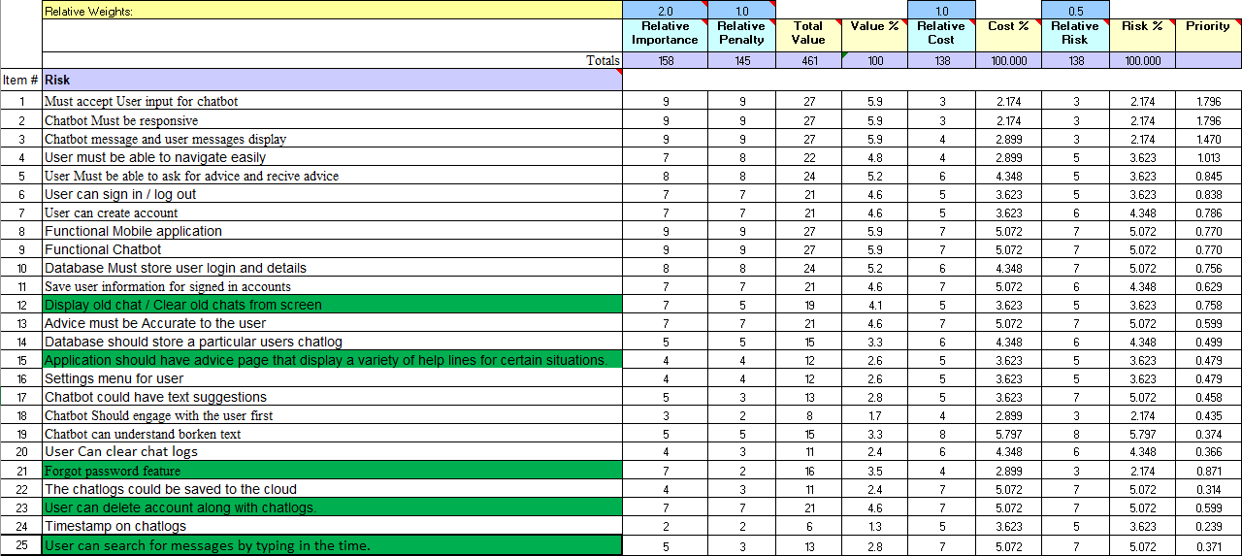

#### Figure 3 - Wieger’s relative weighting Spreadhseet

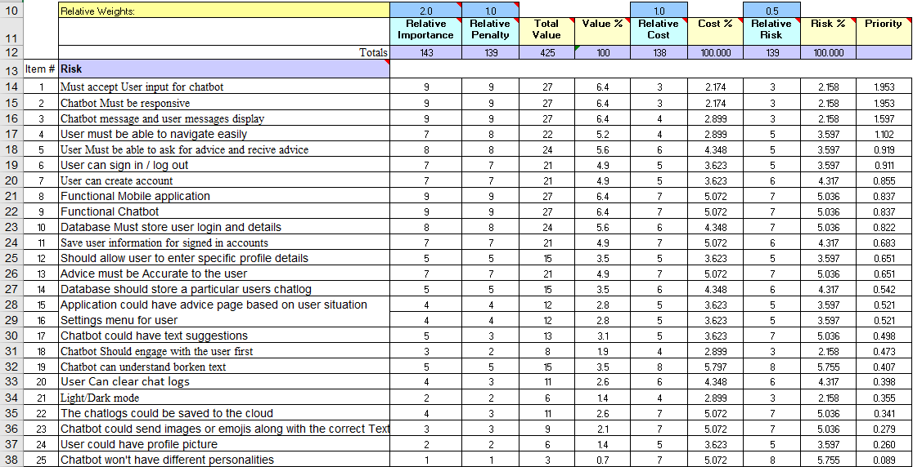

#### Figure 4 - Wieger’s relative weighting Old Spreadsheet

Above shows the new spreadsheet created and the old spreadsheet. The difference from the new one compared to the old one has been highlighted in green. **F12** has had it importance raised by plus two as stated before the feature is considered more important to the overall application, **F15** has stayed the same as it was only a minor tweak to the wording, **F21** had the biggest change as the importance jumped from two to seven, **F23** jumped from three to seven as yet again another important feature compared to what was removed and the last feature got five in terms of importance. It possible that the last one may change as it was debated how important overall it is for the application.

## 1.3 – Risk Assessment Strategy Review

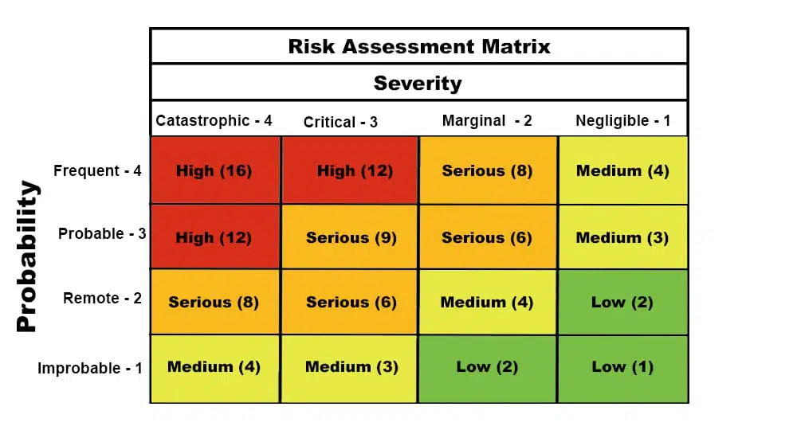

#### Figure 5 - Risk Assessment Matrix

The same Risk Assessment strategy from AP1 is carried over to AP2 as it proved to be extremely effective in showing the likely hood of an event to occur from high to low. it assigns the risk by the probability of that event happening along with the severity of it if it occurs. This method of identifying risk is easy and makes the risk overall easier to understand and assign a value to it, that being high, serious, medium, and low.

Some of the risks stated in AP1 may have not had an impact during the planning of the project and the creation of the prototype, but this risk won’t be dropped down in severity or probability that much as there are still possibilities that these risks can occur throughout the project. For example, the author didn’t have any outside sources effect their life when doing their coursework during AP1, but what Risk did come to be a problem is R1 which was the author having little knowledge of python kivy, this shows in the quality of work produced in the overall prototype at the end of AP1. This risk in hindsight, could have possibly been avoided with constant experimentation throughout the planning process with python kivy when writing the AP1 report, this could have had the possibility of a better outcome for the AP1 prototype instead of the lacklustre results produced.

When using it in AP1 it was used to assign risks to technical aspects of the project and out of control areas like outside aspect effecting course work throughout the semester. Those same risk are still going to apply to this project minus a few changes. These changes come from researching more during the authors break until the start of AP2. To get a better grasp of RASA and kivy throughout the project.

### 1.3.1 – Risk Assessment table

This is the updated risk assessment table for the project in AP2 going forward. R1 and R2 have had a decrease in risk going from 16 to 9 in risk threat level and from a high-risk value to serious. The prototype may have not gone completely to plan but it did teach the author the challenges they will faces when using kivy and RASA but also the places the author could go to learn more about kivy and RASA, that being their respective website and forums. **R3** has been replaced as the author felt that this didn’t apply and more, it has now been replaced with a risk with a higher risk value of high and threat level of 12. This new requirement deals with a much more serious subject of users getting the wrong information resulting it verry serious actions or harm towards the user. This risk will have to be acknowledged when training the chatbot. **R4** risk has been lowered as additional research has helped the user understand how this may work. **R5** has been moved up in risk threat level from 9 to 12 and a risk value of high, features like slots in RASA may be hard to understand or may not be utilized if the author does not have time to add them to the project. The original R8 has been removed and replaced, from a lack of understanding API to a lack of understanding kivy styling is complicated from the research that the author has done as style may differ from widgets.

|  |  |  |  |  |  |
| --- | --- | --- | --- | --- | --- |
| **Risk ID** | **Description** | **Threat Posed** | **Risk Threat Level** | **Risk Value** | **Mitigation Strategy** |
| R1 | The developer has little experience using the frontend python kivy. | An unusable front end renders the entire mobile application aspect unusable. Which impacts the intended requirements for the project. | **3 x 3 = 9** | **Serious** | The developer will use tutorials in order to gain a understanding of the steps needed to produces and acceptable front end. If the developer is unable to produce a suitable frontend other framework will be looked at. |
| R2 | The developer no experience setting up an AI framework before. | Results in low quality chatbot with no interaction capability or possible no chatbot at all. | **3 x 3 = 9** | **Serious** | The developer will go through tutorials on how these AI chatbots are set up and how to build interactions in the AI so that the developer an train it. |
| R3 | The AI chatbot has not been set up with simple talking command so that the developer can experiment with it. | As researched, for an AI chatbot to talk they need to be filled with commands to talk back to the user. If the developer is unable to set this up the chatbot won’t be responsive. | **4 x 2 = 8** | **Serious** | The developer will research the appropriate python setup used to produce and hold the chatbots text capabilities. (The developer has chosen two different AI strategies in RASA and python Chatterbot; Chatterbot is the back up to RASA in case the developer faces difficulties. |
| R3 | Providing correct support and information for people with mental health. | Providing miss information to people struggling with mental health has the possibility to lead to the same outcome as the story listed in [1], as it shows that even though the chatbot isn’t a real person, people can still take the words it produces seriously. | **3 x 4 =12** | **High** | Use references to websites or helplines that the user could use when the user mental state is poor, or their situation is extreme to the point where professional help is needed. The author will learn how to tailor general conversation to outside help like helplines or to get the user to talk to loved ones. |
| R4 | The AI chatbot and frontend have not been linked together. | So, the user can interact back and forth with each other, the user will be able to see their messages and the chatbots messages. This risk results in a unusable chatbot if set up correctly and producing results within its program. | **2 x 4 = 8** | **Serious** | The Developer will research and watch tutorials on how this has been achieved in similar solutions. A back up AI solution in python chatterbot has also been chosen to replace RASA if the developer struggles to implement it into the Kivy frontend. |
| R5 | Little experience using RASA. | As this is the first choice of the developer to produce a working AI chat, this would be important to learn so that it can be used within the project. | **4 x 3 = 12** | **High** | The developer has chosen two different AI strategies in RASA and python Chatterbot, Chatterbot is the back up to RASA in case the developer faces difficulties. |
| R6 | Finding a Data set for the API to pull to compliment the homepage to provide the user with appropriate information. | The homepage will need to be populated with data and given the topic of the application it may be hard to find a data set with appropriate data. | **1 x 2 = 2** | **Low** | This may cause the developer a little problem to find however, if an appropriate dataset does not exist it is possible for the developer to create their own data set just containing crucial information on certain topics. This approach is slow but also gives the developer a chance to understand the data they are work with better. |
| R7 | Storing user chat logs. | The developer has never stored messages in a system before. This could lead to user not having a past conversation | **3 x 3 = 9** | **Serious** | This will be having to be research by the developer later in the creation process when they have a better understanding of the application. This understanding could provide more insight on how the text can be stored and also gives the developer a chance to look at other solution to see how they’ve stored their data. |
| R8 | Unsure on API development when interacting with a mobile application. | Broken API or users being unable to pull data for logins or homepage. | **2 x 2.5 = 5** | **Medium** | The developer over this past 4 months has gained and understanding of how APIs work and how to implement them. The developer will have to research how this can work with a mobile application and python kivy to display data. |
| R8 | Lack of understanding in how to style Kivy pages. | Styling in kivy is one of the bigger features however each widget has its own way of styling it. | **4 x 1** | **Medium** | The developer has realised that Kivy widget have all different types of styling to be applied to them and not all of them are the same, especially for widgets that are added from a python file, as styling in a python file is much more different than styling in a .kv file. However, this does not drastically impact any of the important finale list of requirements. |
| R9 | Computer limitations when running tests. | Laptop may not be able to run automated testing efficiently or new advancements like RASA. | **2.5 x 2 = 5** | **Medium** | The developer is using a laptop to create all the project. Unfamiliar software could potentially cause the laptop to crash as it has done during other University modules. If this occurrence happens using community libraries or ulster resources may have to be the alternative, although travel consideration will have to be considered. |
| R10 | Outside life aspects interfering with coursework. | Travel, work and other obligations like doctor appointments can lead to rushed development of the project leading to broken functions or functions not being added. | **2 x 3 = 6** | **Serious** | Since most information needed can be accessed online all the developer will need is an internet access to prevent some outside occurrences from happening and since it’s a laptop the developer can work from most places. |

#### Table 5 – Risk assessment table

## Diagram Description automatically generated 1.4 – Chatbot Design lifecycle

Following feedback from AP1 the developer has been advised to follow a chatbot life cycle design. After further investigation into chatbot design life cycle the developer has agreed that following one will improve the quality and rate when chatbot prompts can be created. The chatbot design lifecycle was carefully selected to fit the already made plan. It was important to pick a life cycle that wouldn’t overall impact any of the methodologies in place. The above chatbot design life was the chosen in consideration of the iterative and incremental development (IDD) methodology. This chatbot design methodology wont completely overwrites the iterative process but will just work inside of it. After the end of each cycle the iterative process will then continue and the chatbot lifecycle will then take place again if needed.

#### Figure? – Chatbot flow design [5] [6]

**How it works**

Before explaining the others reason related to why this cycle was chosen and the alternatives that were thought of instead, first it’s important to understand the development cycle first. First the user **collects the questions** that are going to be asked by the user, the developer will then move onto **intent clustering**, in this case of the project this will be using the NLU file and filling the intents for that one question the user is asking, these intents will all be similar in nature but worded differently. After the intents have been implemented the user will then move onto the **dialogue design**, this is how the user and chatbot will talk to each other, more specifically what the chatbot will say and how it will say it, this will take place in a spreadsheet first that the developer has been making and storing ideas from for the chatbot, this method was thought of when seeing Chatpals spreadsheet for their design intents. The developer using this spreadsheet will come up with a general overall response from the user, with a semi produces response from the chatbot to get a general flow of how the user and chatbot will interact before implementing it on the real system, this also gives he developer a chance to see how the conversation flow will go. After designing the dialogue, the developer will then build the **conversation flow**, this will be designed first then implemented into the RASA stories to control the flow of how the chatbot and user interact, this will be made up of small stories that can then link to each other to ensure he chatbot is confident in every prediction it set for each response as when the story goes on the chatbot can become more uncertain about its next dialogue option. The next development process is **response design**, this will be how the chatbot talks back to the user. In dialogue design the developer will lay out what the chatbot will say and in response design the developer will write what it says based on the prewritten dialogue on the spreadsheet. The last step is then he optimization of the story line the developer has just created, this will include testing of the chatbot response, story flow, user intents and the contents. This section will be back up with the conversational user interface guidelines that the developer has been using from the Chatpal toolkit (1.4.1). The process will then start all over again with a brand-new conversation with the user and chatbot taking place.

**Why it was picked**

As stated, before this design methodology was picked as it fit with the overall project IID. However, this is not the only reason it was chosen by the developer. The developer knows that their knowledge on RASA is limited and will only progress throughout the project. So, taking on a methodology that handles small segments of the chatbot design at a time, rather than completing whole chunks of it where there is more room for the developer to make errors. There is also an emphasize that has been put into the Chatbot Reponses from the developer, as it important for the chatbot to deliver information that’s not only relevant to the user but information that is factually correct, especially when dealing with user who may be suffering from severe mental issues. This method lets the developer focus on the smaller details of the Chabot through each cycle. The cycle also lets the developer handle stories better as instead of dealing with 150 – 200 chatbot intents at once, they can instead focus on 5 – 6 stories that are related to each other, this ensure that these segments ae tested and working straight away rather than doing 200 tests in a row and missing some out. The lifecycle also works with the Chatpal user interface design guidelines as well, as the author can make sure these guidelines are implemented on each cycle. Overall, the developer feels like this cycle can help to support their lack of knowledge in this area at this moment in time, while also supporting the improvement of the developer as they are learning more making each cycle easier to go through and potentially going through them quicker if in a short time frame. The guidelines that come with Chatpal however that do relate to this life cycle will be applied, for example dialogue design. This is due to the information provided to the document, as the author felt like this was easier to understand and then help to develop their own chatbot.

**Alternative Design cycle**

The alternative design cycle that was considered was the Design Cycle supplied in the Chatpal Toolkit [3]. This Design cycle would have worked with the user interface guidelines set as they would have both come from the same source while he cycles also supports an agile approach as recommended on the toolkit. However, the author opted from this as even though their design cycle provided much more in-depth steps with trailing, health care domain understanding and defining requirements. The reason for this is that the developer thought that they might not be able to keep up with the lifecycle itself as they felt they may make some mistakes throughout the application and as they were already familiar with the ID approach, they decided to go with a methodology that closely represented how it works. The Chatpal approach would be taken if the developer was more confident in their skills going forward with RASA, however as stated before this could change with time the developer understands more. As stated, before the steps that apply to Chatpal life cycle that also apply to this will be used.

### 1.4.1 - Conversational user interface design guidelines best practices

These are the ten guidelines that the author has set themselves. The author believes that following these guidelines can make sure they produce a high standard simple chatbot. These will be used in conjunction with the IID methodology and the chatbot lifecycle methodology to produce a coherent chatbot. Overall following these rules will keep the developer plan in check and hopefully keep them on time to produce a high standard application.

**Ethical issues/Quality of information**

This is the most important guidelines for the author. As discussed before its vital that information that the user is receiving it factual correct [6]. As the developer doesn’t have much knowledge when it comes to mental health issues, they will take from supported online sources like MIND.org, NHS and professionally researched papers produced by health institutions. The chatbot will also stray away from telling user about symptoms. The reason for this is that if this person is suffering from a mental disability self diagnosing themselves may make that potentially worse. Instead, ways to cope with mental health in less serve ways will be implemented to help combat this. The developer will instead lean on more common knowledge on their side, this means just standard dialogue of a friend support another friend that is currently struggling.

**Personalisation**

Personalization of the robot is important. As when interacting with a person in real life normally you can get a hint of people personalities slightly or in some cases straight away. When dealing with a healthcare chat bot this can be difficult as you want to provide the user with information without its personality getting in the way. The plan to avoid this is to have a an extremely upbeat personality, so when the user is having a serious conversation the chatbot responds with supporting statements to the user that it’s going to be ok then provides the information followed by another supporting statement then followed by a question again if needed. In resolution of a conversation the chatbot will then show its supportive personality along with its quirky personality, following up with support and a joke on the chatbots own self instead of at the user. The chatbots supportive messages in between each conversation will be used to make the user feel comfortable will also showing the chatbot over the top Labrador love for the user, hopefully in turn making the user smile or feel joy. The developer has based the personality of the chatbot off of a popular movie character called ‘Dug from the movie Up by Pixar, as it’s an over-the-top positive sounding dog that is always there to comfort the characters that its talking to while also showing their loyalty and trust to the character its talking to.

**Limitations/transparency**

It important to let the user know that the chatbot can’t deal with everything they have said and that they may have to say something in a specific way for the chatbot to understand. To cover for this area the author will first open with a message from the chatbot explaining the limitations of the chatbot and how they can in turn talk to it. The next measure that has been taken is implementing a menu system for the chatbot. This will be set up on RASA most likely using rules as it can override conversations for when the user needs to get information quickly. There will side menus and overall menus, this overall menu will contain the commands the user needs to enter to bring the side menu up. This will set the user up to transverse the chatbot conversation easier getting the help they need faster.

**Consistency**

Consistency will come into place with the writing of the chatbots dialogue and the user intents. The overall user intents will provide a vast number of different intents from the user but will also contain one response that relays what the bot just asked right back to it. For example, if the chatbot asks are you alright, the user could then respond to that question with exactly what the chatbot said but applied to them “Yes I am alright”. The author will try to keep this consistent for all the question if they can. This helps the user quickly navigate through conversations to get help for themselves. The responses from the chatbot will try to keep the same tone of personality will giving the user important information. This consistency also applies to the information provided., as the developer will try to pull from the same trusted sources, If possible, to make the information provided more consistent across the board.

**Emulating real conversation**

Emulating real conversation will come from the rules, stories and chatbot dialogue side of the RASA chatbot. Rules will be set up so that anytime the user says hello the chatbot will say hello as this generally is what happens in real life, this will be applied to response like “no problem” if the user says thanks and so on. The chatbot dialogue as stated in the non-function requirements will try to emulate around 50 – 90%. This is set to this as obviously the chatbot will do and say thing that no ordinary person could do, for example not many people in real-life have a menu in their head they bring up, however this does apply to normal flowing conversations and the dialogue the chatbot says back to the user. As talked about before the chatbot is going to be more like a lovable dog in the way it supports the user, despite this it will always provide the user with vital information while toning down that personality for the sake of the user. As there are not many people like his in real life terms some of the reality may slightly drop so the Chabot can keep up its personality in supporting the user.

**Guiding the user**

As discussed before the rules are going to be important to guide the user along with resolution messages that come at the end of stories, often leading the user back to the menu or onto another conversation they can talk about. These are used to make the user feel like they are the one that have more control over the conversation rather than them feeling like the chatbot is controlling the conversation removing some of the users trust as to what the chatbot actual intentions are. Of course, as stated throughout AP1 the chatbot is always trying to get to the user to talked to a loved one or seek professional help to try and resolve the issue that they are facing, however the chatbot is always trying to push them to talked with loved ones instead as this may be easier for the user to do.

**Menu based**

Menus will be set up with rules, but the entire Chabot will not be menu based, menus will only be used to get definitions on what certain mental health conditions are and hope to cope with them, along with the ref the information was got on. Reference menus will be added as their own fields instead of a part of the coping section as user may just want a reference to an organisation instead of reading about the methods they can use.

**Opportunities for conversation**

Opportunities for more conversation will be added towards the end of resolutions for conversation, this way the user has the option to talk more if needed.

**Avoid areas of weakness**

The developer is avoiding areas of weakness by getting factually correct online resources to write the more technical side of the chatbot responses, this covers for the developers lack mental health knowledge as of writing this. The developer may also try to avoid areas in the RASA framework like slots, as this may over complicate the workload for the user, and instead is going to focus more on using stories and rules along with good dialogue write to help cover for the lack of slots that could help progress the overall story. Instead, the chatbot will act as a day-to-day conversation the user can have rather than a chatbot that tracks the user narrative throughout weeks.

**Fallback messages**

The fall-back message will come in the form of the backend of the mobile application, this should catch that the RASA chatbot didn’t produce any message and post its own message. This message will be trying to guide the user on how to talk to the chatbot like the first message they receive.

### 1.4.2 - chatbot UX / Usability questionnaires

As recommended in the AP1 feedback a chatbot ux/usability questionnaire has been implemented. This won’t be touched on until the application or chatbot has been completed and will come towards the end of the IID cycle. The questionnaire contains sixteen balanced questions, that relates to different areas of a chatbots usability. Eight questions that relate to positive aspects of the chatbot usability and eight relating questions to the negative aspects. As the author will be the only one to do the survey only one survey will be completed. This survey will look to show the stakeholders on the overall completeness of the chatbot itself and the developer how clinical the chatbot is. This questionnaire has not been altered from its original developer as the criteria fits the chatbot for the project [7] [8].

This questionnaire uses CUQ to calculate the overall percentage for the questionnaire. All the sixteen questions are scored using a five-point system, the odd numbered questions will be related to positives of the chatbot, and the even numbered questions will relate to even questions. Odd questions in grey even in white [7] [8].

**Score calculation**

1. For each question, assign a score from 1 to 5 based on the level of agreements from the statement

|  |  |  |  |  |  |  |  |  |  |  |  |  |  |  |  |  |
| --- | --- | --- | --- | --- | --- | --- | --- | --- | --- | --- | --- | --- | --- | --- | --- | --- |
| Question | 1 | 2 | 3 | 4 | 5 | 6 | 7 | 8 | 9 | 10 | 11 | 12 | 13 | 14 | 15 | 16 |
| Score | 4 | 2 | 5 | 4 | 5 | 3 | 4 | 5 | 2 | 1 | 2 | 2 | 4 | 1 | 5 | 3 |

1. Calculate the odd numbers and positive numbers.

odd = 4 + 5 + 5 + 4 + 2 + 2 + 4 + 5 = 31

even = 2 + 4 + 3 + 5 + 1 + 2 + 1 + 3 = 21

1. Subtract 8 form the odd number.

odd = 31 – 8 = 23

1. Sub tracts the even overall from 40

Negative 40 – 21 = 19

1. Add the new odd and even.

Overall = 19 + 23 = 42

1. Convert the score from step five to find out the score out of 100.

New Score = (42 / 64 )*100 = 65.625

This is the method that will be used to estimate how well the chatbot has been developed when the finale product is produced. This will not only give the developer an insight as to what the developer thinks of the overall chatbot but also the developer themselves as they can see where they need to improve if they ever build anther chatbot again in the future [7] [8].

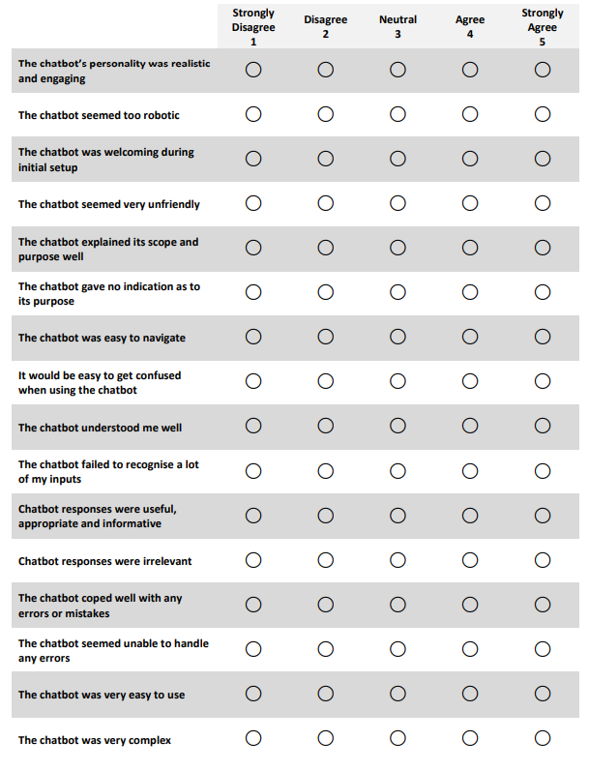

#### Figure? – Chatbot questionnaire [7] [8]

## 1.5 – Modification to the project plan

### 1.5.1 – Modification overview AP2 Finalized

#### 1.5.1.1 - January 2023 – May - 2023

|  |  |  |  |  |
| --- | --- | --- | --- | --- |
| Increment | | Description | Estimated days | Actual days |
| **3 – Login** | | | | |
|  | | Implement Firebase Auth Login | 1 |  |
| Link firebase auth to login | 2 |  |
| Sign-up | 3 |  |
| Forgot password | 1 |  |
| Sign out | 1 |  |
| **Total Days:** | | | 8 |  |
| **3 - Report** | | | | |
|  | | Design | 2 |  |
| Implementation | 2 |  |
| Validation | 2 |  |
| **Total Days:** | | | 6 |  |
| **Increment Total Days:** | | | 14 |  |
| **4 – Chatbot chat screen** | | | | |
|  | | Submit button to send message | 2 |  |
| Send message to chatbot | 3 |  |
| Get and Display chatbot response | 3 |  |
| Chatbot interacts with user first | 1 |  |
| Help screen display | 2 |  |
| **Total Days:** | | | 11 |  |
| **4 - Report** | | | | |
|  | | Design | 2 |  |
| Implementation | 2 |  |
| Validation | 2 |  |
| **Total Days:** | | | 6 |  |
| **Increment Total Days:** | | | 17 |  |
| **5 – Store User chatlogs** | | | | |
|  | | Implement database | 2 |  |
| Implement Code | 5 |  |
| Attempt implementation on cloud | 3 |  |
| Testing | 3 |  |
| Evaluation | 3 |  |
| **Total Days:** | | | 16 |  |
| **5 - Report** | | | | |
|  | | Design | 2 |  |
| Implementation | 2 |  |
| Validation | 2 |  |
| **Total Days:** | | | 6 |  |
| **Increment Total Days:** | | | 22 |  |
| **6 – Settings Menu** | | | | |
|  | | Delete User | 5 |  |
| Clear chatlogs | 5 |  |
| Show history | 3 |  |
| Clear widgets/ chat screen | 1 |  |
| **Total Days:** | | | 14 |  |
| **6 - Report** | | | | |
|  | | Design | 2 |  |
| Implementation | 2 |  |
| Validation | 2 |  |
| Review plan to add more increments if needed | Possible |  |
| **Total Days:** | | | 6 |  |
| **Increment Total Days:** | | | 20 |  |
| **7 - Training AI model** | | | | |
|  | | Provide refs for when the user may need additional help | 3 |  |
| Traditional Talk to the user for mental health | 3 |  |
| Fill NLU | 2 |  |
| Rules / Stories | 2 |  |
| Train chatbot | 2 |  |
| **Total Days:** | | | 12 |  |
| **7 - Report** | | | | |
|  | | Design | 2 |  |
|  | | Implementation | 2 |  |
|  | | Validation | 2 |  |
| **Total Days:** | | | 10 |  |
| **Increment Total Days:** | | | 22 |  |
| **8 – Conclusion** | | | | |
|  | Review code | | 2 |  |
| Verify finale requirements | | 2 |  |
| Run finale tests | | 2 |  |
| Report evaluation | | 2 |  |
| Review Plan | | 2 |  |
| **Total Days:** | | | 10 |  |
| **8 – Report** | | | | |
|  | Conclusion | | 2 |  |
|  | Video | | 2 |  |
|  | Submit AP2 | |  |  |
| **Total Days:** | | | 4 |  |
| **Increment Total Days:** | | | 14 |  |

#### Table 6 – AP2 Time Effort

The plan for AP2 has had a complete overhaul from AP1 plan that was set. Original increments still stay but new ones are also added to better work with the new list of requirements. There is also a larger gap from when the login is started and when the rest of the project commences. This was due to waiting to get feedback before progressing with the rest of the project, to ensure that stakeholder’s advice and guidance could be considered. The new plan set has shorter days set aside for each new requirement added compared to the old plan were some may have had a week set aside for them. The reason for making this plan a more of step-by-step plan rather than doing a huge segment in a week is due to the results of the prototype and the Author being unhappy with what they produced. The author felt like if the plan was more precise with what had to be done when it had to be done that, he would have had produced better results for the prototype. The main purpose is to stop the author from wasting time on the same feature when they could possibly move onto other areas of the program. From looking at the new plan it may look like there is not much room for breaking the plan days if the author were to be sick however, most days have been allocated potentially more time that needed, with some being a day or two days. The author has done this as to cover one of the risk factors of potentially being sick over the semester which has the possibility of happening due to job, UNI and day to day life. Giving these one or two days than needed will have the author swap days around if that occurs and if it doesn’t it give him a better chance to test and sure that the feature is working. I also used Chatpal toolkit PDF. The technology constraints section on page eleven was used an applied to not only the technology the author was working with but to the plan itself that the author was creating. This allowed the plan to be more precise as the ChatPal document itself talks about knowing the limitations of the technology and what you as the developer can do with it, this meant that the author could make the plan less vague as they could figure out what wouldn’t work in the application or chatbot and what might not work for the user in a time constraint environment [3].

The first incrementto be completed is **increment three**. This has taken place after the submission of the prototype as the developer knew that it should have been the main component submitted with the prototype. Another reason for doing this so early is that the developer knew that it was not something the stakeholders would want to get rid of when feedback was provided for AP1 aloginsin are a part of most applications around the world and are just an industry standard. The first increment also reveals the newest change in the system itself in the introduction to firebase. Firebase is a “Google's mobile platform that helps you quickly develop high-quality apps and grow your business.” [2]. The reason why this was chosen was for its synergy with mobile applications and all the features that it provided. Firebase not only supplies an AUTH system that can safely store users’ details and keep track of all their accounts on the system, while also providing features like a real-time database and analytical tools to keep track of the traffic of the mobile application. It can also hold up to 100 users for free users of firebase, while also being scalable for when the application grows. Figure 6

**Increment four** is a new increment added. Originally this was meant to be completed when storing users’ messages, but ass explained before upon further review of the plan the author thought that was poorly laid out and should have been in its own section from the start as it one of the most important parts of the application with it having most of the Must-have components from the from finale requirements list. This is again another example of the author refining the plan to be more previse and easier to follow not only for himself but for the stakeholder upon review. The report section of each increment is the author recording down the increments as they go through and not the report for AP2 as it will come towards the end of the process once everything has been completed. Figure 7

**Increments five** has been moved back by one increment as it makes sense for the storing of chatlogs to only be after the chatbot is functionally working. The help section has been placed into this as the author felt like both will be accessed by using firebase Realtime database and both will be using similar functions. This increment is another that contains most of the Must-have features for the program which is why it’s focused on early in the project. Figure 8

**Increment six** focuses on the settings menu. This increment has the possibility of swap with increments seven as increment seven is an extremely important increments, however the reason why this increment has but put over the chatbot training it due to the settings menu being easier to create. Along with that the author has been likely using kivy for a extended period of time at this point they might find it quicker to create as if they take a break to focus on the RASA chatbot they may not fully remember initially what certain commands for kivy do. Figure 9

**Increment Seven** chatbot training has had a noticeable change from its AP1 plan. The AP1 time had more time delegated to it. This is another example of increments getting shortened as there is now a better understanding of what must be done. This shortening of the timeframe doesn’t mean that the chatbot is less important just that there is a better idea of what must be done and what is going to be done, the author knows that slot may be left out as most of the time it would keep track of the user by storing things like their mental health condition and possibly medication. As the author has discussed before they are not a doctor in this field so areas like why their mental state may be like this or what certain medications can do for them is not known by the author. This can be researched but open the chatbot to display more misinformation if the author pulls from an untrustworthy source. This is why helplines or professional references will be implemented so the user can get expert advice from an expert and have someone to talk to from a Buddy perspective that is the AI. Most of these changes came after reading the chat pal toolkit. In this PDF they talk about avoiding areas of weakness in the technology, choosing a development environment where the chatbot data is private or standalone and the most important point the author took from it was the information being provided to the user being clear and appropriate to the users on the application [3], this is also were the author came up with the idea of the chatbot being a quirky robot like C3P0 with the personality of R2D2 from Star Wars, something that can communicate while being friendly like a dog. Figure 10

**Increment Eight** is the final AP2 report. This will consist of just the write up including more testing done to the overall application. This will also include the video that the user will have to undertake and the oral exam that the user will have to do towards the end of May. Figure 11

### 1.5.2 – Updated Gantt chart

### 1.5.2.1 - Login

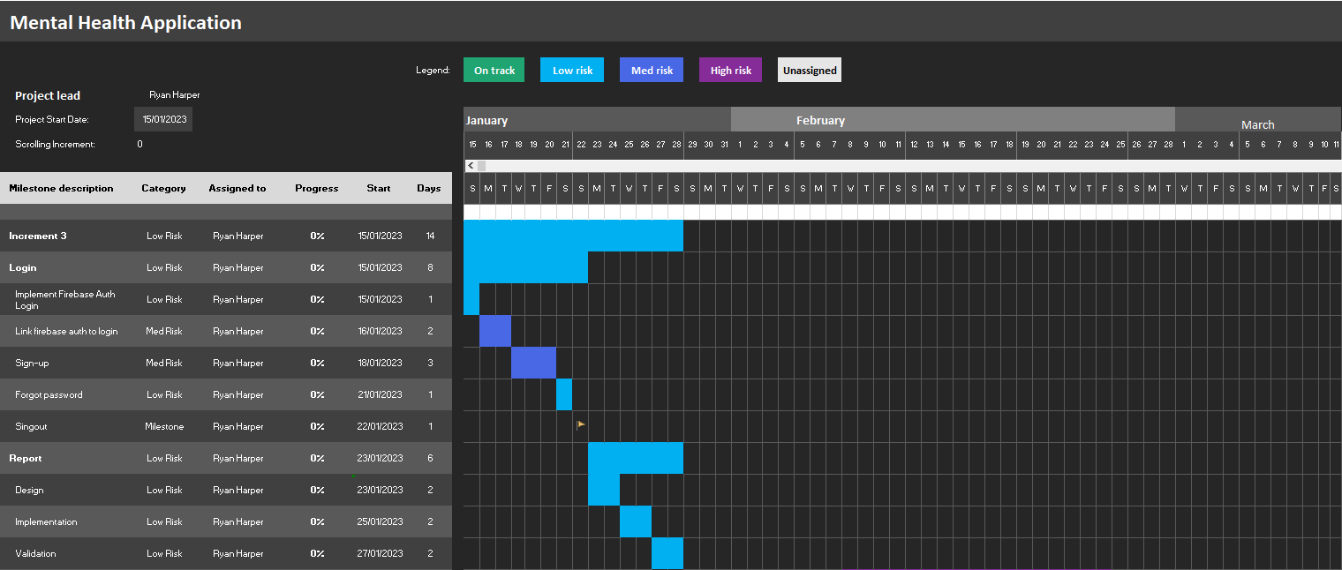

#### Figure 6 – Login increment Gantt chart

### 1.5.2.2 - Chatbot screen

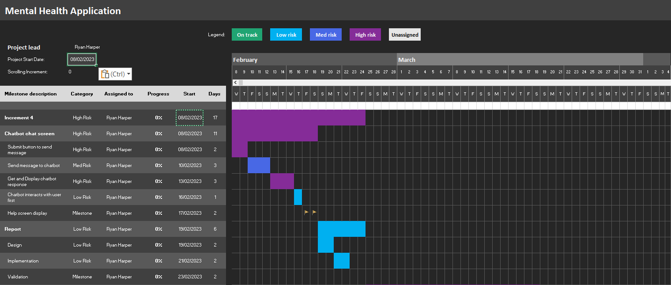

#### Figure 7 – chatbot screen increment Gantt chart

### 1.5.2.3 - Store chatbot messages

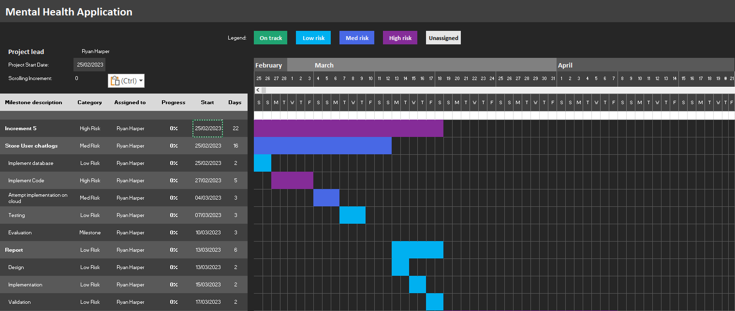

#### Figure 8 – Store message increment Gantt chart

### 1.5.2.4 - Settings menu

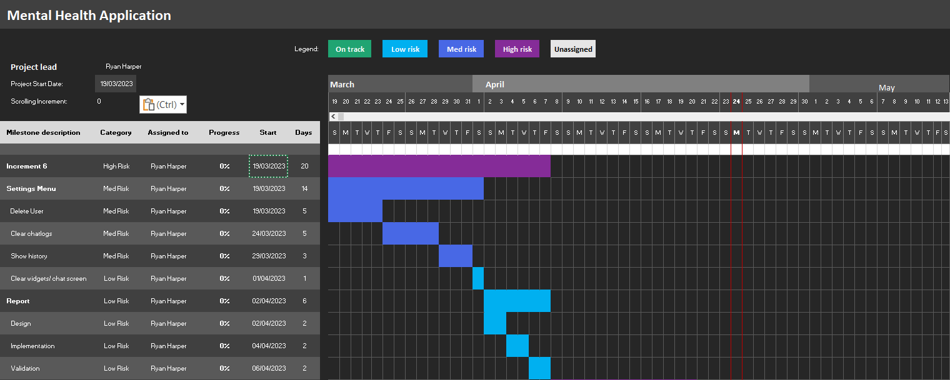

#### Figure 9 – Settings menu increment Gantt chart

### 1.5.2.5 - RASA Chat bot

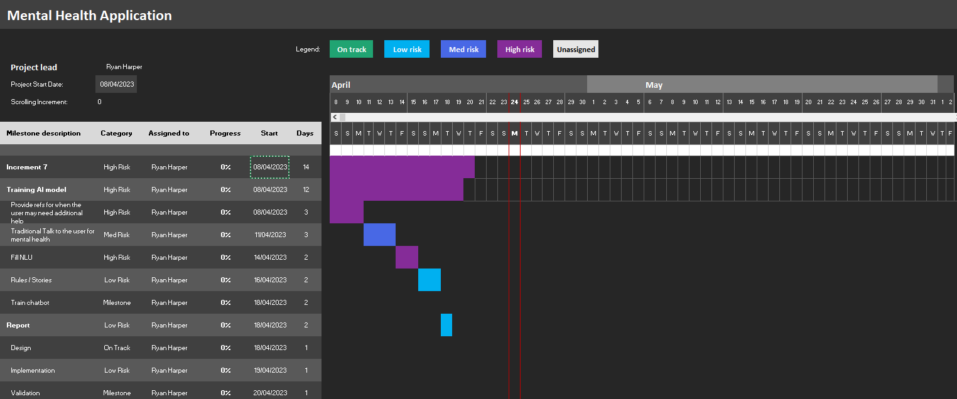

#### Figure 10 – RASA increment Gantt chart

### 1.5.2.6 - Write up report

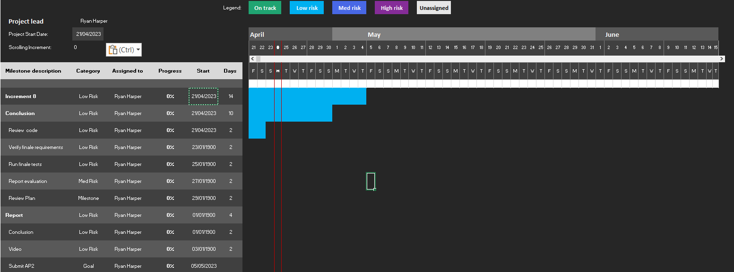

#### Figure 11 – Report increment Gantt chart

# Chapter 2 – System design

## 2.1 – System design overview

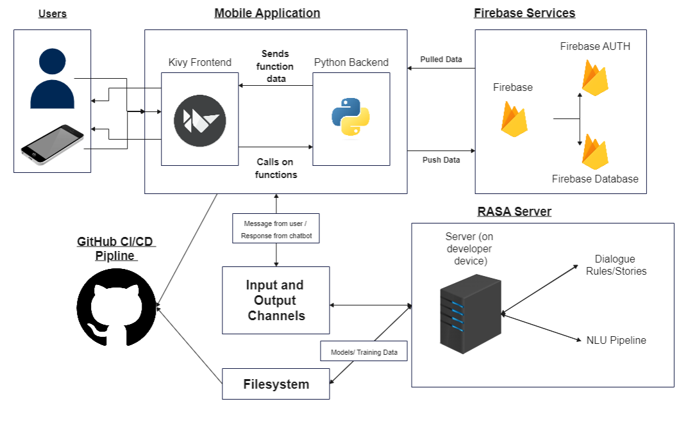

#### Figure 12 – System design overview

The diagram above shows what makes up each part for the mobile application. Python interacts with every individual component like firebase, RASA, and GitHub while those components themselves never interact with each other apart from RASA files being backed up to GitHub. Kivy acts as the frontend of the application and python as the back-end communication back and forth with RASA and with fire base. To start off with RASA, python will send a HTTP response to the RASA server containing the DATA of what he user just said. To determine what to say back to the user the server will use the NLU pipelines to see was intent matches with what the user said, then once there is a match go to Rules or stories to see what it should say back to the user. It will then return with new data on what the chatbots response is prompting python to then interact with the kivy front end so that the data will be displayed, in between that happening within the python code it will also be saving that user message and chatbot response to the Firebase Realtime database.

Firebase will also be interacted with through the login. It won’t interact with the real-time database but only the AUTH side of firebase as the python backend will send it data to save the users account or to check if the user’s login details are correct. The AUTH system will also check if the details have been used before by a previous user. Auth won’t just have data sent to it, but it will also push data to the backend relating to account IDs. Firebase real-time database will have data pushed to it and pulled from it. Data being pushed to it will be chatlogs and data being pulled from it will also be user chatlogs along with the data on the help section.

## 2.2 – interface design

### 2.2.1 – Wireframe diagrams (Max 5 pages)

#### 2.2.1.1 – Login Screen / Sign up Screen / Forgot password

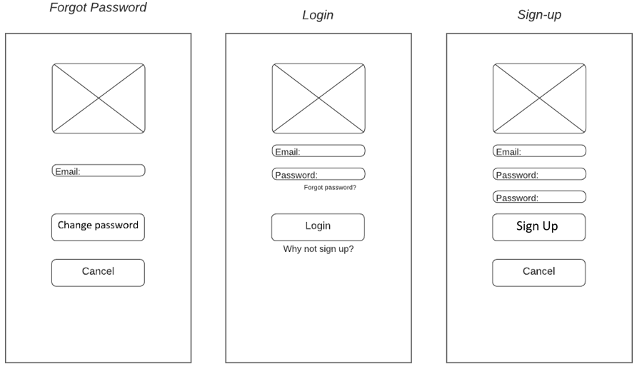

#### Figure 13 – Login / Signup / Forgot password

The only changes made from the original wireframes on AP1 to these wire frames is that forgot password is now its own page. With these pages there are not many creative choices to make in terms of design as all the users will need is input boxes and buttons so that they can freely login, sign up and change their passwords. The only detail added to the page that could help with the design is the logo for buddy AI. From these pages the user will use the frontend to access the back end which then will access the Firebase AUTH services, from their depending on the user action they can then save add a new account to auth by signing up, send a login verification by signing in or send a email to themselves if they want to change their password.

#### 2.2.1.2 – Home Screen / Chatbot

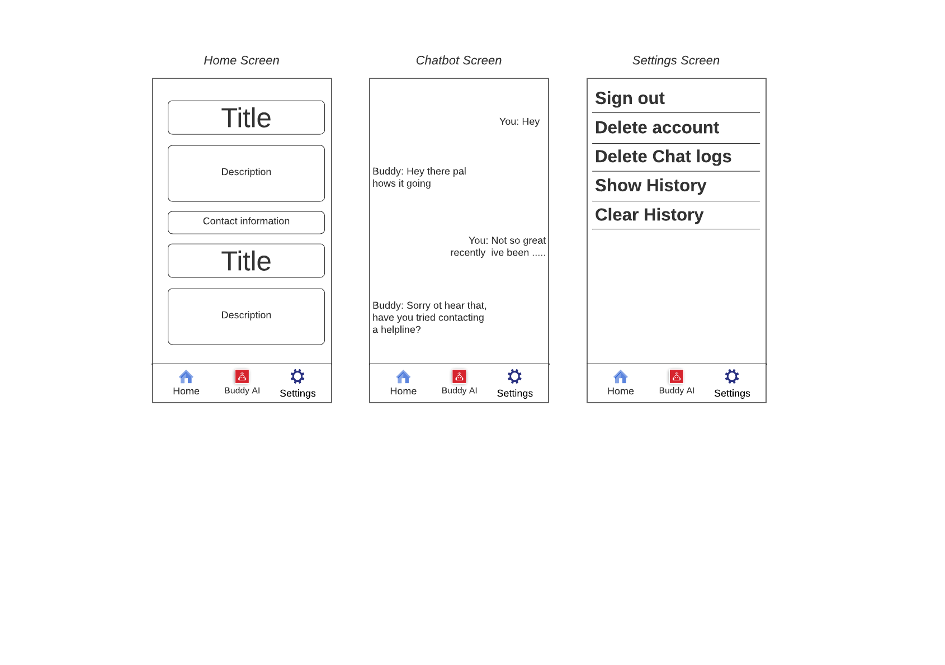

#### Figure 14 – Home Screen / Chatbot / Setting

**Home Screen**

The Home screen will consist of information relating to call lines and help organisations where users can get help relating to their situations. This section will have pre-filled data that is taken from the firebase real-time database. This data that is being pulled is created by the author. The information shown will all be in text format and no images will be shown. This hasn’t really changed from the AP1 home screen with the only real change being the information being displayed in a list instead of being displayed into blocks like the original idea showed. The top bar has also been removed as the updated final requirements list removed the users profile details as it wasn’t needed anymore, this does make the home screen look clearer and easier to see as before it would have looked more closed in.

**Chatbot Screen**

The chatbot screen has changed as instead of going into text bubbles to store the messages and response it will instead work like a chat room where text is displayed instead, with the chatbots being to the left and users being to the right. The chats will be added to a list as a label which will display it on screen after the user has typed in into the input section a submitted the message, this message then goes to RASA server which sends back a response then both messages will be displayed, this all happens relatively fast. A possible upgrade will be trying to add the text boxes like were in the first iterations however from the developers prototype he has found that this could be potentially harder that first expected and kivy has so easy way of achieving this outcome. This is why the idea has been removed so it could save more time to focus on the requirements.

**Settings screen.**

The settings menu has seen the most since AP1 as more features have been removed or replaced since the finale requirements were picked. First change being that the username change has been removed as customisation of the user’s profile has been removed, light and dark mode have also been removed. Ass discussed before these features have been removed as the author felt like they were less important, and the newer features had to be added. The change password section has been moved to the login screen, however a change could be made to shift it back to the settings menu as it can have a use her as well, as it means the user won’t have to log out if they feel like their password is insecure. The new features in the settings are as follows, delete account delete chat logs, which will both display popups for the user to confirms deletion. The finale two are features that effect the chat bot screen as one will clear the screen from chat log build up and one will fill the screen for when the user wants to see pas chat logs.

#### 2.2.1.3 – Wire flow

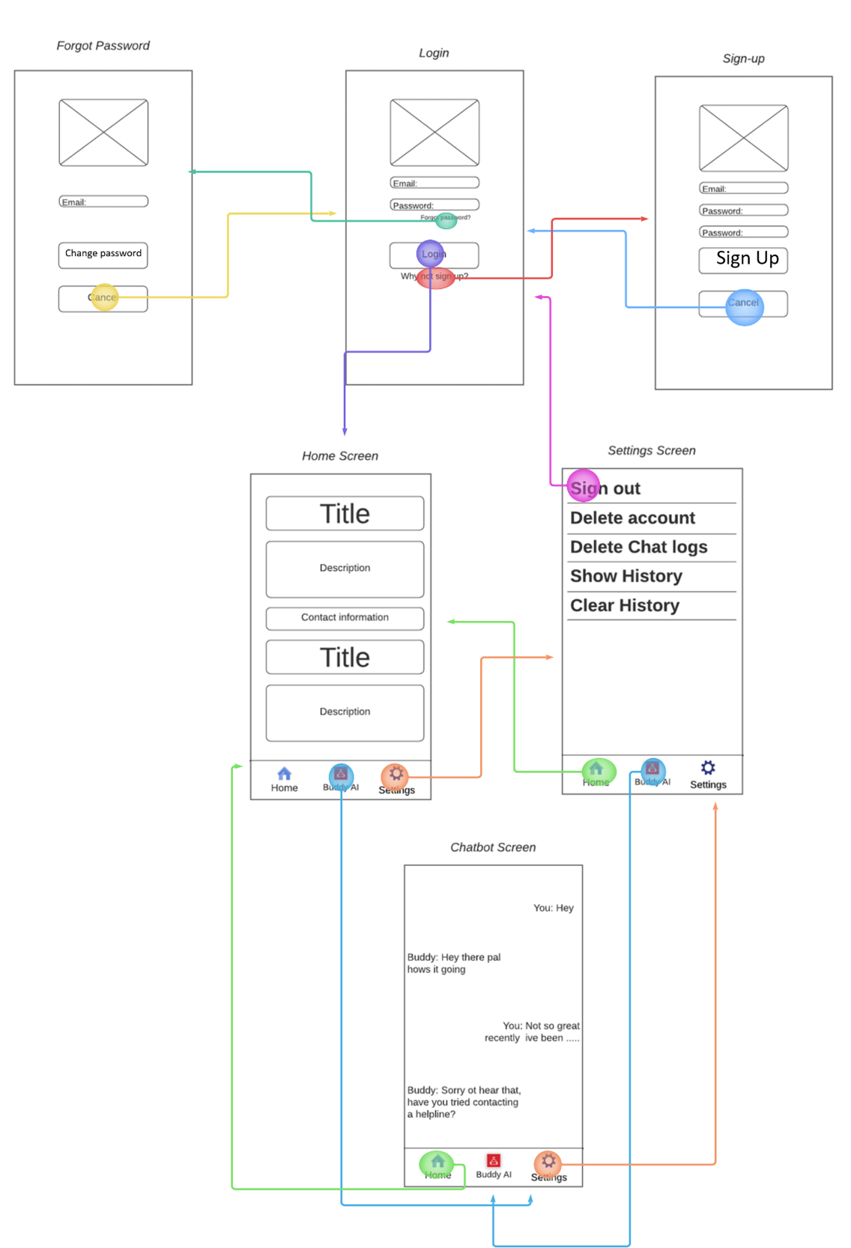

#### Figure 15 – Wire flow

**Login**

The login screen can be looked at as the hub for traveling to different screens as it can connect the user to every screen in the wireframe, and every exit method on all screens will lead right back to the login screen. As seen from the wire flow above the login screen can take the user to the forgot password screen by clicking forgot password, can bring the user to the sign-up screen by clicking “don’t have an account yet?” and can bring the user to the home screen by typing in the correct users’ details and clicking login. If the login button didn’t work correctly the user wouldn’t be able to get to the chatbot screen, home screen or settings. The only screen that can take the user back to the login once they are in the application is the settings screen, this happens through signing out or deleting the account.

**Forgot password screen**

The forgot password screen can only be accessed through the login screen and can only go back to the login screen, either that Is from cancelling the fact the user doesn’t want to change password or by submitting the email of the account that is going to change password.

**Sign up**

The sign-up screen like the forgot password section will only allow the user to get back if they successfully sign up or cancel the interactions. The only way to get to this screen is through the login screen.

**Home**

The home screen can be accessed through the login screen, chatbot screen and settings screen. The user can only travel to the settings screen or the chatbot screen from the home menu this was picked as the page for the user to see first when they come from the home screen as it can have useful information relating to the user.

**Chatbot screen**

The chat screen can only be accessed from the home screen and the settings menu and can only go to those screens as well.

**Settings**

The settings menu is the only screen where the user can go back to the login screen by signing out of the application. The only pages that can go to this screen is the home and chatbot screen. The login screen may possibly go back to this screen by default if the same account goes to log back into the account. The settings menu can also travel to popup windows where the user can delete their account or chatlogs, they will be able to travel back and forth from deleting chatlogs but not from deleting their account this will also send the user back to the login screen.

Overall, the wire flow gives the developer a better understanding of how smooth navigation of the application is before building the application itself. Easy to follow navigations with not too many features will be easier to understand for users who are versed in mobile applications and for users who are not. This can help people with certain mental disability who find it hard to concentrate or find it hard to quickly understand navigation. The login screen being the overall hub needs to be easy for the user to understand and having the buttons say exactly what they do should guide the users from page to page, as they will know that forgot password takes them to change their password and cancel will send them back. In the setting menu the user will not have to worry about miss clicks for deleting user and taking them back to the menu as they will need to verify the deletion first, this saves an confusion in case the user think they clicked on that button by accident.

#### 2.2.1.4 –Popup settings Wire frame

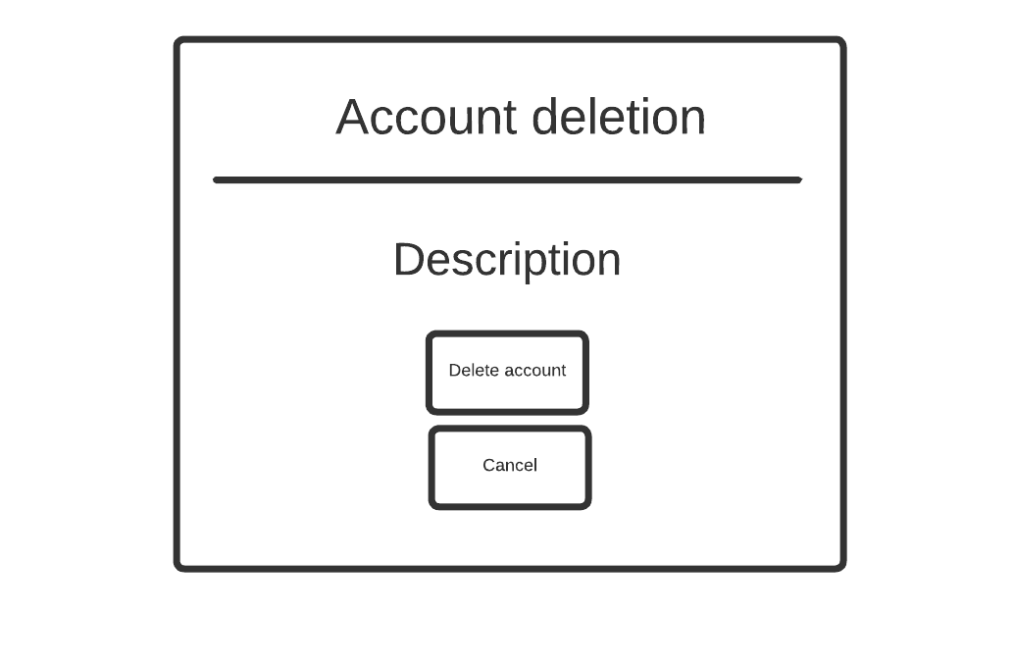

#### Figure 16 - Popup for account deletion

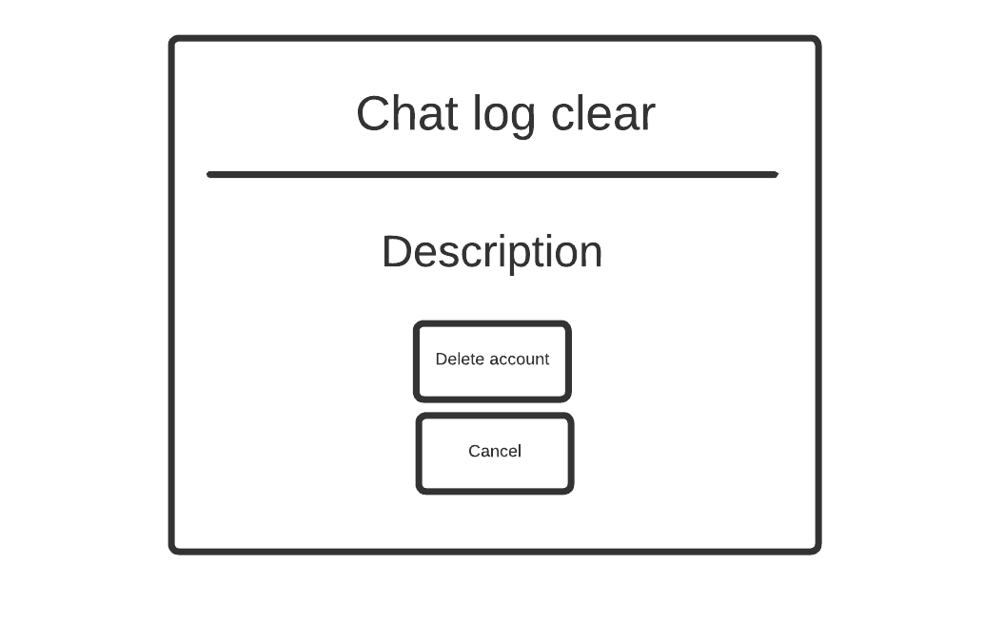

Delete chatlogs

#### Figure 17 - Popup Clearing chat log

These are the wireframe layouts of the popup windows for the delete account feature and the clear chat log feature found in the settings menu in figure 14. This section may be improved by the developer in later iteration to improve the overall security of the system. This would let the user type in their username or password as if they were logging in, then by clicking delete account or delete chatlogs the python backend would use auth to verify that those details are correct then carry out the appropriate functions.

### 2.2.2 – HCI and Usability/Accessibility of the user interface

From looking at the updated plan (Table 4) no time has been set aside for the stylization of the project apart from the chatbot screen. This doesn’t mean that the UI won’t be focused on more. AS seen from the wireframe a plan has been laid out for what the design looks like. This clearly displays all of all the features on the page and helps to visualize what the finale product would look like. With the Wire flow it shows the navigation between both pages, with the plan being that mostly every page that has been designed being accessed through the login screen. The plan for the colour palette for the website is going to be simple with just a normal soft tone purple being the background along with the chatbot screen being text based rather than storing the text in a chat bubble like Facebook messenger. The reason for going down this route is so that the developer can focus on meeting the finale requirements for the applications. The guide that has been used for the project’s usability is the Nielsen Rule, while also applying Google usability guidelines towards it as the original concept is old with a few rules being outdated [4]. These rules are as follows:

**User Control:**

**“Decide for the user but let them have the finale word”** [4]. This method will be done by letting the user be able to navigate to any screen. This lets the creator decide for the user what screen they can go to on a certain page but leaves it up to them to make the finale decision, rather than letting the user access all the pages and have a harder time navigation through them. In this application the number of screens is small compared to other application, this in turn makes it easier to give the user full control of going where they like but while still unknowingly being restricted to going to certain areas of the application without logging in.

**Consistency:**

**“The app utilizes consistent design, typography, colour function and content.”** [4] This rule will be the most used throughout the project as the developer will be focusing more on the backend of the application and the chatbot. By keeping everything consistent throughout the application lets the developer easily produce a UI that stays the same while the user moves throughout the application. Inconsistent designs can confuse the user especially on pages like the homepage with information being displayed, as this information is important it’s crucial that the layout stays the same as the user will need to be able to read it as it contains helps lines for mental health. The same font used for the help page will be carried over to the chatbot screen to display messages, this is why the chatbot page is more like a chat forum from old school website, this way the background can stay the same along with the text style**. “App uses familiar paradigm.”** [4]. Logins are a feature every application has so designing it like every other login page lets the user navigate through the screens easier as they’ve used a similar application before with a login screen like it, this removes added effort from the developer of having to explain to the user where to go. The home screen, chatbot screen and settings menu has also been designed like other mobile application, with the navigation bar showing everywhere the user can go on the page. Having a familiar design to other application lets the user understand the navigation process quicker. The settings menu labels what each button does prompting the users on the action they are taking. “If it looks the same it should act the same” [4]. The best example of this will be the settings menu, as clearing the chatlog meets the user with a prompt to confirm and delete the user meets a prompt that the user will have to confirm. Whereas clearing chat widgets is met with no prompt and loading history is met with no prompted as these features don’t have any huge impact to the user.

**Information and visual hierarchy**

“Information hierarchy and structure” [4]. This is best displayed in the home page, where the information will be shown with a heading to the org or help lines along with information about them, followed by the contact information of them. This stays consistent throughout each org or helplines shown. This doesn’t mean that the help menu help line are ranked on importance just that the information will be bigger and bolder that text on other pages as it meant to drag attention from the user. Visual hierarchy is also applied to the chatbot as when the chatbot speaks, it will have its message appear at the top of the page, then when the users speak their message will appear below that and so on. This stays the same when message history is shown but with timestamps below each message.

**Visibility**

“The mobile application should always keep users informed about what is going on, through appropriate feedback within reasonable time” [4]. The application does this by displaying popup windows to let the user know when they have either miss typed information or when they must confirm and action that they are going to take. This lets the user know exactly what they are doing and exactly what is going wrong when it goes wrong. This is why wireframe for the popup windows were created as they will be used to guide the user when they do something wrong throughout the application, this will also stop the application from crashing on the user.

**Dynamic engagement**

“The mobile applications should provide users with easy-to-use features to engage in two-way communications with widgets and other users to fulfil a complete engaged experience” [4]. The application displays friendly messages to the users when appropriate to help guide them through the application if they make a mistake or mistype information like their login. It’s easy for the user to create a new account to join the platform and easy for the user to remove their account from the platform if they feel like they didn’t need it anymore. The application provides many two-way engagement features. One of this is when they sign-up they are sending their details to the auth firebase to store email and password. The other is when they talk with the chatbot, as this sends the message to the RASA server and then it sends a response back to the user and this continuously happen. From the settings menu there are many two-way engagements as the clear widgets button clears all the widgets, show history shows the user chat history, delete chatlogs prompts a popup window to delete the chatlog from the firebase real time database, and the same happens for delete user but this removes the account from firebase AUTH, deletes chatlogs and then logs the user out as they won’t have access to the main page anymore.

## 2.3 – Data support design

### 2.3.1 – Security

#### 2.3.1.1 – Password hash parameter

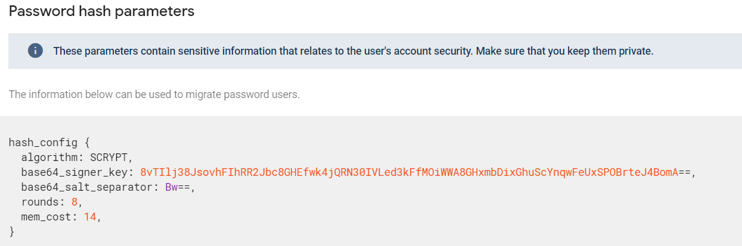

#### Figure 18 – Password hash parameters

This is the password hash which has been set to its default hash that firebase auth has set it to. Password hashing is when the user’s password is turned into a long string a of letters when they sign up to the system. This is a huge security feature as it protects the user’s password from un-wanted users who could gain access to auth, or users who can pull the users auth details from the auth system, this means all that they can feasible get is the email. This is a huge component for the author as it saves time for them to develop this method themselves and instead makes it even securer as this has been created by a team of professionals. However, even with that said like all cloud storage and auth providers there is always the risk of the providers themselves having a breach. Whereas if the developer had made the password hash and stored the login details on their own database they could monitor and control it how they would like, this would stop those cloud provider from losing it or getting hacked. The reason why this option wasn’t choose as stated was due to time, getting a higher standard security than what the author could have created and the fact that the same attack regardless could still happen to the system that the author would have to develop themselves.

#### 2.3.1.2 – restricted access to database

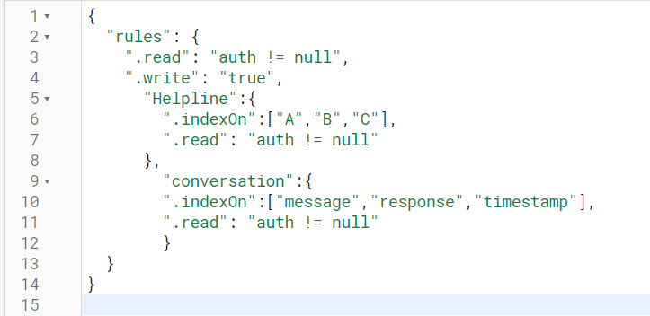

#### Figure 19 – Restricted access to database

The is the rule set for the real time database. As seen from above the users can only access read and write features if they are auth users. This feature may seem redundant as the user can only access them pages by logging in but in case a work around is found this can help to prevent that from happening prompting the user with a permission denied response. There is the issue that this means that any users can write into the database however this would only be possible on the mobile application itself as it takes the user UID and submits it to the database as a unique key, the users never see their UID so its impossible for someone to copy this method outside of the application without already having accesses to AUTH. So, any conversation being added to the database would have to be done so by creating an account and logging in.

#### 2.3.1.3 – Config access keys

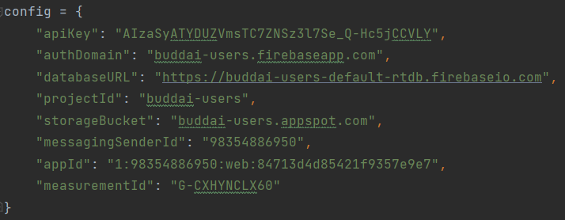

#### Figure 20 – Config access keys

These are the unique access keys for the application to access firebase. These add another layer of security as these keys are unique to the corresponding firebase project and the only way to access the project is through these keys. It is possible to update and changes these keys every so often in case if someone from the outside does get access to the config option, they may have already change hindering those keys as redundant.

### 2.3.2 – Data validation

#### 2.3.2.1 – Storing conversations

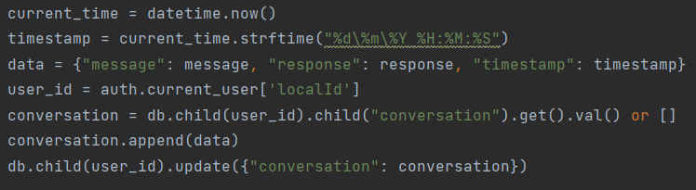

#### Figure 21 – Storing user conversation

This is how the conversation data from the user and the bot will be stored in the database. The appropriate message from the user, response from the chatbot and timestamp from the python library get saved into the data list, as message, response, and timestamps, this is the names that they will take into the database. This will save it into its own child of conversation in the users UID. The conversation database will have the value of 0 to whatever number of messages the user and Chabot have had. For example, when the user has talked to the bot and the bot responds that will then be saved into the child of 0 which is a child of the conversation heading in the database. This helps to validate the data being sent to the database as it will only send the chat between the users and bot, timestamp, and nothing else. The works in junction with the database rules in figure 19, as indexing these will index them on the firebase servers improving the performance of the queries used.

This method for validating the data that get sent to the real-time database ensure that no errors occur from the backend of the application and from the firebase side of development. Only the python backend will be able to send data to the firebase database. This segment of code can be adjusted to remove more fields or add more fields and it won’t have any effect on the database with the way the messages are stored, this is why its stored in a number instead of a unique ID for each message an response. The only aspect that will have to be changed is the indexon figure 19.

#### 2.3.2.2 – Displaying Helplines

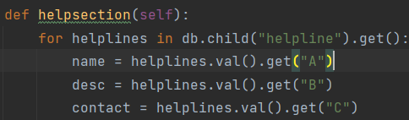

#### Figure 22 – Displaying help lines

This segment of code is used to pull data from the helpline section of the database using a for loop. The for loop will pull “A” being the title, “B” being the description and C being the contact information. It will keep pulling and storing all of this data until there are no more values left in the helpline section. Each helpline will be stored like each conversation using numbers as this is easier for the program to cycle through. The code will then go on to add the data pulled from the database to a list which is then displayed in the kivy frontend. The code pulls the data from the helpline database as a value, this is so it can be displayed on the frontend, this piece of code could have been applied to anything storing the data from the helpline loop, if it doesn’t have the value on it won’t produce the correct data.

#### 2.3.2.3 – Displaying Past conversation

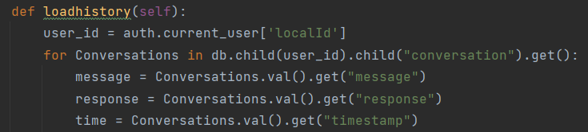

#### Figure 23 – Displaying past conversation

The load history function is the same as helpline function. The only difference being is that it gets the userID from the current users local ID. The reason for this is that the when the user and chatbot talk the data overall is saved into the database as the user ID, so when the user doesn’t have any previous chats with the bot the system won’t be able to find it. This won’t make the program crash and just come up with a popup window. If the user does have previous chats with the bot it will get the user ID, then the conversation section then will pull the first user message, chatbot response and timestamp saved in item 0 then it will go through the rest till there is no more left. These will be displayed in messages in the scroll view in the frontend of kivy.

#### 2.3.2.4 – Auth Sign-up / login / delete user

**Sing-up**

auth.create_user_with_email_and_password(email, password)

#### Figure 24 – Auth Sign up

The sign-up section validates data by making sure that the email entered by the user is not already on the system. If it’s not on the system, the account will be added to the firebase AUTH storage. Which will just store the email the hashed password and various other details like local id and verification of the suers account. Other data can be saved to the user like name and profile image.

**Login**

auth.sign_in_with_email_and_password(email, password)

#### Figure 25 – Auth Sign in

The login feature will let the user progress onto the next page in the front end of the program and in the backend. In the Firebase end it will verify that the email and password enter both math the correct accounts. If the email is wrong, it won’t verify the account, if the password is wrong, it won’t verify the account. Firebase AUTH does all the verification on their end by validating all the data sent to it. By letting the firebase AUTH system do this the author has saved more time on development as shown from the new plan.

**Delete user**

sis = auth.current_user   
auth.delete_user_account(sis['idToken'])

#### Figure 26 – Auth account deletion

The delete user function is an auth function that takes the current users UID and delete the user via that method. AUTH validates the input to check if that account exists then deletes it if it does and doesn’t remove anything if it doesn’t. This will also only work if the there is a current user logged in. This works as a safe measure as it means a user can’t just delete a random account and must be logged into that account so that the user UID has to be sent for that account to be deleted.

#### 2.3.2.4 – Remove chat data from database

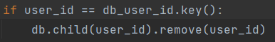

#### Figure 27 – Remove child from database

These two lines of code are used to verify that the users ID is on the database and then delete the users chatlog from the database. If the user doesn’t have chatlogs on the database, then nothing is deleted. The if statements validate the data, then firebase also validates the data to see if it exists on the database. This means that the using this function won’t crash the mobile application.

### 2.3.3 – Data structure Design

#### 2.3.3.1 – data structure for User Conversations (300 words)

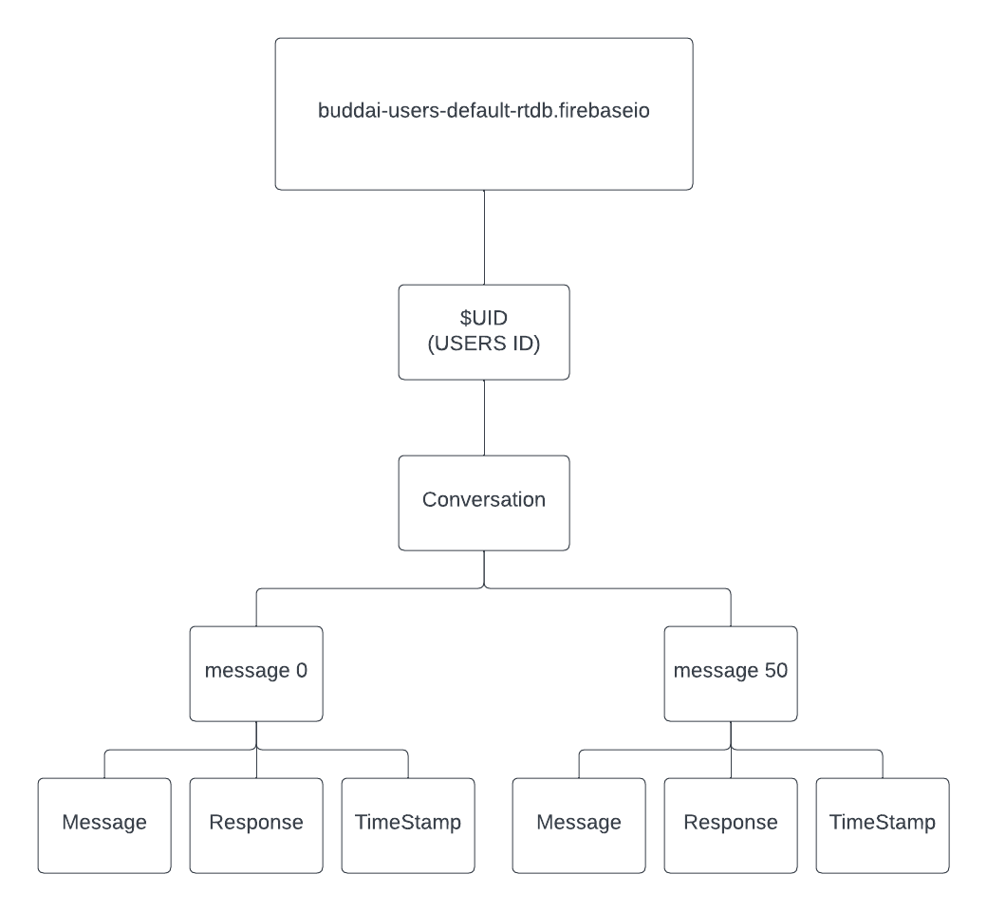

#### Figure 28 – User Conversation structure

The is the data structure for the users chatlogs that is stored in the Firebase Real-time database. The Buddai-users-default-rtdb.firebaseio is the name of the database itself and when the database is being called from the code this won’t be shown, and it is only shown in the database URL in the config section (Figure 20). The $UID is the users localID, this is a unique ID that is different for every user. This ID is saved to the database using the storing conversation function. It will store the Users ID, then the conversation child key being stored in it and then the number of the message interaction, then the message bot response and timestamp within that. As seen on the diagram the message system doesn’t have any set limit and can go higher than the 50 messages displayed on the diagram, this is just to show that all numbered messages will have the same content. With the way the code is set up, if the data added to the database where to change, for example, an additional attribute like message data and message time instead of having it in one timestamp element this wouldn’t affect the database and the data would be accepted if rules have been changed. The overall data structure is very simplistic due to its small size but fits the purpose of the of the application. This structure is again doubles if more users sign up and talk to the chatbot.

#### 2.3.3.2 – data structure for Helpline (300 words)

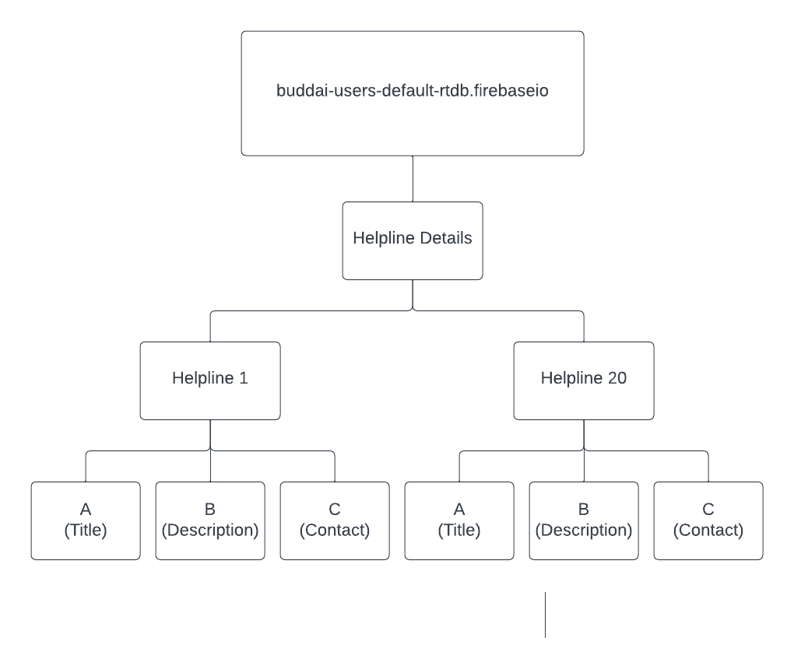

#### Figure 29 – Helpline dataset structure

The helpline data structure is very similar to the user conversation data structure minus one extra atribute of that being the user UID as this wasn’t needed for data being displayed on a homepage. The only segment of code that has access to the helpline data structure is the load_helpline function (Figure 22). No data from the backend adds anthing to the database itslef with data only able to be read from the database to be displayed on the frontend. The helpline also has the same number storing atributes that the user conversation had, this is something that could be changed to the titles of the helplines or orgs themselves. This was kept as a number as it was easier for the author to vizualise. The title, message and contact information are displayed as A, B and C, yet again this was kept like this as it was easier to visaulise when putting it in a loop.

#### 2.3.3.2 – data structure for Overall data structure (300 words)

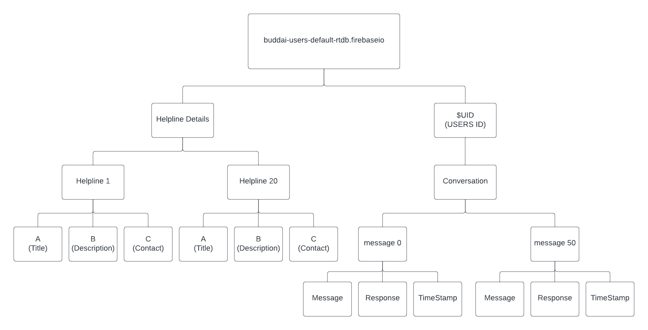

#### Figure 30 – Overall Data structure

This is the overall data structure of the real-time database. Both database structures do not interact with each other. The buddai overall database can have more userID if more new users talk to the chatbot. This data structure diagram can grow to a massive size if more users are added to the system. This may potentially need another section added to the database to hold all the users as normally when application grow more fields get added to store more user information or more details for the home page. Each individual UID will hold the same values within them that being the user’s conversation and only the users themselves of that account can access them.

#### 2.3.3.2 – Data design consideration artifacts (300 words per artifact)

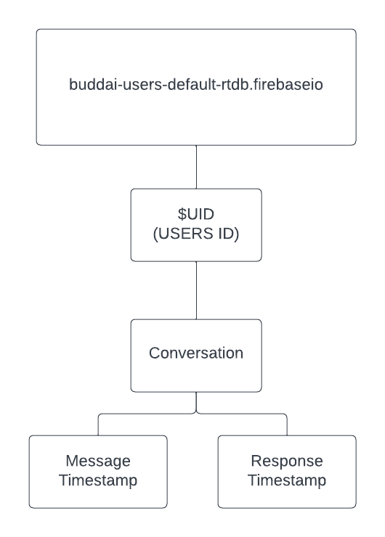

This concept was the original idea for the database for storing users’ message, the timestamp taken from the python backend would have been used and a unique ID to identify the message. However, the author thought that this method would cause too many errors as pulling the data from the database would cause problems as the ID of the message couldn’t be pulled up due to the time changing. Other ideas that were considered for the UID was adding them to their own database that way additional databases like the helpline database wouldn’t get lost in between all the users that had talked to the chatbot. Other minor changes that were considered was changing the A, B and C to title, description and contact to better represent what those fields were holding.

#### Figure 31 – Design consideration for user conversation

## 2.4 – User Interaction Design

### 2.4.1 – system flow diagram (300 words)

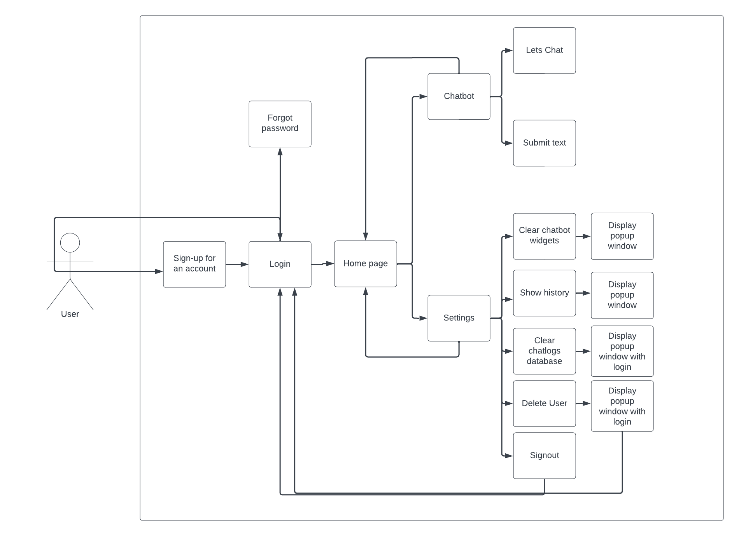

#### Figure 32 – Overall system flow diagram

The user will start off at the login screen as their first page, from there they can login or create a new account. If the user does not have an account already, they will create the account, then move onto the login process. If the user already has an account but has forgot their password, they can go to the forgot password section, then log in once their account has been recovered. Once logging in they will be taken to the home page, which acts as the second hub of the application, which is able to let the user navigate to the chatbot screen or setting screen. If the user chooses to go to the chatbot screen from there they can click the let’s chat feature to prompts the chatbot to say the first dialogue line. Then the user can choose to type and submit a message to the chatbot. These are the only options on the chatbot screen that will give the user a reaction if they interact with anything. The settings screen can then be accessed from the home screen or chatbot and vice versa. The settings screen contains the most user interactions. The first interact the user can do is clearing chat screen widgets, this will then bring up a prompt saying it was successful, the same action applies to the show history screen which will show the users old chat logs. The next option of clearing the user chatlogs from the database will bring up a popup window where the user will have to enter their login details to confirm their actions, this option will also appear for delete user except once that happens it will take the user to the login screen. The sign out option will take the user back to the login screen.

### 2.4.2 – Use Case diagram (300 words)

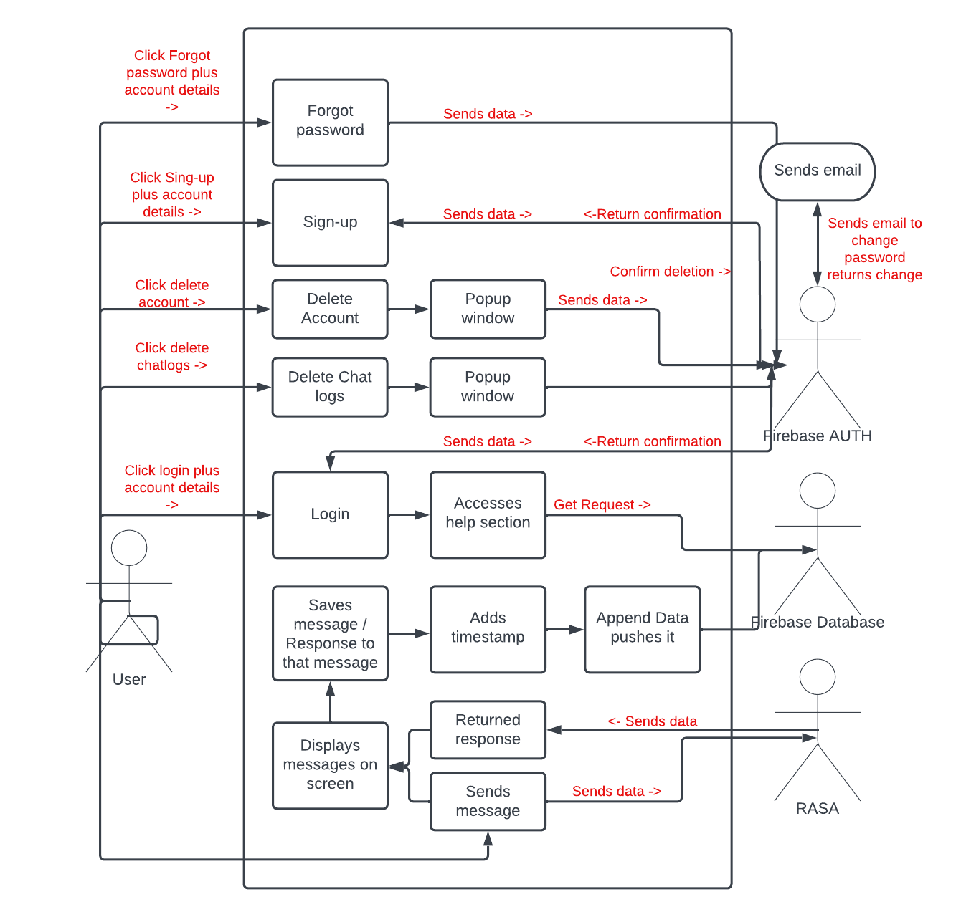

#### Figure 33 – Use Case diagram for overall system

This is the flow of each system feature and what it interacts with. Starting from the bottom the user sends the message RASA chatbot receives the message then produces the message back, however another outcome could happen here where the message doesn’t come straight from RASA but comes from a fail safe from the backend of python as the RASA chatbot may have not produced a result from what the user has said. Once the message and response have been stored it then adds a timestamp and appends that data and send it to the database. The next process is the login, which simply send the data for validation and AUTH services produce a result on whether the data entered is correct or relates to an account at all. The same process is done for the sign-up feature as well except this time is checks to see whether that account has been created before with hat email. The delete user button and clear chatlog button but bring up the same result with a popup window appearing where the user will have to be authenticated by auth before they can even delete anything first, the only difference between the two is that delete account has access to AUTH and the database as the account will also have to be removed from the auth system. A few other features not included on this diagram include the clear widgets and show history functions. The clear widget function would only affect the front end while the show history function will only access readable data from the database, however it only does this by using an AUTH feature of finding the current logged in users UID.

## 2.5 – Additional Design Artefacts (Topic Specific)

### 2.5.1 – Conversational flow diagram

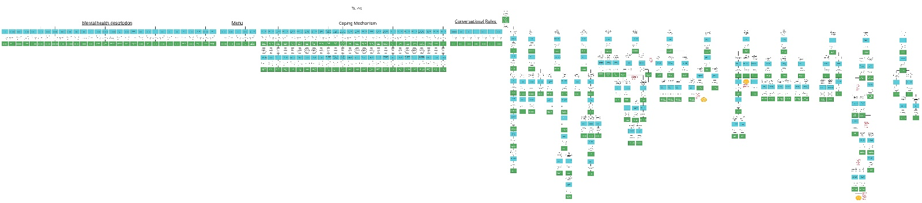

#### Figure 34 – Conversation flow diagram

The diagram above may be difficult to view that’s why in the submission for the project this conversational flow diagram will be provided in a PDF so that the stake holders can take a further view and the flow developed by the author. This flow contains the Rules of the RASA chatbot to the left and the stories to the right. The rules have the same conversational flow as they are used as more menus. The stories may be the most important aspect of the diagram as this gave the developer a much better visual representation of how the chatbot should talk based on all of the data created within their spreadsheet. The Diagram was time consuming but will end up saving more time in the development process of the RASA chatbot.

The stories that will be implemented in RASA are in circles with their story titles, and the users inputs are in the blue squares, these hold the intents. The reason why the developer used these as the inputs instead of proper inputs, is for understanding purposes, having over 100 - 200 plus intents can be hard to manage especially when they will have to have 100 – 200 outputs, for this reason everything has been labelled with the variable that it will affect. The hexagons are while rules or stories are being applied, and the orange circles are when one stories path tries to move the user over to a completely different story path. As can be also seen from the diagram when the AI introduces itself to the user, the user is then opened to the entire chatbot rules and stories and can start interacting with it. Overall, the tedious planning done with this diagram should set a good understanding going ahead with the project.

### 2.5.2 –Confusion matrix (RASA)

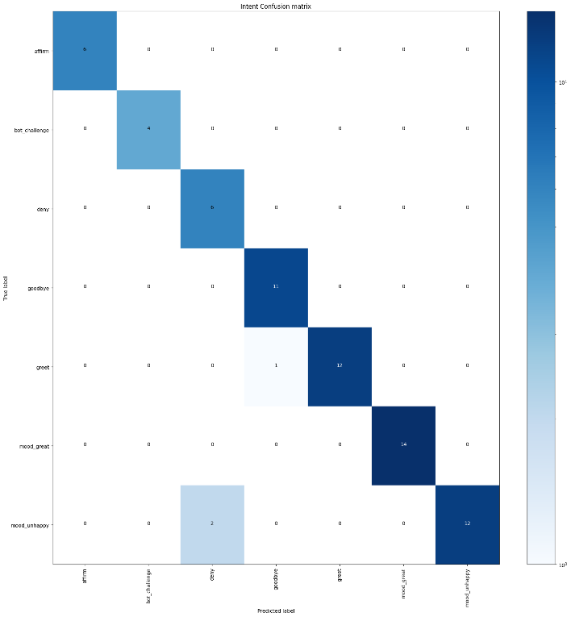The confusion matrix will be a RASA implementation using the developer data. Two matrixes will be produces from RASA one being the Intents from the NLU and the stories created on the chatbot stories section. This will help show intents which are mistaken for other intents or stories that may intercept other stories, this figure to the right is only an example of the matrix could look like, the actual end matric will be shown in the testing section of the document. This matrix will help to represent the summary of predictions made in the RASA testing command. This lets the author understand when in tents are being confused for other intents.

#### Figure 35 – Matrix prediction [9]

### 2.5.3 – intent prediction confidence distribution

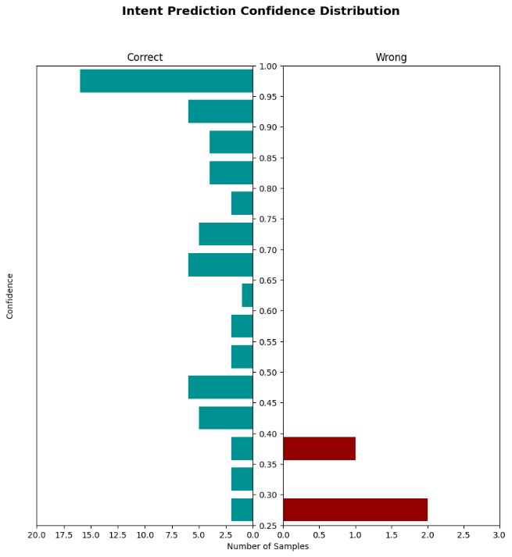This is a histogram that can help to visualize the confidence for all of the predictions with the correct and incorrect predictions being displayed. The blue bar represents high confidence the red bar represents poor confidence. By improving the quality of training data, the bar once tested can then move, if the NLU is has improved then the blue bar will be raised but if it isn’t the red bar may potential show even more. The histogram to the right I not the once for the project histogram this is just an example taken of f of the rasa website. This will be a great way for the author to measure how far there chatbot is progressing and to guide them if they start going down the wrong path.

#### Figure 35 – Histogram confidence distribution [9]

# Chapter 3 – System Implementation

## 3.1 – Reflection on the implementation of the plan and execution

In chapter one the original plan saw a series of changes. Most of the changes came from the iteration cycles. The methodology still styed the same but the days those certain iterations were meant to take place changed. The reason for this changing was to accommodate for some of the authors potential short comings when it comes to the development process. The new plan ensured to break everything down into the smallest details so it’s easier to understand. As the author programming skills may not be excellent, they decided to lean back on their strength of planning. With this, and thanks to help from feedback, the author implemented a design that would work best to produce the best outcome the author could with their skill set. From the feedback the author choice a chatbot lifecycle design, the helped the author to produce around 200 different intents, ranging from 10 to 20 user examples within them. Along with this the author managed to produce 82 user stories and around 100 rules for the project. This could not have been done without the new change to chatbot development cycle, as before the original plan for the author was to write all the NLU, the domain responses, then all the stories, and finally all the rules. The reason why this method would have been detrimental is that the author would have created a lot of work then when they went to train it would have no doubtable been met with a copious number of errors. Using those short iterations to produce just one NLU add it to the domain, then add it to either the story or rules, helped to ensure no mistakes were made and that the author could quickly process onto the next intent to slowly build up stories and the chatbots learning knowledge.

As for the iterations the overhaul worked out extremely well minus one error on the author’s side. They did not incorporate much room for the design of the mobile application UI. They did focus on function F4 and F9 were the navigational purposes of the mobile applications meet a high standard, which they do as the user knows exactly what they are clicking on, as everything is labelled, where there going and get prompted with errors either from the chatbot or the backend itself, saying what went wrong. The side of the UI that did not pan out was the stylization of the application. From research the developer thought that using kivy would make the design aspect easier, which it did in some areas, however the larger the program grew the harder it was for the developer to style the application. The developer thought that through each iteration they could just add the styling then and there, but it progressively became more of a problem o the developer thought it was best to make is as basic as possible and to focus on the back-end requirements as much as possible. The biggest hit from a UI perspective as the chatbot UI, all elements can still be clearly seen as they are now text based instead of being inside of a chat bubble. The developer thought this was the biggest downside out of the UI but used the time set to focus more on the back end than what the overall frontend looked like, just as long as the text messages could be seen by the user. Thanks to the user planning though they did manage to get a decent amount left in development when they wrapped up the main portion of the plan, this as stated before was intentional just in case any errors came up, but instead of focusing on the UI the developer though it would be better to focus on the chatbots functionality. Through conversation with the authors mentor, they agreed that 140 would be a good limit, however due to some of the free time the author jumped that up to 200. The author felt this change was needed to add more complex stories and give the user more to talk about. The same life cycle plan was followed.

The conversational user interface guidelines were heavily followed by the author to ensure that the best response to the user were produced. This helped to ensure that the user got correct and accurate advice while still being able to have a normal conversation as if they were talking to an actual person. The developer with these guidelines managed to keep the chatbots personality for the most part must pull it done on more serious matters as to not let the user think the chatbot was joking about them.

Finally, the IID methodology proved to be extremely useful for the same reason why the chatbot lifecycle was, it managed to help correct the author on if they made any mistakes through the project by helping break problems down through increments. Overall, the developer is happy with how the planned turned out, yes another section could have been added for frontend but this lack on stylization went into a mor important area that being the chatbot and refining other main functional requirements.

## 3.2 – Rational for tools (1000 words)

This is the overall summary of how the mobile application was crafted, this includes framework, web wrappers, programming languages, databases and other tools that were used in conjunction to support the project through the development, for building diagrams, or directly interact with the program itself.

### 3.2.1 – Frameworks

#### 3.2.1.1 – Python kivy

Python kivy is a open source, cross platform python framework, used for the development of multi-touch applications with a natural user interface. This can then allow developers to build applications that run on multiple platforms, like IOS, android, window etc [10]. Kivy helped the developer produce a simple application touch-based project for the frontend. The developer did meet some problems with Kivy like versioning where some newer version has older features removed. But overall, the building process for basic UI was considerable easy as their were so many widgets to use and change the landscape with.

#### 3.2.1.2 – KivyMD

KivyMD is a collection of material design compliant widgets for the use of kivy, this is a cross platform, touch enabled application framework. This helps to produce more clean looking components [11]. KivyMD helped added important complex features to the application like MD scrolls and MD float for the chatbot screen. This help to keep the chat within the screen. KivyMD helps to cover for kivys lack of complex features and can give the application a sleeker design.

#### 3.2.1.3 – RASA

RASA is open-source framework for helping to work with AU chatbots that uses NLU (natural language understanding). The framework lets the user train the model and add custom actions [12]. RASA was heavily used in the backend of the project as it helps to produce the main component of the project that being the chatbot. RASA was chosen over other chatbot frameworks as the developer needed an application that may be able to cover for the lack of previous experience, and RASA did just that by adding tools that could help the developer training process, testing process and finding errors for the developer in their work. This helped the developer to focus more on the crafting of the stories, rules and the intents. RASA also had great guide on their website that the developer could easily follow to access certain features.

### 3.2.2 – Web Wrapper

#### 3.2.2.1 – Pyrebase

Pyrebase is a simple wrapper for the firebase API. Pyrebase helps the developer to interact with the firebase APIs, so the backend can communicate with them. Pyrebase is used to access the firebase APIs so the developer can access AUTH and the real time database. This provided the developer with simple method that could log the user into the system, log them out, delete account and change password for the application.

### 3.2.3 – programming languages

#### 3.2.3.1 – Python

Python is a interpreted, object- orientated, high level programming language with dynamic semantic [13]. It has a high level of built in data structures make it very useful for rapid application development, as well as connecting existing components together. Python is simple and easy to learn which helps to reduce the cost of program maintenance [13]. This was chosen as the developer considers these their strongest programming languages with the fat that python can interact with a range of other components like RASA and Kivy. Python supported the developer it meant they could make up time in the project if they fell behind in other areas like firebase or kivy as python was much simpler to them, always closing the gap on time lost when it came to python implementation.

### 3.2.4 – Databases / API

#### 3.2.4.1 – firebase auth

Firebase auth is a token-based authentication system that helps to provide easy integrations with most platforms. The core features include SMS and social network authentication. The main advantages of firebase auth is integration with other firebase services like firebase real time database [14]. Firebase auth lets the backend sign user up to the auth system and then keep track of their email and password, not only this but the user didn’t have to worry about security as AUTH deal with this on their end, this gave the author more time to develop other functions.

#### 3.2.4.2 – firebase Realtime database

Firebase Realtime database is a cloud hosted database which stores the data as a JSON file and synchronizes in real time to every connected client. This helps to automatically receives updates and the newest data [15]. The real time database helps to meet the F21 and F4 of storing the chatlogs. This also provides a level of security that even the developer can control to ensure that only verified people can access the database.

### 3.2.5 – Other tools

#### 3.2.5.1 – Creativly

Creativly is a diagram building tool for massive network diagrams. This was used to create the user conversational flow diagram. This software was good as it could handle the massive diagram.

#### 3.2.5.2 – Excel

Microsoft excel is a spreadsheet program. Used to help keep track of the authors stories that were written for RASA and check them off as they were added.

#### 3.2.5.3 – RASA testing

A component within RASA that was heavily used after each development cycle providing feedback after every test. This produces the matrix and histogram that will be seen in the testing section

#### 3.2.5.4 – GITHUB

Is a cloud-based Git repository hosting service. This makes it easier for individuals and teams to use Git version control and collaborations [16]. Github was used to store version of the data base just s a backup in case any risks of the computer crashing or getting wiped.

#### 3.2.5.5 – Lucid chart

A diagram making tool. Was used to create most of the diagram needed for the project minus the conversational flow. This tool was vital for the author to have more of a visual representation of their program.

## 3.3 – version control (300 words)

Git was used as the primary choice of version control for the project in case something happened to the program and needed to be changed. As can be seen this is the respiratory that the versions of buddy AI got saved to. As can be seen 11 possible commits were made. These happened mostly when key functions were implemented. Sometimes the developer forgot to upload the GIT so the upload schedule will vary from increments set. The GIT came in extremely useful when one of the risk limitations came into play, that being R9 of the computer crashing. This happened when working on the backend, the developer pushed the Git then continued working on the project, they then deleted a section of the project so they could focus on area, then the computer froze then causing a crash in the software, when the developer came back it was saved to the state of that big segment of code being deleted, this is where git hub done its job by having the back-up with little progress lost.

The developer had prior experience with GIT hub through placement so was very familiar with how to use it, this was a big influence in why it was chosen for versioning. Git hub was also capable of holding any models in case the developer couldn’t handle all of the RASA models being on the computer.

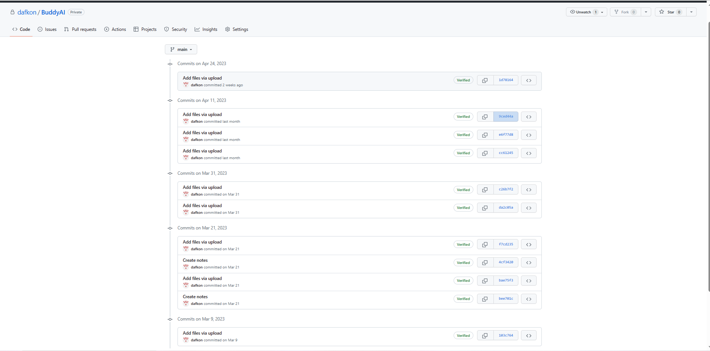

#### Figure 36 – Version control

## 3.4 – summary of the code volume

|  |  |
| --- | --- |
| File | Value (Number of lines) |
| Rasa (NLU) | 3040 |
| RASA (Rules) | 482 |
| RASA(Stories) | 480 |
| RASA (Domain) | 1328 |
| Kivy .kv file | 405 |
| Python back end | 400 |

#### Table 7 – Summary of code volume

## 3.5 – System walkthrough (5 pages minimum)

### 3.5.1 – Login frontend/backend

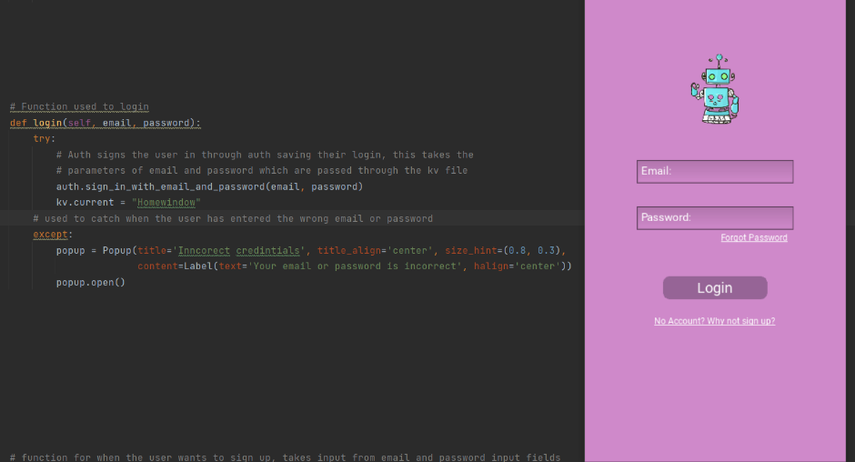

The login screen acts as the initial hub before the settings screen as it can take the user to any screen. To start off with the code for the login button itself uses a try and catch method to verify that the login details are correct. If they are the user gets brought to the home screen. If the details are wrong, they are met with a pop-up window. From the frontend side, it will call upon two methods for the login button, the login function, and the load help section for the home screen. The frontend buttons for signup and password will reset the text input fields for the login and take them to their respective pages. The login button will also send two values to the login function that being the input from both text fields of login and password.

#### Figure 36 – Login button code

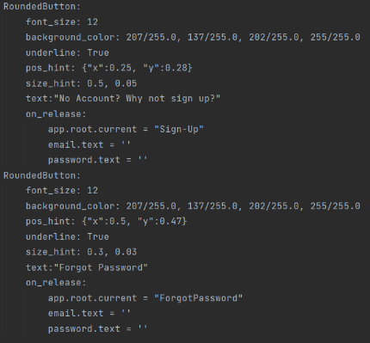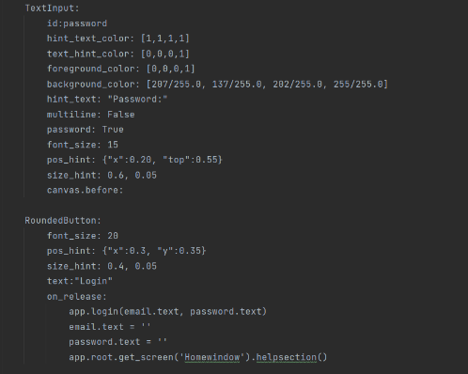

#### Figure 37 – Login front end buttons

### 3.5.2 – sign up frontend / backend

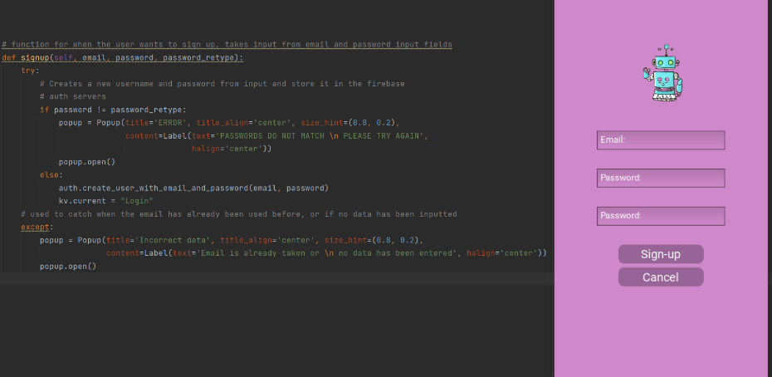

Once clicking the sign-up button from the home screen, the user will then be brought to the signup screen. Five elements appear on the screen, three text boxes and two buttons. The three texts boxes are for email, password, and password confirmation. The cancel button takes the user to the home page. The sign-up button will first verify if the two logins are the same, with an if statement inside a try and catch, if the password does not equal the second password typed in then the user will be met with an error, if they are equal it will then skip this and go to the else if where it will try to save the user auth system, however if an account already has that email the user can sign up and they will be sent to the catch error which will prompts a pop up saying that email address is used.

#### Figure 38 – sign-up backend

#### Figure 39 – sign-up frontend

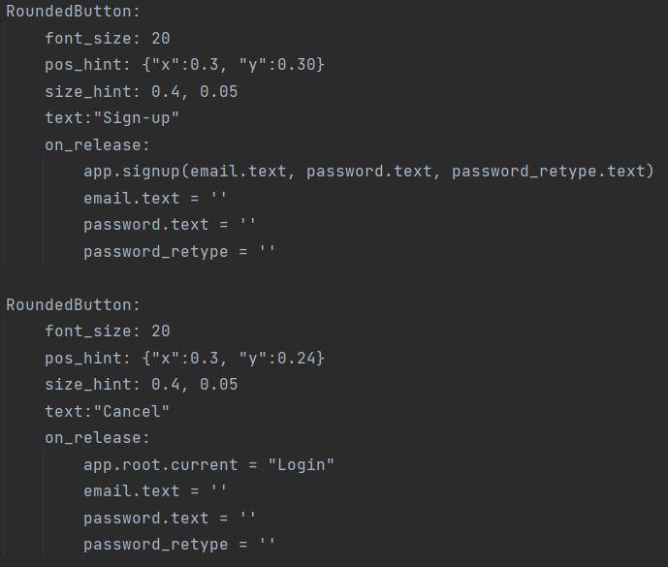

### 3.5.3 – Forgot password

This is the forgot password screen. It only has one text input with two buttons. The cancel buttons bring the user back to the login screen. The change password button is linked to the forgot password function. Through the front-end code, it will access the function by call it then sending it what is in the text input, if the email address matches one on the auth system it will then send a password to the user where they can enter a new password through a link from their email. This adds a layer of security as the user as anyone who want to change the user’s password is going to have to get their actual email address first which is even harder. If email doesn’t match the one on the auth system, the pop-up validation will appear to say that its wrong or its not on the system. If the users successfully make it through it will clear the forgot password, check box and move on to the login screen.

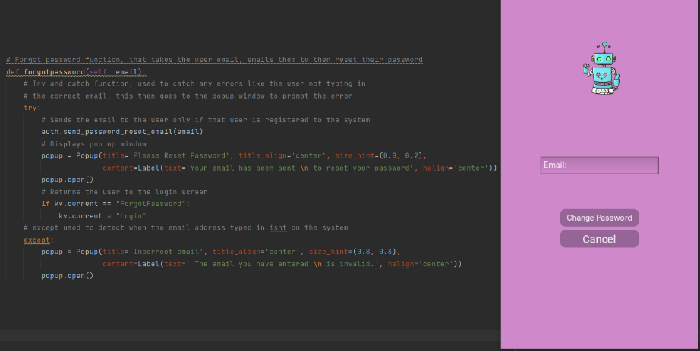

#### Figure 40–Forgot password backend

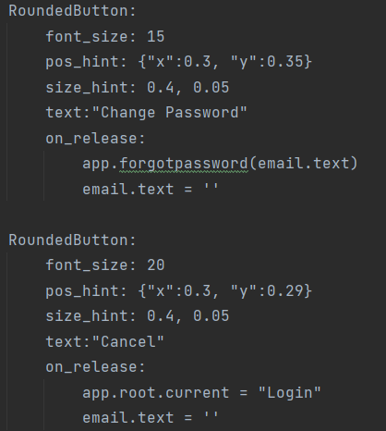

#### Figure 41 –forgot password frontend

### A screen shot of a computer Description automatically generated with medium confidence 3.5.4 – Home Screen frontend / backend

This is what the home screen looks like. This screen gets it information loaded into it with the help section function. When the user clicks the login button it will then load the functions labels and objects into the help screen id in the home screen front end. It does this by using a for loop that goes through all the elements in the help line field in the database. It will then take each individual value store it in a individual label, it then gets loaded into the help screen section.

#### Figure 42–home screen backend

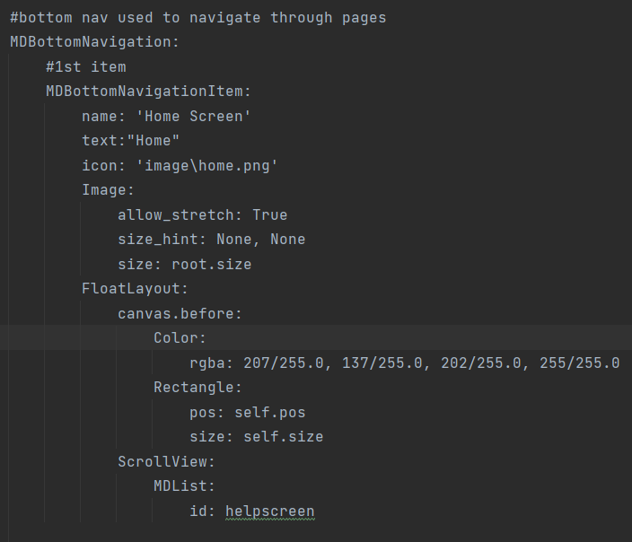

#### Figure 43 –home screen frontend

### 3.5.5 – Settings Screen frontend / backend

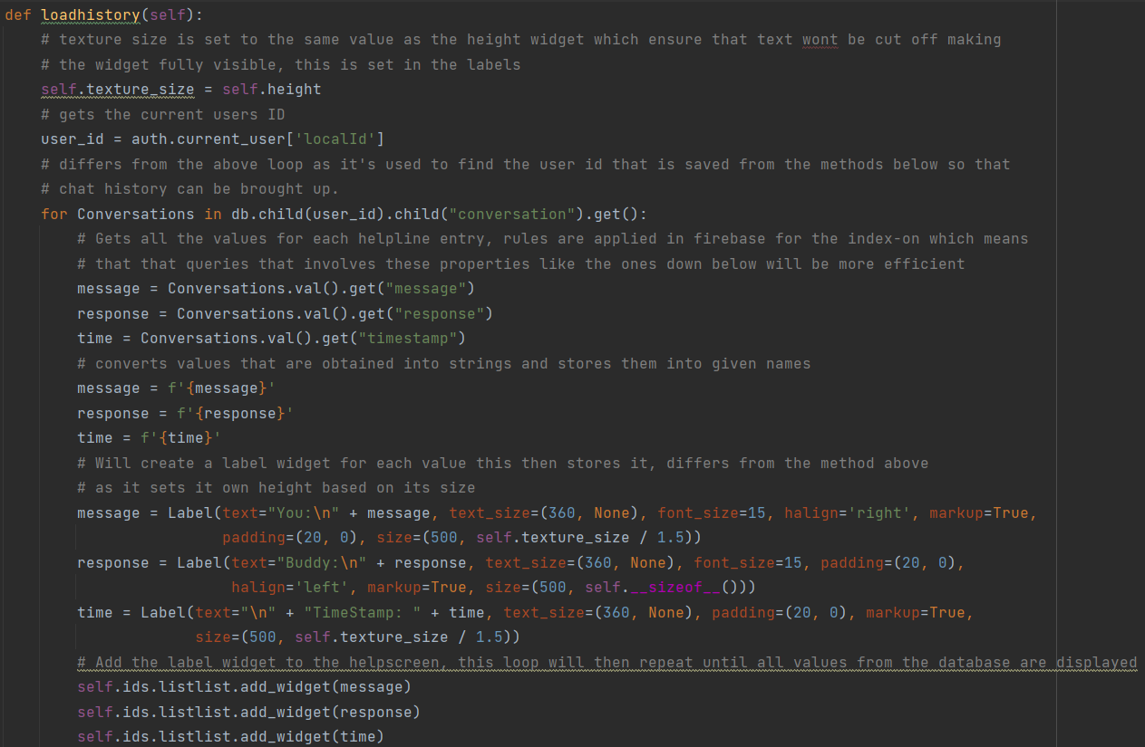**Load history button (1)**

The load history function is what creates the labels and the object list to store the labels, the frontend values are applied to it in the backend for when it gets displayed in the front end. This pulls all the data out of the real time data base for every element in the users ID section in the database. This repats util there is no data let. Each element pulled from the data base is stored in a individual label. However, the one below does

#### Figure 44–Load history button back end (1)

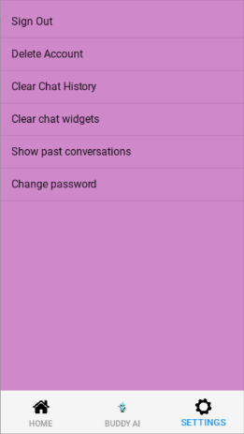**Load chat history button (2)**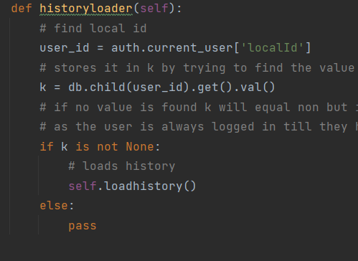

This is a security measure used to ensure that only the account logged in can get their own data This was added as an extra layer of security and validation. As no user knows their local ID this acts as a good security step to stop anyone else from sending it. This will then load all of the messages into the let’s chat section, but only if it is clicks already, if not then the history won’t appear.

#### Figure 45–Load history button (2)

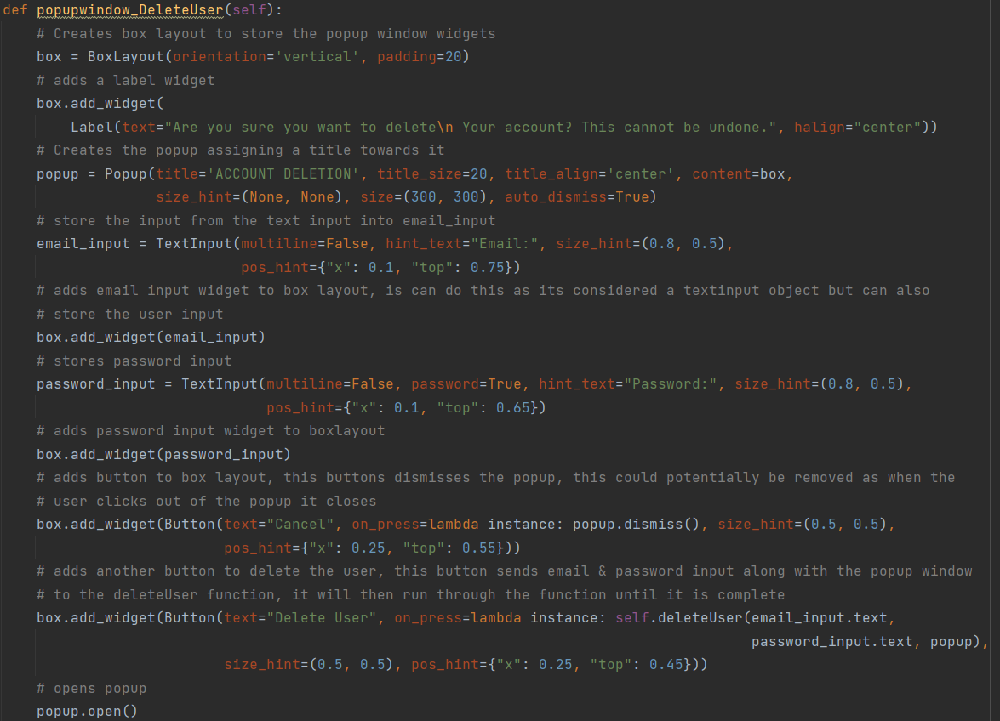**Delete User popup window (1)**

The Delete pop up window is another form of security and validation. This prompts a popup window when the user clicks delete user prompting them to data their account. The account can only be deleted if they can type in their username and password correctly. If not then the account cannot be deleted and they will be hit with another prompted message. This message will be different from most messages as it will have two inputs, and two buttons, one to cancel the action and one to send the information to the function below in figure 47. It will send the email and password box, along with the popup so it can carry over to the next function.

#### Figure 46–Delete user pop- up window (1)

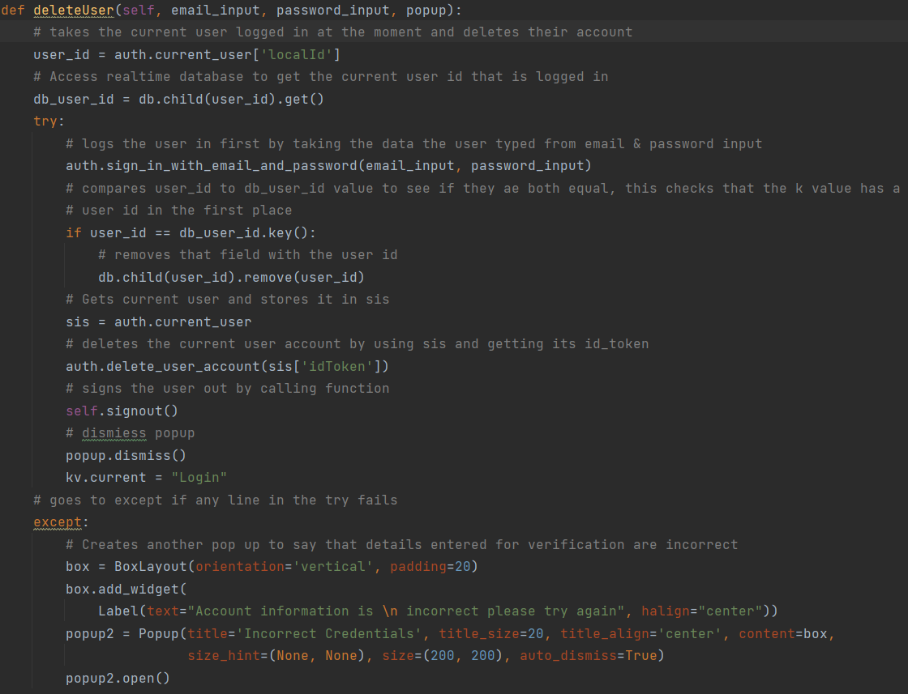**Delete User popup window (2)**

This function carries over from the delete user popup. This function verifies that the user email and password are correct by using a try catch method. it will then try to find the users ID on the real time database to see if they have chatlogs that can also be deleted, if not it will then pass by the if statements, this is more validation to stop errors. If it makes it through all of that it will then delete the account and by sending the user ID and then sign the user out. This will remove the users account from the firebase auth system, meaning that email can be used again for sign up. If the user can get through the first three steps of validation, they will then be met with a pop-up window say their details are incorrect and to try again.

#### Figure 47–Delete user pop- up window (2)

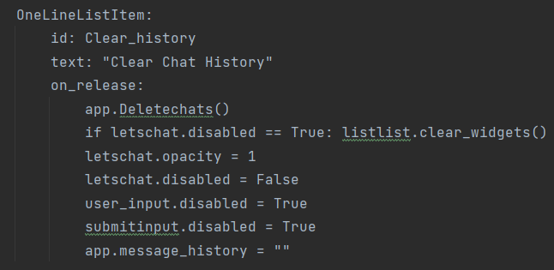

**Clear chat history (Widgets)**

The clear widget It just a simple frontend command. It checks if the MD list called “listlist” has any widgets in it and if it does it clear them. Validation has been added to this as it would crash if it doesn’t. it then also then returns the lets chat button to use and disables the text input and submit button.

#### Figure 48–clear widgets

**Delete chat history (1)**

Delete chat history works very similar to delete user. It gets the user to login from the pop-up window. It then sends the exact same data of the username password and the popup window. Then it will wait to get a response returned.

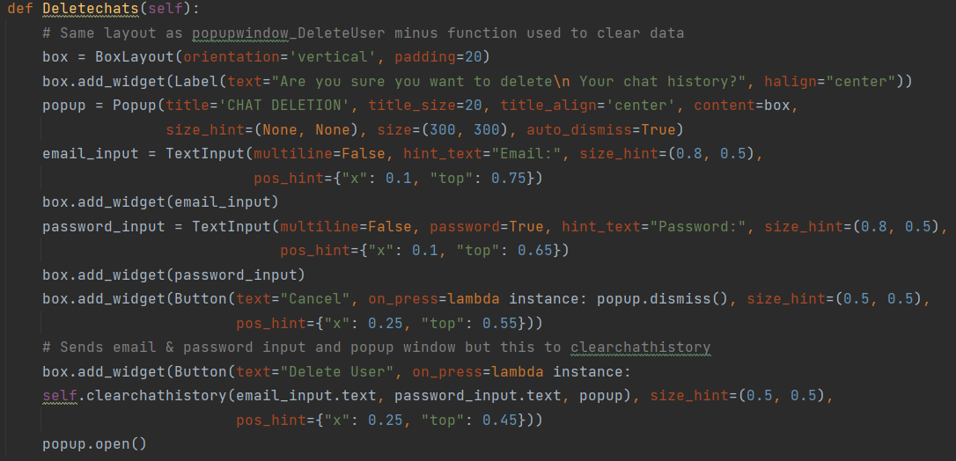

#### Figure 49– Delete chat history (1)

**Delete chat history (2)**

Clear chat history runs through the same methods as delete user only this time it deletes the chatlogs instead of the user. No additional validation from delete user has been added.

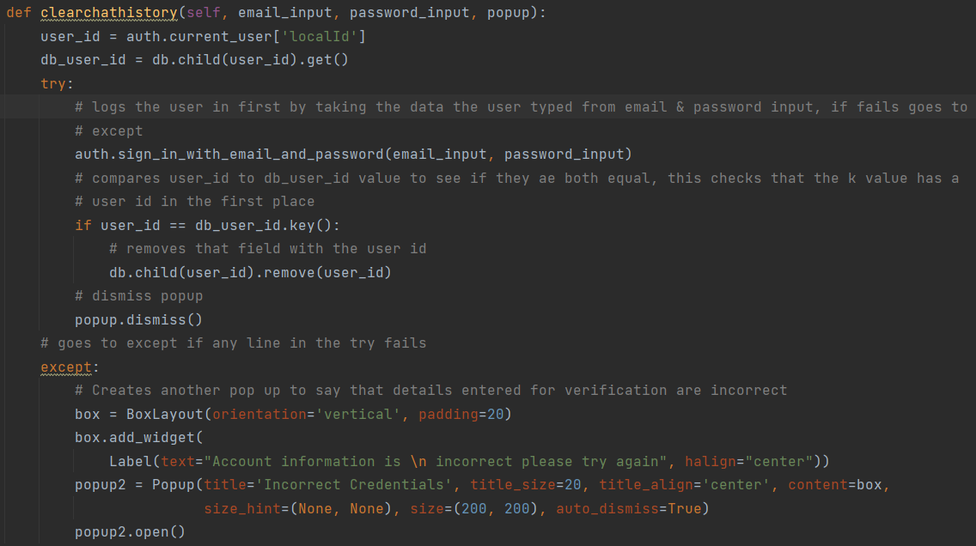

#### Figure 50 – Delete chat history (2)

### 3.5.6 –Chatbot frontend / backend

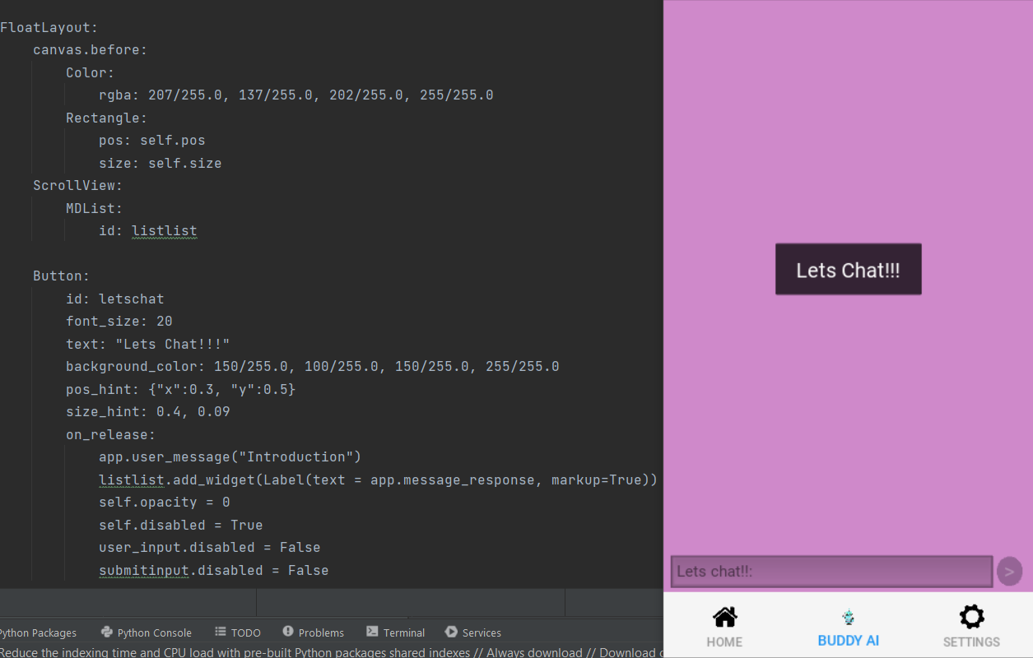**Let’s chat button**

The let’s chat button is set up as a cheat button to let the chatbot interact with the user first. It will secretly send a command to the RSSA chatbot this will produce a special message that will always introduce the user to the chatbot. Once clicked it will then be disable allowing the screen to be displayed and along with the text box and submit button. When this button is clicking the clear chat widget button and display history can be used.

#### Figure 51 – Lets chat button

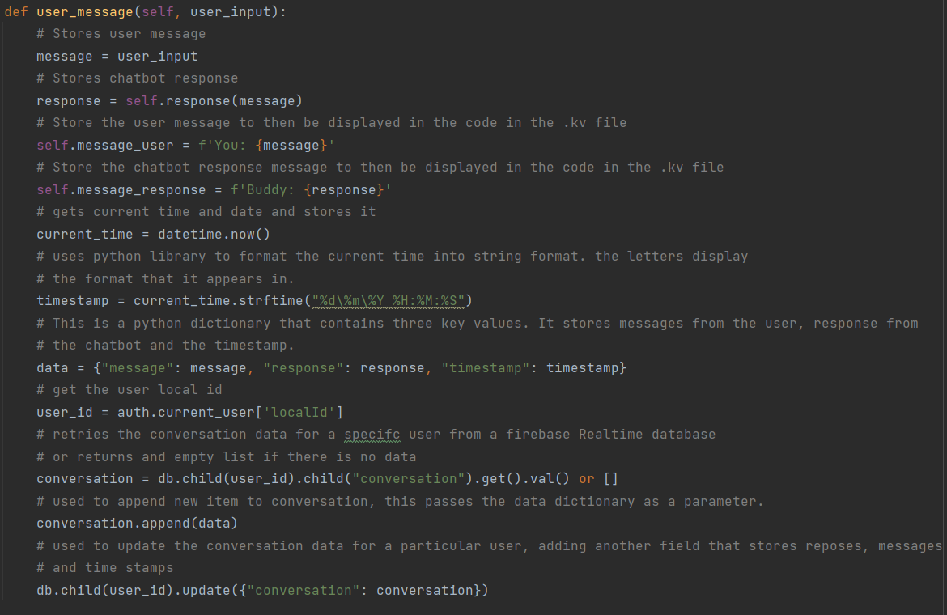**User message**

The user message function is one of the most important backend functions along with the response function. This function helps to display what the user said and what the chatbot said into the front end. It does this by sending storing the values in their own list of message_user and message_response, then those list get called from the front end to be displayed in a label. It gets the response message by calling the function in the variable and sending it the text input. It then saves the user message, chatbot response along with the current time stamp to the real time data base. It does this by storing it in its own conversation function and then then appending the data to the database, without overriding previous chat logs.

#### Figure 52 – User message

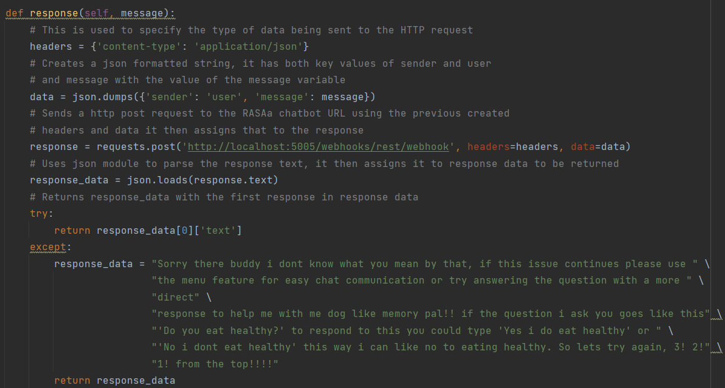

**Chatbot response**

This is another important function as it’s the reason why the chatbot can communicate with the backend in the first place. It first specifies the type of data to be sent, creates a Json formatted string, then it sends a https post request to the RASA server along with the json. It then saves the response from the server. If no response is gotten from the server, the backend will then jump in and fill out a response to the user to say that the input should be changed.

#### Figure 53 – chatbot response

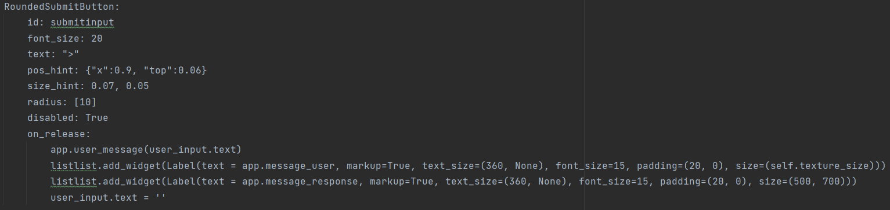**Submit button**

This is the submit button that adds a label to the listlist id, it stores the message_user in the first one and then the message_response to the second label, and produces them onto the chatbot screen.

#### Figure 54 – Displays messages and response

## 3.6 – consideration of security implementation

Security was considered heavily throughout this project. As stated in chapter two there have been many security steps taken to ensure that the user’s information and account are safe. As seen from chapter 3.5 above security considerations were considered were taken with the user pop up windows often displaying logins for the user to confirms their details before doing a serious action.

The hash parameter as discussed before help to hide the users password from outside sources by completely scrambling it, even if someone did get into the auth system they couldn’t understand it. This was on of the reasons why auth was chosen for this particular project as sensitive user data is being dealt with.



#### Figure 55 – password hash parameters

The only way to access the database is by logging in to the system, this is the only way to access the help line section and the only way to save user chatlogs. The conversation will be saved under the users ID. So to get into the database the users will need the API keys, the users local ID to only be able to access a text exchange, they couldn’t manipulate any data from it either as they will need to append the data as well in t the correct format meaning they will need this format as well. The reason why this is being mentioned is to show how many steps someone would need to go through just to get into the database, as they can take that route or try and figure out the parameter hash.



#### Figure 56 - Restricted access to database



#### Figure 57 – API access keys

Other users won’t be able to access other users chat logs as they will need to other logged in local ID. Which none of the users will know.



#### Figure 58 – Needs local ID security

Need the user’s login to access a function so they can delete their account. This may not stop someone who already knows that information, but it will stop the users who just happened to access the person physical device. As they won’t be able to clear the database logs or delete the account without know the user name and password. The user will also need the users ID, along with the API key if they plan on doing it from outside the application.



#### Figure 59 – Need login to delete chat history (1)



#### Figure 60 – Need login to delete chat history (2)

Need the user’s login to access a function so they can clear chatlogs. This may not stop someone who already knows that information, but it will stop the users who just happened to access the person physical device. As they won’t be able to clear the database logs or delete the account without know the username and password. The user will also need the users ID, along with the API key if they plan on doing it from outside the application.



#### Figure 61 – Need login to delete account (1)



#### Figure 61 – Need login to delete account (2)

Auth can handle validating the user safe and securely. As the email and password will be sent and it will verify it with their system.

auth.sign_in_with_email_and_password(email, password)

#### Figure 62 – Auth login

Can only delete user by getting the current ID token which is unknow to any unless they have the API keys or backend with the user logged in.

sis = auth.current_user   
auth.delete_user_account(sis['idToken'])

#### Figure 63 – Delete user

# Chapter 4 – System Verification

## 4.1 – Reflection on the verification plan

Overall, the plan from AP1 to AP2 in terms of system verification is still relatively the same. Due to changes at the start of AP2 some aspects did have to be changed. One example of this is the test cases. They have all been changed but do keep the original layout. The reason for changing them is that all requirements changed to a couple merging or getting removed. This allowed for much more accurate test cases and removing any mistakes that may have occurred if the original had been kept in. Each requirements have a link to a Test case that involves one of the steps that was needed to make the test case work. Many functions could have multiple test cases as they relate to what is being tested.

The first set of tests including the test cases only cover the mobile application. The reason for this is that its more reasonable to run test cases on functions rather that on a chatbot which has over 200 intents and utters. This plan has carried over from AP1 to AP2 as ap1 always had the chatbot functionality being automated. Automation also gives the developer more time to fix any errors that may occur in the system. No automation template for testing has been carried over from AP1 as it was unknown at the time how this automation would be done. If it would be done through the chatbot using something like selenium command line to slowly work through the rules and stories to ensure they work. The actual option was much easier with using RASA own automated testing features. These testing feature came on each build of the new model, with the terminal letting the user know when certain stories were conflicting, when rules where or when intents and utters were not called on the domain. This is not the main function of RASA train but does supply the developer with the knowledge of weaknesses in prior areas to fix later. The actual function used to do automated testing was:

**RASA data validate**

Data validation verify that no mistakes or major inconsistencies appear in your domain, NLU or story data [17]. RASA validate does not test if your rules are consistent, but they do during the training of the rule policy. This is how the rules were automatically tested. The rule policy checks for conflicts between rules and stories and if found it will abort the training.

**RASA test**

This is the default command that will run tests on stories from any file with the name start with test [17]. This was used to test all the stories and measure accurate they were. This can be seen on table 42 and 43. This like the NLU test speed the process of testing up massively for the author. RASA test helps to populate the results file with information regrading the automated tests. It populates failed test stories, intent confusion, intent errors, intent histogram, and intent report, along with the store equivalents and the ted policies. This can be seen throughout the document.

**RASA test NLU**

This uses the current NLU data to see how well the model can predict the data that has been trained on the model [17]. This was used in table 39 to produce the given automated testing results. This command although easy to do was vital to the RASA testing process s having to manually test all 200 intents again wile also have to assign prediction accuracy too them would have been too time consuming causing the developer to potentially scrap it or produce inaccurate results.

**RASA cross validation**

Cross validation is used when adding a lot of training example to the intents. Cross validation helps to automatically create and train multiple tests and averages the results of the evaluations on each train or test. This means that all the data is being evaluated during the cross validation, this makes the cross validation process the best way to automatically test your NLU data [17]. This was vital for ensuring accuracy in the intent for the developer. Cross validation came in around the end of the project due to the developer’s computer limitations R**9** and not being able to run it while working on a something else. However, the developer though this needed to be done to show the difference between the standard test and the cross-evaluation test which can be seen below.

Tests from RASA were important using a Json to excel feature on Microsoft excel. Then the data was sorteand added to the word document

Overall, from the new insertion of the cross validation, changes could have been made to the model however as explained before limitation restricted this from happening much later in the project. The overall accuracy prediction of 70 however is a good mark to land on considering how much user data was in the NLU examples. The cross validation turns out to be an impact tool for training the model and test the model and the developer would consider using it again in a project like this in the future.

## 4.2 – System Verification Results

### 4.2.1 – Mobile application

These are the updated testing tables along with the test cases. This had to be update due to the changes at the start of AP2. Overall, the testing results for the table were passes apart from function **F16** and **F24** which didn’t fail but were just not implemented as the developer focused more of that time on the RASA chatbot to produce better results. This is something that could be improved upon on later updates. Overall, the test case cover tall of the main requirements of the application that were finalized in AP2

|  |  |  |  |  |  |  |  |
| --- | --- | --- | --- | --- | --- | --- | --- |
| Test ID | Requirement tested ID | Test Case ID | Description | Dependencies | Expected results | Actual results | PASS / Accept / Fail |
| T1 | F1 | TC9 | Must accept User input for chatbot even with numbers from the users. | N/A | Let’s the user input data | As expected | PASS |
| T2 | F2 | TC9 | The chatbot Must be responsive when the user asks it any questions. | F1 | Chatbot responds | As expected | PASS |
| T3 | F3 |  | Chatbot messages and user messages display each time when the user enters text and when the bot is expected to output it. | F1, F2 | Messages are displayed | As expected | PASS |
| T4 | F4 | All | Users must be able to navigate easily throughout the mobile application. | N/A | User can navigate easily | As expected | PASS |
| T5 | F5 | TC11 | The user Must be able to ask for advice and receive advice on the appropriate situation the user is discussing. | F1, F2, F3 | User gets advice | As expected | PASS |
| T6 | F6 | TC2, TC3 | Users can sign in / log out of accounts through the settings menu. | F7 | User can sign in and log out | As expected | PASS |
| T7 | F7 | TC1 | Users can Sign up to create an account at the start screen. | F6 | User can sign up | As expected | PASS |
| T8 | F8 | ALL | Functional Mobile application. | ALL APPLICABLE | Fully functional based on all requirements | As expected | PASS |
| T9 | F9 | ALL | Functional Chatbot. | **This will be covered in the chat bot testing section** | N/A here base on future test | As expected | PASS |
| T10 | F10 | TC1, TC2, TC3, TC4, TC5, TC6, TC7 | store account details on chosen system storing approach | F6, F7, F21 | Store users details | As expected | PASS |
| T11 | F11 | TC12  TC13 | Display old chat / Clear old chats from screen | F10,F1,F2, F14 | Displays / clears history | As expected | PASS |
| T12 | F12 | TC11 | Advice must be Accurate to the user's situation. | F1, F2, F5 | This depends on the person, but it was sourced from health care specialists | Stake holder feedback will determine | PASS |
| T13 | F13 | TC14 | The database should store a particular user's chatlog. | F1, F2, F6, F7, F8, F9 | Database stores user logs | As expected | PASS |
| T14 | F14 | TC8 | Application should have advice page that display a variety of help lines for certain situations. | N/A | Application has advice page | As expected | PASS |
| T15 | F15 | TC7  TC6  TC5  TC4 | The settings menu for the user. | F20, F6, F23 | Has settings menu | As expected | PASS |
| T16 | F16 | N/A | A chatbot could have text suggestions. | N/A | N/A | N/A | NOT ADDED |
| T17 | F17 | TC9 | The chatbot Should engage with the user first. | F2, F3 | The chat bot engages the user first | As expected | PASS |
| T18 | F18 | TC11 | A chatbot can understand the broken text. | F1, F2 | Can understand when letter are missing | As expected | PASS |
| T29 | F19 | TC15 | User Can clear chat logs from the database. | F14, F16 | Can clear chat logs from database | As expected | PASS |
| T20 | F20 | TC4, TC 5 | Forgot password feature | F6, F7 | Send an email | As expected | PASS |
| T21 | F21 | TC1, TC2, TC3, TC4, TC5, TC6, TC7 | The chatlogs could be saved to the cloud. | F14, HOWEVER ITS DEPENDABLES MUST BE MET | Saved to Firebase real time database | As expected | PASS |
| T22 | F22 | TC7 | User can delete account along with chatlogs. | F6, F7, F14, F1 | User can delete account along with chat log | As expected | PASS |
| T23 | F23 | TC1, TC2, TC3, TC4, TC5, TC6, TC7 | Time Stamp saved when uploaded to database and displayed when showing chatlogs | F1, F2, F14 | Timestamp added to database | As expected | PASS |
| T24 | F24 |  | User can search for messages by typing in the time. | F23 | N/A | N/A | FAIL |

#### Table 8 - system verification table

### 4.2.2 – Test cases

This is the same test case that was created in AP1 but as stated before the contents that was inside them has mostly changed to accommodate for the new changes to the application. Each test case is related to a function or test ID which can be found in table 8. All test cases below have passed their test and this have been representing on the table as pass.

|  |  |
| --- | --- |
| **Test Case ID:** TC1 | **Test Designed by:** Ryan Harper |
| **Test Priority:** HIGH | **Test Designed Date:** 25/11/2022 |
| **Module Name:** SIGN UP | **Test Executed by:** Ryan Harper |
| **Test Name: SIGN UP TEST** | **Test Executed Date:** 01/05/2023 |
| **For Test ID:** T1 | **Dependencies:** F7, F6, F10 |
| **Description:** Testing that the user can sign up | **Precondition:** User has text input |

#### Table 9 – Test Case 1

|  |  |  |  |  |  |  |
| --- | --- | --- | --- | --- | --- | --- |
| Step | Test Step | Test Data | Expected results | Actual Results | Status (Pass / Fail) | Notes |
| 1 | Fill in email | Harper-r6@ulster.ac.uk | N/A | N/A | PASS | N/A |
| 2 | Fill in password | Password | N/A | N/A | PASS | N/A |
| 3 | Fill in password again | password | N/A | N/A | PASS | N/A |
| 4 | Click sign up | Touch | brings user to login | brings user to login | PASS | N/A |

#### Table 10 – Test Case 1

|  |  |
| --- | --- |
| **Test Case ID:** TC2 | **Test Designed by:** Ryan Harper |
| **Test Priority:** HIGH | **Test Designed Date:** 25/11/2022 |
| **Module Name:** Login | **Test Executed by:** Ryan Harper |
| **Test Name: User login** | **Test Executed Date:** 01/05/2023 |
| **For Test ID: T2** | **Dependencies:** F10, F7 |
| **Description:** User can log into account | **Precondition:** User has an account |

#### Table 11 – Test Case 2

|  |  |  |  |  |  |  |
| --- | --- | --- | --- | --- | --- | --- |
| Step | Test Step | Test Data | Expected results | Actual Results | Status (Pass / Fail) | Notes |
| 1 | Fill in email | [Harper-ry@ulster.ac.uk](mailto:Harper-ry@ulster.ac.uk) | N/A |  | PASS | N/A |
| 2 | Fill in password | password | N/A |  | PASS | N/A |
| 3 | Click sign up | Touch | Take user to home page | Take user to home page | PASS | N/A |

#### Table 12 – Test Case 2

|  |  |
| --- | --- |
| **Test Case ID:** TC3 | **Test Designed by:** Ryan Harper |
| **Test Priority:** HIGH | **Test Designed Date:** 25/11/2022 |
| **Module Name:** Sign out | **Test Executed by:** Ryan Harper |
| **Test Name: Can sign out** | **Test Executed Date:** 01/05/2023 |
| **For Test ID: T2** | **Dependencies:** F10, F7, F6 |
| **Description:** User signs out | **Precondition:** User logs in |

#### Table 13 – Test Case 3

|  |  |  |  |  |  |  |
| --- | --- | --- | --- | --- | --- | --- |
| Step | Test Step | Test Data | Expected results | Actual Results | Status (Pass / Fail) | Notes |
| 1 | User Click sign out | Touch | User is logged out | User is logged out | PASS | N/A |

#### Table 14 – Test Case 3

|  |  |
| --- | --- |
| **Test Case ID:** TC4 | **Test Designed by:** Ryan Harper |
| **Test Priority:** HIGH | **Test Designed Date:** 25/11/2022 |
| **Module Name:** Forgot password (Login screen) | **Test Executed by:** Ryan Harper |
| **Test Name: Forgot password** | **Test Executed Date:** 01/05/2023 |
| **For Test ID: T19** | **Dependencies:** F6, F7, F10, F15 |
| **Description:** User gets email to change password | **Precondition:** User has an account |

#### Table 15 – Test Case 4

|  |  |  |  |  |  |  |
| --- | --- | --- | --- | --- | --- | --- |
| Step | Test Step | Test Data | Expected results | Actual Results | Status (Pass / Fail) | Notes |
| 1 | User click on forgot password |  | N/A | N/A | PASS | N/A |
| 2 | Fills in email | [Harper-r6@ulster.ac.uk](mailto:Harper-r6@ulster.ac.uk) | N/A | N/A | PASS | N/A |
| 3 | Clicks submit | touch | User gets email | User got email | PASS | N/A |
| 4 | Changes password | Password1 | New password is accepted | New password is accepted | PASS | N/A |

#### Table 16 – Test Case 4

|  |  |
| --- | --- |
| **Test Case ID:** TC5 | **Test Designed by:** Ryan Harper |
| **Test Priority:** HIGH | **Test Designed Date:** 25/11/2022 |
| **Module Name:** Forgot password (Settings screen) | **Test Executed by:** Ryan Harper |
| **Test Name: Forgot password** | **Test Executed Date:** 01/05/2023 |
| **For Test ID: T19** | **Dependencies:** F10, F7, F6, F15 |
| **Description:** User gets email to change password | **Precondition:** User has an account |

#### Table 17 – Test Case 5

|  |  |  |  |  |  |  |
| --- | --- | --- | --- | --- | --- | --- |
| Step | Test Step | Test Data | Expected results | Actual Results | Status (Pass / Fail) | Notes |
| 1 | Fill in email | [Harper-ry@ulster.ac.uk](mailto:Harper-ry@ulster.ac.uk) | N/A | N/A | PASS | N/A |
| 2 | Fill in password | Password1 | N/A | N/A | PASS | N/A |
| 3 | Click login | Touch | Take user to home page | Take user to home page | PASS | N/A |
| 4 | Click settings | Touch | Takes the user to settings page | Takes the user to settings page | PASS | N/A |
| 5 | Click forgot password | Touch | Sends email and becomes un clickable | Sends email and becomes un clickable | PASS | N/A |

#### Table 18 – Test Case 5

|  |  |
| --- | --- |
| **Test Case ID:** TC6 | **Test Designed by:** Ryan Harper |
| **Test Priority:** HIGH | **Test Designed Date:** 25/11/2022 |
| **Module Name:** Forgot password (Settings screen) | **Test Executed by:** Ryan Harper |
| **Test Name:** Forgot password (Settings screen see if button is clickable) | **Test Executed Date:** 01/05/2023 |
| **For Test ID: T19** | **Dependencies:** F10, F7, F6F 15 |
| **Description:** User gets email to change password | **Precondition:** User has n account |

#### Table 19 – Test Case 6

|  |  |  |  |  |  |  |
| --- | --- | --- | --- | --- | --- | --- |
| Step | Test Step | Test Data | Expected results | Actual Results | Status (Pass / Fail) | Notes |
| 1 | Fill in email | [Harper-ry@ulster.ac.uk](mailto:Harper-ry@ulster.ac.uk) | N/A | N/A | PASS | N/A |
| 2 | Fill in password | Password1 | N/A | N/A | PASS | N/A |
| 3 | Click log in | Touch | Take user to home page | Take user to home page | PASS | N/A |
| 4 | Click settings | Touch | Takes the user to home page | Takes the user to home page | PASS | N/A |
| 5 | Click forgot password | Touch | Sends email and becomes un clickable | Sends email and becomes un clickable | PASS | N/A |
| 6 | Fill in email | [Harper-ry@ulster.ac.uk](mailto:Harper-ry@ulster.ac.uk) | N/A | N/A | PASS | N/A |
| 7 | Fill in password | Password1 | N/A | N/A | PASS | N/A |
| 8 | Click log in | Touch | Take user to home page | Take user to home page | PASS | N/A |
| 9 | Click settings | Touch | Takes the user to settings page | Takes the user to settings page | PASS | N/A |
| 10 | N/A | N/A | Forget password buttons is now clickable | Forget password buttons is now clickable | PASS | N/A |

#### Table 20 – Test Case 6

|  |  |
| --- | --- |
| **Test Case ID:** TC7 | **Test Designed by:** Ryan Harper |
| **Test Priority:** HIGH | **Test Designed Date:** 25/11/2022 |
| **Module Name:** Delete account | **Test Executed by:** Ryan Harper |
| **Test Name: Delete account** | **Test Executed Date:** 01/05/2023 |
| **For Test ID: T22** | **Dependencies:** F6, F7, F14, F10, F15 |
| **Description:** Can delete user account | **Precondition:** have an account |

#### Table 21 – Test Case 7

|  |  |  |  |  |  |  |
| --- | --- | --- | --- | --- | --- | --- |
| Step | Test Step | Test Data | Expected results | Actual Results | Status (Pass / Fail) | Notes |
| 1 | Fill in email | [Harper-ry@ulster.ac.uk](mailto:Harper-ry@ulster.ac.uk) | N/A | N/A | PASS | N/A |
| 2 | Fill in password | Password1 | N/A | N/A | PASS | N/A |
| 3 | Click log in | Touch | Take user to home page | Take user to home page | PASS | N/A |
| 4 | Click settings | Touch | Takes the user to home page | Takes the user to home page | PASS | N/A |
| 5 | Click delete account | Touch | Popup window appears | Popup window appears | PASS | N/A |
| 6 | Fill in email | [Harper-ry@ulster.ac.uk](mailto:Harper-ry@ulster.ac.uk) | N/A | N/A | PASS | N/A |
| 7 | Fill in password | Password1 | N/A | N/A | PASS | N/A |
| 8 | Click delete account | Touch | Take user to login page | Take user to login page | PASS | N/A |
| 9 | Click settings | Touch | Takes the user to home page | Takes the user to home page | PASS | N/A |
| 10 | N/A | N/A | Forget password buttons is now clickable | Forget password buttons is now clickable | PASS | N/A |

#### Table 22 – Test Case 7

|  |  |
| --- | --- |
| **Test Case ID:** TC8 | **Test Designed by:** Ryan Harper |
| **Test Priority:** HIGH | **Test Designed Date:** 25/11/2022 |
| **Module Name:** Homepage advice | **Test Executed by:** Ryan Harper |
| **Test Name: Homepage advice** | **Test Executed Date:** 01/05/2023 |
| **For Test ID: T14** | **Dependencies:** F14 F6 |
| **Description:** Advice page loads up when user logs in | **Precondition:** User has an account |

#### Table 23 – Test Case 8

|  |  |  |  |  |  |  |
| --- | --- | --- | --- | --- | --- | --- |
| Step | Test Step | Test Data | Expected results | Actual Results | Status (Pass / Fail) | Notes |
| 1 | Fill in email | [Harper-ry@ulster.ac.uk](mailto:Harper-ry@ulster.ac.uk) | N/A | N/A | PASS | N/A |
| 2 | Fill in password | Password1 | N/A | N/A | PASS | N/A |
| 3 | Click log in | Touch | Take user to home page | Take user to home page | PASS | N/A |
| 4 | N/A | N/A | Shows home page advice | Shows home page advice | Pass | N/A |

#### Table 24 – Test Case 8

|  |  |
| --- | --- |
| **Test Case ID:** TC9 | **Test Designed by:** Ryan Harper |
| **Test Priority:** HIGH | **Test Designed Date:** 25/11/2022 |
| **Module Name:** Input | **Test Executed by:** Ryan Harper |
| **Test Name: Accept input** | **Test Executed Date:** 01/05/2023 |
| **For Test ID: T1 T2 T17** | **Dependencies:** F1 F2 F17 |
| **Description:** Chatbot accepts input | **Precondition:** User is on the chatbot page |

#### Table 25 – Test Case 9

|  |  |  |  |  |  |  |
| --- | --- | --- | --- | --- | --- | --- |
| Step | Test Step | Test Data | Expected results | Actual Results | Status (Pass / Fail) | Notes |
| 1 | User click lets chat | Touch | Greeted with message | Greeted with message | PASS | N/A |
| 2 | User types in message | Hey | N/A | N/A | PASS | N/A |
| 3 | Sends message | Touch | Message sends | Message sent | PASS | N/A |
| 4 | N/A | N/A | Chatbot responds | Chatbot responds | PASS | N/A |

#### Table 26 – Test Case 9

|  |  |
| --- | --- |
| **Test Case ID:** TC10 | **Test Designed by:** Ryan Harper |
| **Test Priority:** HIGH | **Test Designed Date:** 25/11/2022 |
| **Module Name:** Display messages | **Test Executed by:** Ryan Harper |
| **Test Name: Display messages** | **Test Executed Date:** 01/05/2023 |
| **For Test ID: T3 T1 T2** | **Dependencies:** F3 F1 F2 |
| **Description:** The message displays | **Precondition:** Chatbot has started |

#### Table 27 – Test Case 10

|  |  |  |  |  |  |  |
| --- | --- | --- | --- | --- | --- | --- |
| Step | Test Step | Test Data | Expected results | Actual Results | Status (Pass / Fail) | Notes |
| 1 | User click lets chat | Touch | Greeted with message | Greeted with message | PASS | N/A |
| 2 | User types in message | Hey | N/A | N/A | PASS | N/A |
| 3 | Sends message | Touch | Message sends | Message sent | PASS | N/A |
| 4 | N/A | N/A | Chatbot responds | Chatbot responds | PASS | N/A |
| 5 | N/A | N/A | User message appears then chatbot message appears | User message appears then chatbot message appears | PASS | N/A |

#### Table 28 – Test Case 10

|  |  |
| --- | --- |
| **Test Case ID:** TC11 | **Test Designed by:** Ryan Harper |
| **Test Priority:** HIGH | **Test Designed Date:** 25/11/2022 |
| **Module Name: Accurate advice** | **Test Executed by:** Ryan Harper |
| **Test Name: Accurate advice** | **Test Executed Date:** 01/05/2023 |
| **For Test ID: T5 T18 T12** | **Dependencies:** F18 F5 |
| **Description:** when user ask for advice on depression it gets advice on depression | **Precondition:** On chatbot screen |

#### Table 29 – Test Case 11

|  |  |  |  |  |  |  |
| --- | --- | --- | --- | --- | --- | --- |
| Step | Test Step | Test Data | Expected results | Actual Results | Status (Pass / Fail) | Notes |
| 1 | User click lets chat | Touch | Greeted with message | Greeted with message | PASS | N/A |
| 2 | User types in message | Caping depression | N/A | N/A | PASS | N/A |
| 3 | Sends message | Touch | Message sends | Message sent | PASS | N/A |
| 4 | N/A | N/A | Chatbot responds understanding the users spelling mistake | Chatbot responds understanding the users spelling mistake | PASS | N/A |

#### Table 30 – Test Case 11

|  |  |
| --- | --- |
| **Test Case ID:** TC12 | **Test Designed by:** Ryan Harper |
| **Test Priority:** HIGH | **Test Designed Date:** 25/11/2022 |
| **Module Name:** Display old chat logs | **Test Executed by:** Ryan Harper |
| **Test Name: Old chat logs** | **Test Executed Date:** 01/05/2023 |
| **For Test ID: T11** | **Dependencies:** F11, F10, F1, F2, F14 |
| **Description:** Displays chat logs | **Precondition:** Be logged in |

#### Table 31 – Test Case 12

|  |  |  |  |  |  |  |
| --- | --- | --- | --- | --- | --- | --- |
| Step | Test Step | Test Data | Expected results | Actual Results | Status (Pass / Fail) | Notes |
| 1 | Go to chatbot page | Touch | N/A | N/A | PASS | N/A |
| 2 | Click lets chat | Touch | N/A | N/A | PASS | N/A |
| 3 | Go to settings page | Touch | N/A | N/A | PASS | N/A |
| 4 | Click show history | Touch | Data appears on chatbot page | Data appears on chatbot page | PASS | N/A |
| 5 | Click chatbot page | Touch | Old chat logs are on chatbot page | Old chat logs are on chatbot page | PASS | N/A |

#### Table 32 – Test Case 12

|  |  |
| --- | --- |
| **Test Case ID:** TC13 | **Test Designed by:** Ryan Harper |
| **Test Priority:** HIGH | **Test Designed Date:** 25/11/2022 |
| **Module Name:** clear old chat logs on page | **Test Executed by:** Ryan Harper |
| **Test Name: clear chat logs on page** | **Test Executed Date:** 01/05/2023 |
| **For Test ID: T11** | **Dependencies:** F11, F10, F1, F2, F14 |
| **Description:** clear chat logs on screen | **Precondition:** Be logged in on the chatbot page |

#### Table 33 – Test Case 13

|  |  |  |  |  |  |  |
| --- | --- | --- | --- | --- | --- | --- |
| Step | Test Step | Test Data | Expected results | Actual Results | Status (Pass / Fail) | Notes |
| 1 | Click lets chat | Touch | N/A | N/A | PASS | N/A |
| 2 | Go to settings page | Touch | N/A | N/A | PASS | N/A |
| 3 | Click show history | Touch | Data appears on chatbot page | Data appears on chatbot page | PASS | N/A |
| 4 | Click chatbot page | Touch | Old chat logs are on chatbot page | Old chat logs are on chatbot page | PASS | N/A |
| 5 | Go to settings page | Touch | N/A | N/A | PASS | N/A |
| 6 | Click clear history | Touch | Widgets | Widgets are gone | PASS | N/A |
| 7 | Click chatbot page | Touch | All widgets are gone from screen | All widgets are gone from screen | PASS | N/A |

#### Table 34 – Test Case 13

|  |  |
| --- | --- |
| **Test Case ID:** TC14 | **Test Designed by:** Ryan Harper |
| **Test Priority:** HIGH | **Test Designed Date:** 25/11/2022 |
| **Module Name:** Store chat log | **Test Executed by:** Ryan Harper |
| **Test Name: Store chat log** | **Test Executed Date:** 01/05/2023 |
| **For Test ID: T13** | **Dependencies:** All |
| **Description:** Store a particular users chat log | **Precondition:** on chatbot page |

#### Table 35 – Test Case 14

|  |  |  |  |  |  |  |
| --- | --- | --- | --- | --- | --- | --- |
| Step | Test Step | Test Data | Expected results | Actual Results | Status (Pass / Fail) | Notes |
| 1 | Go to chatbot page | Touch | N/A | N/A | PASS | N/A |
| 2 | Click lets chat | Touch | N/A | N/A | PASS | N/A |
| 3 | Go to settings page | Touch | N/A | N/A | PASS | N/A |
| 4 | Click show history | Touch | Data appears on chatbot page | Data appears on chatbot page | PASS | N/A |
| 5 | Click chatbot page | Touch | Old chat logs are on chatbot page | Old chat logs are on chatbot page | PASS | N/A |
| 6 | N/A | N/A | This proves chat logs are stored on database. | This proves chat logs are stored on database. | PASS | N/A |

#### Table 36 – Test Case 14

|  |  |
| --- | --- |
| **Test Case ID:** TC15 | **Test Designed by:** Ryan Harper |
| **Test Priority:** HIGH | **Test Designed Date:** 25/11/2022 |
| **Module Name:** clear chat log from database | **Test Executed by:** Ryan Harper |
| **Test Name: clear chat logs on database** | **Test Executed Date:** 01/05/2023 |
| **For Test ID: T19** | **Dependencies:** F11, F10, F1, F2, F14 |
| **Description:** clear chat logs on database | **Precondition:** Be logged in on the chatbot page with chats |

#### Table 37 – Test Case 15

|  |  |  |  |  |  |  |
| --- | --- | --- | --- | --- | --- | --- |
| Step | Test Step | Test Data | Expected results | Actual Results | Status (Pass / Fail) | Notes |
| 1 | Click lets chat | Touch | N/A | N/A | PASS | N/A |
| 2 | Go to settings page | Touch | N/A | N/A | PASS | N/A |
| 3 | Click show history | Touch | Data appears on chatbot page | Data appears on chatbot page | PASS | N/A |
| 4 | Click chatbot page | Touch | Old chat logs are on chatbot page | Old chat logs are on chatbot page | PASS | N/A |
| 5 | Go to settings page | Touch | N/A | N/A | PASS | N/A |
| 6 | Click clear logs | Touch | Brings up pop up | Brings up pop up |  |  |
| 7 | Type in email | Harper-r6@ulster.ac.uk | N/A | N/A | PASS | N/A |
| 8 | Type in password | Password1 | N/A | N/A | PASS | N?A |
| 9 | Click Clear logs | Touch | Logs will clear | Logs will clear | PASS | N/A |
| 10 | Click clear widgets button | Touch | Widgets are gone | Widgets are gone | PASS | N/A |
| 11 | Click show history | Touch | History will not show | History will not show | PASS | N/A |
| 11 | Click Chatbot page | Touch | The screen is blank | The screen is blank | PASS | N/A |

#### Table 38 – Test Case 15

### 4.2.3 – RASA tests intents (Automated Normal tests)

Overall, all the intents passed their test with very high accuracies and only some falling behind by a little from the prediction score of 1. However, some errors did occur with some of the NLU data within the intent. These just couldn’t be changed in time due the increments ending and the write up process starting. Automating the entire intent process has been extremely beneficial and has provided great feedback to the author on where he went wrong with writing some intents and what he was doing correctly with others. This when compared to the cross validation produce very different results as cross validation is more accurate.

|  |  |  |  |  |  |  |  |  |
| --- | --- | --- | --- | --- | --- | --- | --- | --- |
| **ID** | **Story ID** | **Name** | **precision** | **recall** | **f1-**  **score** | **support** | **Confused**  **with** | **Result** |
| I1 | S65 | Bullied_A | 1 | 1 | 1 | 12 | N/A | PASS |
| I2 | S109 | Transitions_B | 1 | 1 | 1 | 18 | N/A | PASS |
| I3 | S46 | relationship_  boundaries_C_1_1 | 1 | 1 | 1 | 15 | N/A | PASS |
| I4 | S92 | Sleep_pattern_C_2 | 1 | 1 | 1 | 13 | N/A | PASS |
| I5 | S80 | Maintain  _Healthy_habits_C_1 | 1 | 1 | 1 | 14 | N/A | PASS |
| I6 | RULE | bot_challenge | 1 | 1 | 1 | 4 | N/A | PASS |
| I7 | RULE | Coping_strategies_B | 1 | 1 | 1 | 2 | N/A | PASS |
| I8 | RULE | Coping_strategies  _C_Phobias | 1 | 1 | 1 | 10 | N/A | PASS |
| I9 | S20 | Maintain_  Healthy_habits_E_2 | 1 | 1 | 1 | 14 | N/A | PASS |
| I10 | RULE | Coping_strategies_  C_Insomnia | 1 | 1 | 1 | 19 | N/A | PASS |
| I11 | S94 | sought_Help | 1 | 1 | 1 | 7 | N/A | PASS |
| I12 |  | Family_problems | 0.928571 | 1 | 0.962962963 | 13 | N/A | PASS |
| I13 | S91 | Healthy_  work_lifestyle_B_3 | 1 | 1 | 1 | 20 | N/A | PASS |
| I14 | S87 | purpose_  in_life_B_2 | 0.823529 | 1 | 0.903225806 | 14 | N/A | PASS |
| I15 | S59 | Friend_Mental  _problems_C_2 | 1 | 1 | 1 | 10 | N/A | PASS |
| I16 | S23 | Maintain_Healthy  _habits_B_2 | 1 | 1 | 1 | 17 | N/A | PASS |
| I17 | S61 | purpose_in_life_B_1 | 1 | 1 | 1 | 24 | N/A | PASS |
| I18 | RULE | Coping_strategies_  C_Depression | 1 | 1 | 1 | 9 | N/A | PASS |
| I19 | RULE | Coping_strategies  _C_Abusive  _relationship_Planning | 1 | 1 | 1 | 14 | N/A | PASS |
| I20 | S52 | Relationship  _boundaries_B_3 | 1 | 1 | 1 | 14 | N/A | PASS |
| I21 | RULE | Coping_strategies_C  _Body_dysmorphic_REF | 1 | 1 | 1 | 2 | N/A | PASS |
| I22 | S104 | Relationship  _boundaries_C_3_3 | 1 | 1 | 1 | 14 | N/A | PASS |
| I23 | S11 | improve_mood_B_1_1 | 1 | 1 | 1 | 15 | N/A | PASS |
| I24 | S66 | Healthy_work_  lifestyle_C_3_1 | 1 | 1 | 1 | 18 | N/A | PASS |
| I25 | RULE | addiction | 1 | 1 | 1 | 15 | N/A | PASS |
| I26 | S99 | purpose_in_life_A | 1 | 1 | 1 | 17 | N/A | PASS |
| I27 | S6 | Self_harm_e_2 | 1 | 1 | 1 | 6 | N/A | PASS |
| I28 | S71 | Sleep_pattern_B_1 | 1 | 1 | 1 | 15 | N/A | PASS |
| I29 | S60 | emotional_episode_C_2 | 1 | 1 | 1 | 15 | N/A | PASS |
| I30 | S9 | purpose_in_life_C_2 | 1 | 1 | 1 | 24 | N/A | PASS |
| I31 | S28 | improve_mood_B_2 | 1 | 1 | 1 | 15 | N/A | PASS |
| I32 | RULE | Coping_strategies_C_Anger | 1 | 1 | 1 | 8 | N/A | PASS |
| I33 | S14 | Bullied_C_1 | 1 | 0.9 | 0.947368421 | 10 | N/A | PASS |
| I34 |  | Phobias | 1 | 1 | 1 | 15 | N/A | PASS |
| I35 | S1 | emotional_episode_D_2 | 1 | 1 | 1 | 16 | N/A | PASS |
| I36 | RULE | Coping_strategies_C_  Phobias_5_REF | 1 | 1 | 1 | 2 | N/A | PASS |
| I37 | RULE | Atychiphobia | 1 | 1 | 1 | 15 | N/A | PASS |
| I38 | RULE | Coping_strategies  _C_OCD_REF | 1 | 1 | 1 | 4 | N/A | PASS |
| I39 | S44 | Reason_for_not_  seeking_Help | 1 | 1 | 1 | 23 | N/A | PASS |
| I40 |  | Claustrophobia | 1 | 1 | 1 | 15 | N/A | PASS |
| I41 | S100 | purpose_in_life_C_1 | 1 | 1 | 1 | 18 | N/A | PASS |
| I42 | RULE | Body_dysmorphic_disorder | 1 | 1 | 1 | 15 | N/A | PASS |
| I43 | RULE | Eating_disorders | 1 | 1 | 1 | 15 | N/A | PASS |
| I44 | RULE | Coping_strategies_C  _Phobias_4_REF | 1 | 1 | 1 | 2 | N/A | PASS |
| I45 | S88 | improve_mood_C_1_1 | 1 | 1 | 1 | 18 | N/A | PASS |
| I46 |  | Coping_strategies_  C_Trauma_REF | 1 | 1 | 1 | 2 | N/A | PASS |
| I47 | S35 | relationship_  boundaries_C_2_2 | 1 | 1 | 1 | 9 | N/A | PASS |
| I48 | RULE | OCD | 1 | 1 | 1 | 15 | N/A | PASS |
| I49 | RULE | Coping_strategies_C_ADHD | 1 | 1 | 1 | 10 | N/A | PASS |
| I50 | RULE | Coping_strategies  _C_PTSD_flashbacks | 1 | 1 | 1 | 10 | N/A | PASS |
| I51 | S18 | relationship_boundaries_A | 1 | 1 | 1 | 11 | N/A | PASS |
| I52 | S8 | Self_harm_d_1 | 1 | 1 | 1 | 14 | N/A | PASS |
| I53 | RULE | Coping_strategie  s_C_Phobias_5 | 1 | 1 | 1 | 8 | N/A | PASS |
| I54 | S107 | Maintain_Healthy  _habits_D_1 | 1 | 1 | 1 | 10 | N/A | PASS |
| I55 | S54 | Bullied_B_2 | 1 | 1 | 1 | 27 | N/A | PASS |
| I56 | RULE | Coping_strategies  _C_Stress | 1 | 1 | 1 | 8 | N/A | PASS |
| I57 | S15 | purpose_in_life_E_1 | 1 | 1 | 1 | 14 | N/A | PASS |
| I58 |  | Depression_Description | 1 | 1 | 1 | 15 | N/A | PASS |
| I59 | S32 | purpose_in_life_D_1 | 1 | 1 | 1 | 14 | N/A | PASS |
| I60 | RULE | Coping_strategies_C_Racism | 1 | 1 | 1 | 8 | N/A | PASS |
| I61 | RULE | Healthy_work_lifestyle_C_1_2 | 0.947368 | 1 | 0.972972973 | 18 | N/A | PASS |
| I62 | RULE | Anxiety_Description | 1 | 1 | 1 | 15 | N/A | PASS |
| I63 | S74 | emotional_episode_G_1 | 1 | 1 | 1 | 5 | N/A | PASS |
| I64 | S101 | Healthy_work_lifestyle_A | 1 | 1 | 1 | 17 | N/A | PASS |
| I65 | RULE | Coping_strategies_  C_Phobias_3_REF | 1 | 1 | 1 | 2 | N/A | PASS |
| I66 | RULE | greet | 1 | 1 | 1 | 13 | N/A | PASS |
| I67 | RULE | Coping_strategies_C_OCD | 1 | 1 | 1 | 10 | N/A | PASS |
| I68 | S16 | Improve_mood | 1 | 1 | 1 | 16 | N/A | PASS |
| I69 | RULE | Grief | 1 | 1 | 1 | 15 | N/A | PASS |
| I70 | RULE | Coping_strategies_C_  Abusive_relationship  _Current_REF | 1 | 1 | 1 | 2 | N/A | PASS |
| I71 | S51 | Sleep_pattern_A | 1 | 1 | 1 | 20 | N/A | PASS |
| I72 | S2 | Self_harm_e_1 | 1 | 1 | 1 | 23 | N/A | PASS |
| I73 | RULE | Coping_strategies_C_  Abusive_relationship_  Planning_REF | 1 | 1 | 1 | 2 | N/A | PASS |
| I74 | S62 | Chatbot_expectation | 1 | 1 | 1 | 13 | N/A | PASS |
| I75 | RULE | Trauma_Description | 1 | 1 | 1 | 15 | N/A | PASS |
| I76 | S67 | Transitions_C_1 | 1 | 1 | 1 | 20 | N/A | PASS |
| I77 | S77 | emotional_episode_H_5 | 1 | 1 | 1 | 3 | N/A | PASS |
| I78 | S36 | purpose_in_life_E_1_1 | 1 | 1 | 1 | 15 | N/A | PASS |
| I79 | RULE | Suicide | 1 | 1 | 1 | 15 | N/A | PASS |
| I80 | RULE | Coping_strategies_  C_Homophobia | 1 | 1 | 1 | 8 | N/A | PASS |
| I81 | S27 | improve_mood_  C_2_2_2 | 1 | 1 | 1 | 16 | N/A | PASS |
| I82 | S102 | Friend_Mental_  problems_B_1 | 1 | 1 | 1 | 5 | N/A | PASS |
| I83 | RULE | Coping_strategies  _C_Phobias_2_REF | 1 | 1 | 1 | 2 | N/A | PASS |
| I84 | RULE | Coping_strategies_  C_Depression_REF | 1 | 1 | 1 | 2 | N/A | PASS |
| I85 | S50 | Bullied_E_4 | 1 | 1 | 1 | 12 | N/A | PASS |
| I86 | RULE | Coping_strategies  _C_Phobias_Menu | 1 | 1 | 1 | 4 | N/A | PASS |
| I87 | RULE | Mood_Swings | 1 | 1 | 1 | 15 | N/A | PASS |
| I88 | RULE | Bipolar_Disorder | 1 | 1 | 1 | 15 | N/A | PASS |
| I89 | RULE | Coping_strategies_C_  Phobias_1_REF | 1 | 1 | 1 | 2 | N/A | PASS |
| I90 | S90 | Friend_Mental  _problems_A | 1 | 1 | 1 | 14 | N/A | PASS |
| I91 | RULE | goodbye | 1 | 1 | 1 | 16 | N/A | PASS |
| I92 | RULE | Coping_strategies_C_  Abusive_relationship_Left | 1 | 1 | 1 | 17 | N/A | PASS |
| I93 | S22 | Self_harm_d_2 | 1 | 1 | 1 | 20 | N/A | PASS |
| I94 | S13 | Improving_Social_skills_B | 1 | 1 | 1 | 21 | N/A | PASS |
| I95 | S95 | Sleep_pattern_B_2 | 1 | 1 | 1 | 16 | N/A | PASS |
| I96 | RULE | Coping_strategies_C_  Addiction_REF | 1 | 1 | 1 | 2 | N/A | PASS |
| I97 | S49 | improve_mood_A_1 | 1 | 1 | 1 | 29 | N/A | PASS |
| I98 | RULE | Coping_strategies_  C_Grief_REF | 1 | 1 | 1 | 2 | N/A | PASS |
| I99 | RULE | BPD | 1 | 1 | 1 | 15 | N/A | PASS |
| I100 | S75 | mood_unhappy | 1 | 1 | 1 | 15 | N/A | PASS |
| I101 | S40 | Relationship  _boundaries_B_1 | 1 | 1 | 1 | 14 | N/A | PASS |
| I102 | RULE | Coping_strategies  _C_Anxiety_REF | 1 | 1 | 1 | 2 | N/A | PASS |
| I103 | S76 | improve_mood_B_1 | 1 | 1 | 1 | 16 | N/A | PASS |
| I104 | RULE | Tokophobia | 1 | 1 | 1 | 15 | N/A | PASS |
| I105 | RULE | Introduction | 1 | 1 | 1 | 11 | N/A | PASS |
| I106 | S58 | Bullied_B_1 | 1 | 1 | 1 | 12 | N/A | PASS |
| I107 | S5 | Healthy_work  _lifestyle_C_1_1 | 1 | 0.941176471 | 0.96969697 | 17 | N/A | PASS |
| I108 | RULE | Coping_strategies_C_  Eating_Disorder | 1 | 1 | 1 | 21 | N/A | PASS |
| I109 | RULE | Coping_strategies  _C_PTSD_flashbacks_REF | 1 | 1 | 1 | 4 | N/A | PASS |
| I110 | S19 | Healthy_work  _lifestyle_C_3_2 | 1 | 1 | 1 | 21 | N/A | PASS |
| I111 | S72 | Maintain_  Healthy_habits_A | 1 | 1 | 1 | 16 | N/A | PASS |
| I112 | S17 | Mental_Health_Update | 1 | 1 | 1 | 23 | N/A | PASS |
| I113 | S81 | Transitions_D_1 | 1 | 1 | 1 | 15 | N/A | PASS |
| I114 | S53 | Bullied_D_3 | 1 | 1 | 1 | 10 | N/A | PASS |
| I115 | S41 | Maintain_Healthy_  habits_C_2 | 1 | 1 | 1 | 15 | N/A | PASS |
| I116 | RULE | Seasonal_affective_  disorder | 1 | 1 | 1 | 15 | N/A | PASS |
| I117 | RULE | ADHD | 1 | 1 | 1 | 15 | N/A | PASS |
| I118 | S39 | Healthy_work  _lifestyle_B_1 | 1 | 1 | 1 | 21 | N/A | PASS |
| I119 | S21 | Transitions_C_2 | 1 | 1 | 1 | 17 | N/A | PASS |
| I120 | RULE | Mysophobia | 1 | 1 | 1 | 15 | N/A | PASS |
| I121 | S41 | Maintain_Healthy_  habits_B_2_2 | 1 | 1 | 1 | 21 | N/A | PASS |
| I122 | S24 | relationship_boundaries_C_1 | 1 | 1 | 1 | 15 | N/A | PASS |
| I123 | RULE | Coping_strategies_C_  Insomnia_REF | 1 | 1 | 1 | 2 | N/A | PASS |
| I124 | S108 | Cause | 1 | 0.958333333 | 0.978723404 | 24 | N/A | PASS |
| I125 | S37 | Sleep_pattern_C_1 | 1 | 1 | 1 | 17 | N/A | PASS |
| I126 | S84 | Maintain_Healthy_  habits_B_1 | 1 | 1 | 1 | 14 | N/A | PASS |
| I127 | RULE | Coping_strategies  _C_Abusive_relationship  _Current | 1 | 1 | 1 | 11 | N/A | PASS |
| I128 | S10 | relationship_boundaries_B_2 | 1 | 1 | 1 | 18 | N/A | PASS |
| I129 | S96 | emotional_episode_F_3 | 1 | 0.6 | 0.75 | 5 | N/A | PASS |
| I130 | S86 | Sleep_pattern_C_1_1 | 1 | 1 | 1 | 19 | N/A | PASS |
| I131 | S64 | Maintain_Healthy_habits_D_2_2 | 1 | 1 | 1 | 15 | N/A | PASS |
| I132 | RULE | Schizophrenia | 1 | 1 | 1 | 15 | N/A | PASS |
| I133 | S45 | Improving_Social_skills_C_1 | 1 | 1 | 1 | 17 | N/A | PASS |
| I134 | S43 | Transitions_D_2 | 1 | 1 | 1 | 14 | N/A | PASS |
| I135 | RULE | Coping_strategies_C_PTSD | 1 | 1 | 1 | 10 | N/A | PASS |
| I136 | RULE | thanks | 1 | 1 | 1 | 6 | N/A | PASS |
| I137 | S73 | emotional_episode_G_1_1 | 1 | 1 | 1 | 4 | N/A | PASS |
| I138 | S55 | emotional_episode_F_1 | 1 | 1 | 1 | 12 | N/A | PASS |
| I139 | RULE | Coping_strategies_C_  Stress_REF | 1 | 1 | 1 | 2 | N/A | PASS |
| I140 | S4 | Self_harm_b | 1 | 1 | 1 | 16 | N/A | PASS |
| I141 | S103 | Maintain_Healthy_  habits_C_2_2 | 1 | 1 | 1 | 21 | N/A | PASS |
| I142 | S34 | Transitions_A | 1 | 1 | 1 | 15 | N/A | PASS |
| I143 | S70 | emotional_episode_E_3 | 1 | 1 | 1 | 11 | N/A | PASS |
| I144 | S31 | Bullied_D_2 | 1 | 1 | 1 | 14 | N/A | PASS |
| I145 | RULE | Coping_strategies_C_Addiction | 1 | 1 | 1 | 10 | N/A | PASS |
| I146 | RULE | Insomnia | 1 | 1 | 1 | 15 | N/A | PASS |
| I147 | RULE | Coping_strategies_C_Phobias_2 | 1 | 1 | 1 | 8 | N/A | PASS |
| I148 | S48 | emotional_episode_B | 1 | 1 | 1 | 28 | N/A | PASS |
| I149 | RULE | Coping_strategies  _C_Anger_REF | 1 | 1 | 1 | 2 | N/A | PASS |
| I150 | RULE | Coping_strategies_  C_Eating_Disorder_REF | 1 | 1 | 1 | 2 | N/A | PASS |
| I151 | S78 | emotional_episode_C_1 | 1 | 1 | 1 | 15 | N/A | PASS |
| I152 | S93 | emotional_episode_A | 1 | 1 | 1 | 15 | N/A | PASS |
| I153 | S3 | Maintain_Healthy_habits_D_2 | 1 | 1 | 1 | 10 | N/A | PASS |
| I154 | S25 | Maintain_Healthy_habits_E_1 | 1 | 1 | 1 | 16 | N/A | PASS |
| I155 | S68 | Bullied_C_2 | 0.909091 | 1 | 0.952380952 | 10 | N/A | PASS |
| I156 | RULE | Coping_strategies_  C_Homophobia_REF | 1 | 1 | 1 | 2 | N/A | PASS |
| I157 | RULE | Coping_strategies_C_  Abusive_relationship  _Left_REF | 1 | 1 | 1 | 2 | N/A | PASS |
| I158 | RULE | Coping_strategies_C  _Phobias_3 | 1 | 1 | 1 | 8 | N/A | PASS |
| I159 | RULE | Coping_strategies_C_  Antisocial_REF | 1 | 1 | 1 | 2 | N/A | PASS |
| I160 | S26 | improve_mood_C_1 | 1 | 1 | 1 | 20 | N/A | PASS |
| I161 | RULE | Stress_Description | 1 | 1 | 1 | 15 | N/A | PASS |
| I162 | S79 | emotional_episode_D_3 | 1 | 1 | 1 | 12 | N/A | PASS |
| I163 | RULE | Coping_strategies_  C_ADHD_REF | 1 | 1 | 1 | 4 | N/A | PASS |
| I164 | RULE | Coping_strategies_A | 1 | 1 | 1 | 26 | N/A | PASS |
| I165 | RULE | PTSD | 1 | 1 | 1 | 15 | N/A | PASS |
| I166 | S83 | improve_mood_C_2_2_3 | 1 | 1 | 1 | 15 | N/A | PASS |
| I167 | RULE | Coping_strategies_C_  Racism_REF | 1 | 1 | 1 | 2 | N/A | PASS |
| I168 | RULE | Abusive_relationship | 1 | 1 | 1 | 15 | N/A | PASS |
| I169 | S56 | Relationship  _boundaries_C_3 | 1 | 1 | 1 | 14 | N/A | PASS |
| I170 | RULE | Coping_strategies_C  _Phobias_4 | 1 | 1 | 1 | 8 | N/A | PASS |
| I171 | S47 | Self_harm_c | 1 | 1 | 1 | 13 | N/A | PASS |
| I172 | S97 | Friend_Mental_problems_B_2 | 1 | 1 | 1 | 10 | N/A | PASS |
| I173 | S38 | improve_mood_C_2_2_1 | 1 | 1 | 1 | 16 | N/A | PASS |
| I174 | S98 | Improving_Social_skills_C_2 | 1 | 1 | 1 | 18 | N/A | PASS |
| I175 | RULE | deny | 1 | 1 | 1 | 13 | N/A | PASS |
| I176 | S42 | Self_harm_a | 1 | 1 | 1 | 25 | N/A | PASS |
| I177 | S30 | Healthy_work_lifestyle_B_2 | 1 | 1 | 1 | 20 | N/A | PASS |
| I178 | RULE | Social_anxiety_disorder | 1 | 1 | 1 | 15 | N/A | PASS |
| I179 | RULE | Coping_strategies  _C_Phobias_1 | 1 | 1 | 1 | 8 | N/A | PASS |
| I180 | RULE | Coping_strategies_C_Grief | 1 | 1 | 1 | 8 | N/A | PASS |
| I181 | S82 | relationship_boundaries_C_2 | 1 | 1 | 1 | 10 | N/A | PASS |
| I182 |  | Coping_strategies_C_Trauma | 1 | 1 | 1 | 8 | N/A | PASS |
| I183 | S69 | emotional_episode_D_1 | 1 | 1 | 1 | 17 | N/A | PASS |
| I184 | RULE | Coping_strategies_  C_Phobias_REF | 1 | 1 | 1 | 2 | N/A | PASS |
| I185 | RULE | Coping_strategies_  C_Body_dysmorphic | 1 | 1 | 1 | 8 | N/A | PASS |
| I186 | RULE | Resource | 1 | 1 | 1 | 2 | N/A | PASS |
| I187 | RULE | Generalized_anxiety_  disorder | 1 | 1 | 1 | 15 | N/A | PASS |
| I188 | RULE | Menu | 1 | 1 | 1 | 5 | N/A | PASS |
| I189 | S49 | improve_mood_A_2 | 1 | 0.85 | 0.918918919 | 20 | N/A | PASS |
| I190 | S7 | purpose_in_life_C_2_2 | 0.866667 | 0.866666667 | 0.866666667 | 15 | N/A | PASS |
| I191 | RULE | Coping_strategies_C  _PTSD_REF | 0.666667 | 1 | 0.8 | 2 | N/A | PASS |
| I192 | RULE | Coping_strategies_C  _Antisocial | 1 | 1 | 1 | 8 | N/A | PASS |
| I193 | RULE | joke | 1 | 1 | 1 | 18 | N/A | PASS |
| I194 | RULE | Anger_Description | 1 | 1 | 1 | 15 | N/A | PASS |
| I195 | RULE | Coping_strategies_C_  Anxiety | 1 | 1 | 1 | 8 | N/A | PASS |
| I196 | S29 | emotional_episode_E_1 | 0.833333 | 1 | 0.909090909 | 5 | N/A | PASS |
| I197 | RULE | Panic_disorder | 1 | 1 | 1 | 15 | N/A | PASS |
| I198 | RULE | Hypochondria | 1 | 1 | 1 | 15 | N/A | PASS |
| I199 | S63 | Bullied_E_3 | 1 | 1 | 1 | 8 | N/A | PASS |
| I200 | S33 | Why_They_Sought_help_Now | 1 | 1 | 1 | 18 | N/A | PASS |
| I201 | S57 | Bullied_D_1 | 1 | 1 | 1 | 11 | N/A | PASS |
| I202 | S12 | Improving_Social_skills_A | 1 | 1 | 1 | 19 | N/A | PASS |

#### Table 39 – Intent automated testing with prediction accuracy

**Prediction intent Averages**

Overall, Macro average, weighted average and micro average all show how consistent the NLU structure with no values falling below the given 0.96. This helps to represent the overall intents table rather than having to read through every intent.

|  |  |  |  |  |
| --- | --- | --- | --- | --- |
| **Accuracy type** | **Precision** | **Recall** | **F1-Score** | **Support** |
| macro avg | 0.9969351399425657 | 0.9965129233511587 | 0.9965946161698681 | 2551 |
| weighted avg | 0.9963567253992578 | 0.9960799686397491 | 0.9960712555057071 | 2551 |
| micro avg | 0.9960799686397491 | 0.9960799686397491 | 0.9960799686397491 | 2551 |
| Overall accuracy: | 0.9960799686397491 | | | |

#### Table 40 – Averages and overall accuracy

### 4.2.4 – RASA intent confusion matrix

This is the RASA intent confusion matrix. This display visually how many intents are getting lower predictions of the AI is unsure where to place them. As can be seen from the matrix below there are very little intents that are getting confused with other intents with the prediction accuracy being very consistent across the board. This graph will be uploaded with the program as the diagram may be currently hard tot read in its given format, this is to show stakeholders a clearer view. However, in the cross validation matrix this is heavily changed.

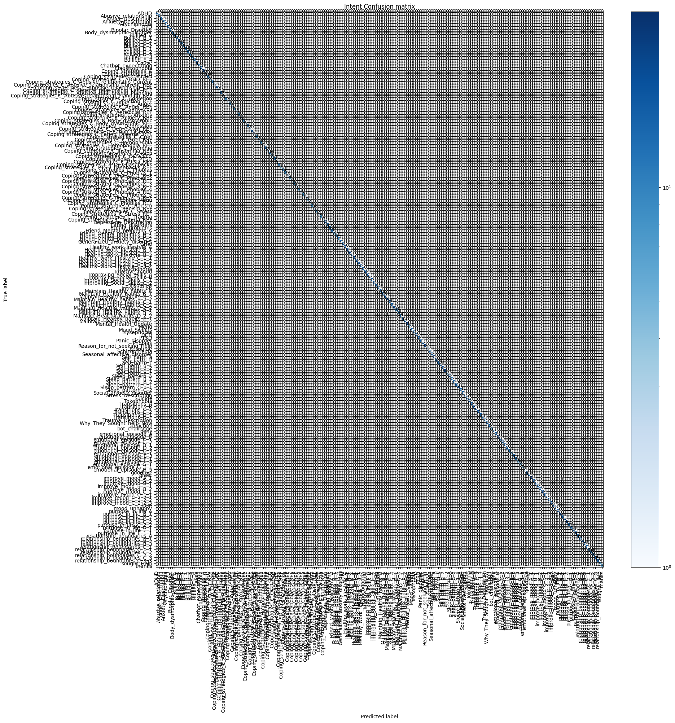

#### Figure 64 – intent confusion matrix

### 4.2.5 – RASA Intent Histogram

This is the RASA intent histogram. This histogram is a visual representation of the confidence throughout all the NLU examples. As you can see there are several samples with poor predictions however this is to be expected given the huge range of NLU contents there is, the corrects in this case outweigh the wrongs by a proportionate margin. This differs from the cross validation as its more test inductive and this takes just the normal data simply input

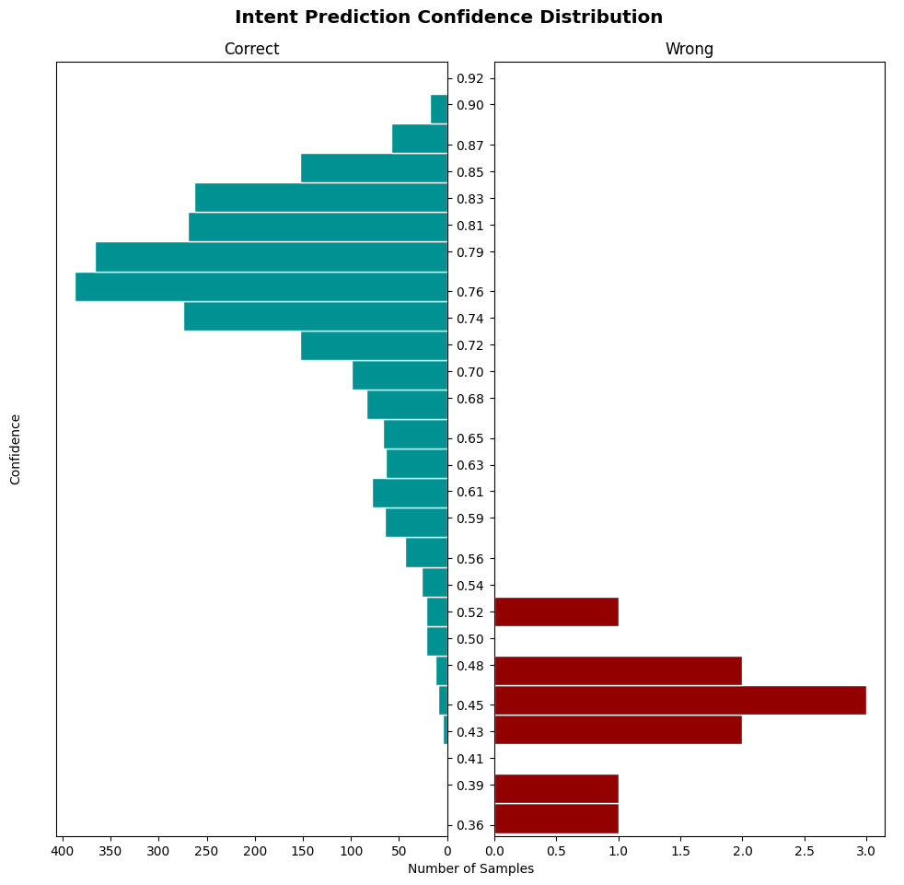

#### Figure 65 – Intent prediction confidence histogram

### 4.2.6 – RASA Intent results (Automated) With Cross validation

Cross validation was a late entry to the testing environment as it was difficult to run on the user computer to limitation in the software. However, the developer is happy with the implementation of it, as they got to see the true outcome of the model. It is much lower than the normal NLU tests ran before but an average prediction accuracy of 0.7 is good considering the overall data added to the NLU file. Over all the developer is happy with the outcome of the testing.

|  |  |  |  |  |  |
| --- | --- | --- | --- | --- | --- |
| **Name** | **precision** | **recall** | **f1-score** | **support** | **confused_with** |
| Anger_Description | 0.9375 | 1 | 0.967741935 | 15 | [Record] |
| Coping_strategies_C_Anxiety | 0.8 | 1 | 0.888888889 | 8 | [Record] |
| addiction | 0.9375 | 1 | 0.967741935 | 15 | [Record] |
| Coping_strategies_C_Phobias_3 | 1 | 1 | 1 | 8 | [Record] |
| Bullied_E_3 | 0.6 | 0.375 | 0.461538462 | 8 | [Record] |
| Coping_strategies_C_ADHD | 1 | 1 | 1 | 10 | [Record] |
| Sleep_pattern_B_2 | 0.705882353 | 0.75 | 0.727272727 | 16 | [Record] |
| Sleep_pattern_C_1 | 0.294117647 | 0.294117647 | 0.294117647 | 17 | [Record] |
| Abusive_relationship | 0.882352941 | 1 | 0.9375 | 15 | [Record] |
| Sleep_pattern_C_2 | 0.928571429 | 1 | 0.962962963 | 13 | [Record] |
| Hypochondria | 1 | 1 | 1 | 15 | [Record] |
| Coping_strategies_C_Grief | 1 | 1 | 1 | 8 | [Record] |
| purpose_in_life_A | 0.941176471 | 0.941176471 | 0.941176471 | 17 | [Record] |
| Transitions_D_1 | 0.4 | 0.266666667 | 0.32 | 15 | [Record] |
| emotional_episode_C_1 | 0.642857143 | 0.6 | 0.620689655 | 15 | [Record] |
| Self_harm_e_2 | 0 | 0 | 0 | 6 | [Record] |
| Transitions_C_1 | 0.576923077 | 0.75 | 0.652173913 | 20 | [Record] |
| Coping_strategies_C_Body_dysmorphic | 1 | 1 | 1 | 8 | [Record] |
| Healthy_work_lifestyle_C_1_1 | 0.545454545 | 0.352941176 | 0.428571429 | 17 | [Record] |
| emotional_episode_C_2 | 0.909090909 | 0.666666667 | 0.769230769 | 15 | [Record] |
| Healthy_work_lifestyle_B_3 | 0.619047619 | 0.65 | 0.634146341 | 20 | [Record] |
| purpose_in_life_C_2_2 | 0.333333333 | 0.333333333 | 0.333333333 | 15 | [Record] |
| Body_dysmorphic_disorder | 1 | 1 | 1 | 15 | [Record] |
| PTSD | 0.9375 | 1 | 0.967741935 | 15 | [Record] |
| Sleep_pattern_A | 0.703703704 | 0.95 | 0.808510638 | 20 | [Record] |
| Sleep_pattern_B_1 | 0.615384615 | 0.533333333 | 0.571428571 | 15 | [Record] |
| Coping_strategies_C_Depression | 0.888888889 | 0.888888889 | 0.888888889 | 9 | [Record] |
| Healthy_work_lifestyle_C_3_1 | 0.842105263 | 0.888888889 | 0.864864865 | 18 | [Record] |
| joke | 0.941176471 | 0.888888889 | 0.914285714 | 18 | [Record] |
| Maintain_Healthy_habits_E_2 | 0.5 | 0.571428571 | 0.533333333 | 14 | [Record] |
| Mental_Health_Update | 0.368421053 | 0.304347826 | 0.333333333 | 23 | [Record] |
| Improve_mood | 0.705882353 | 0.75 | 0.727272727 | 16 | [Record] |
| Coping_strategies_C_OCD | 0.833333333 | 1 | 0.909090909 | 10 | [Record] |
| Family_problems | 0.909090909 | 0.769230769 | 0.833333333 | 13 | [Record] |
| Improving_Social_skills_A | 0.818181818 | 0.947368421 | 0.87804878 | 19 | [Record] |
| Bullied_E_4 | 0.7 | 0.583333333 | 0.636363636 | 12 | [Record] |
| Coping_strategies_C_Stress | 0.727272727 | 1 | 0.842105263 | 8 | [Record] |
| Healthy_work_lifestyle_B_2 | 0.615384615 | 0.4 | 0.484848485 | 20 | [Record] |
| purpose_in_life_C_2 | 0.666666667 | 1 | 0.8 | 24 | [Record] |
| Transitions_A | 0.722222222 | 0.866666667 | 0.787878788 | 15 | [Record] |
| Stress_Description | 0.833333333 | 1 | 0.909090909 | 15 | [Record] |
| Bullied_D_2 | 0.75 | 0.857142857 | 0.8 | 14 | [Record] |
| Self_harm_b | 0.590909091 | 0.8125 | 0.684210526 | 16 | [Record] |
| Maintain_Healthy_habits_C_2 | 0.4 | 0.4 | 0.4 | 15 | [Record] |
| sought_Help | 0 | 0 | 0 | 7 | [Record] |
| improve_mood_A_2 | 0.214285714 | 0.15 | 0.176470588 | 20 | [Record] |
| emotional_episode_E_3 | 0.1 | 0.090909091 | 0.095238095 | 11 | [Record] |
| Coping_strategies_C_PTSD | 1 | 0.8 | 0.888888889 | 10 | [Record] |
| Coping_strategies_C_Addiction | 0.909090909 | 1 | 0.952380952 | 10 | [Record] |
| Healthy_work_lifestyle_C_1_2 | 0.7 | 0.777777778 | 0.736842105 | 18 | [Record] |
| Mysophobia | 1 | 1 | 1 | 15 | [Record] |
| Coping_strategies_C_Phobias_2 | 1 | 1 | 1 | 8 | [Record] |
| emotional_episode_F_3 | 0.833333333 | 1 | 0.909090909 | 5 | [Record] |
| Improving_Social_skills_B | 0.384615385 | 0.238095238 | 0.294117647 | 21 | [Record] |
| emotional_episode_E_1 | 0.75 | 0.6 | 0.666666667 | 5 | [Record] |
| Transitions_B | 0.785714286 | 0.611111111 | 0.6875 | 18 | [Record] |
| Self_harm_c | 0.363636364 | 0.307692308 | 0.333333333 | 13 | [Record] |
| Bipolar_Disorder | 1 | 1 | 1 | 15 | [Record] |
| emotional_episode_D_3 | 0.315789474 | 0.5 | 0.387096774 | 12 | [Record] |
| improve_mood_C_2_2_1 | 0.733333333 | 0.6875 | 0.709677419 | 16 | [Record] |
| Anxiety_Description | 1 | 1 | 1 | 15 | [Record] |
| relationship_boundaries_B_1 | 0.642857143 | 0.642857143 | 0.642857143 | 14 | [Record] |
| Tokophobia | 1 | 1 | 1 | 15 | [Record] |
| Maintain_Healthy_habits_D_2_2 | 0.555555556 | 0.333333333 | 0.416666667 | 15 | [Record] |
| relationship_boundaries_C_2_2 | 0.857142857 | 0.666666667 | 0.75 | 9 | [Record] |
| Self_harm_d_1 | 0.7 | 0.5 | 0.583333333 | 14 | [Record] |
| relationship_boundaries_C_1_1 | 0.538461538 | 0.466666667 | 0.5 | 15 | [Record] |
| purpose_in_life_B_2 | 0.65 | 0.928571429 | 0.764705882 | 14 | [Record] |
| improve_mood_C_2_2_2 | 0.625 | 0.625 | 0.625 | 16 | [Record] |
| Improving_Social_skills_C_2 | 0.4 | 0.333333333 | 0.363636364 | 18 | [Record] |
| Coping_strategies_C_Anger | 1 | 1 | 1 | 8 | [Record] |
| relationship_boundaries_C_1 | 0.705882353 | 0.8 | 0.75 | 15 | [Record] |
| improve_mood_B_1 | 0.4 | 0.625 | 0.487804878 | 16 | [Record] |
| Panic_disorder | 1 | 1 | 1 | 15 | [Record] |
| mood_unhappy | 0.533333333 | 0.533333333 | 0.533333333 | 15 | [Record] |
| emotional_episode_D_2 | 0.476190476 | 0.625 | 0.540540541 | 16 | [Record] |
| Maintain_Healthy_habits_D_1 | 0.625 | 0.5 | 0.555555556 | 10 | [Record] |
| Menu | 0.666666667 | 0.8 | 0.727272727 | 5 | [Record] |
| Depression_Description | 1 | 1 | 1 | 15 | [Record] |
| Maintain_Healthy_habits_D_2 | 0.25 | 0.4 | 0.307692308 | 10 | [Record] |
| ADHD | 1 | 1 | 1 | 15 | [Record] |
| Cause | 0.260869565 | 0.25 | 0.255319149 | 24 | [Record] |
| Healthy_work_lifestyle_A | 0.785714286 | 0.647058824 | 0.709677419 | 17 | [Record] |
| Maintain_Healthy_habits_C_2_2 | 0.789473684 | 0.714285714 | 0.75 | 21 | [Record] |
| Coping_strategies_A | 0.72 | 0.692307692 | 0.705882353 | 26 | [Record] |
| Coping_strategies_C_Phobias_5 | 1 | 1 | 1 | 8 | [Record] |
| OCD | 1 | 1 | 1 | 15 | [Record] |
| Transitions_C_2 | 0.555555556 | 0.294117647 | 0.384615385 | 17 | [Record] |
| improve_mood_A_1 | 0.47826087 | 0.379310345 | 0.423076923 | 29 | [Record] |
| BPD | 1 | 1 | 1 | 15 | [Record] |
| Maintain_Healthy_habits_B_2_2 | 0.65 | 0.619047619 | 0.634146341 | 21 | [Record] |
| Bullied_B_1 | 0.75 | 0.75 | 0.75 | 12 | [Record] |
| Coping_strategies_C_  Abusive_relationship_Current | 1 | 1 | 1 | 11 | [Record] |
| Seasonal_affective_disorder | 1 | 1 | 1 | 15 | [Record] |
| Self_harm_d_2 | 0.375 | 0.3 | 0.333333333 | 20 | [Record] |
| Reason_for_not_seeking_Help | 0.35 | 0.304347826 | 0.325581395 | 23 | [Record] |
| Friend_Mental_problems_A | 0.736842105 | 1 | 0.848484848 | 14 | [Record] |
| Self_harm_a | 0.566666667 | 0.68 | 0.618181818 | 25 | [Record] |
| purpose_in_life_E_1_1 | 0.666666667 | 0.666666667 | 0.666666667 | 15 | [Record] |
| Eating_disorders | 0.882352941 | 1 | 0.9375 | 15 | [Record] |
| Friend_Mental_problems_B_1 | 1 | 0.8 | 0.888888889 | 5 | [Record] |
| Maintain_Healthy_habits_B_2 | 0.533333333 | 0.470588235 | 0.5 | 17 | [Record] |
| Coping_strategies_C_  Abusive_relationship_Left | 1 | 1 | 1 | 17 | [Record] |
| purpose_in_life_D_1 | 0.933333333 | 1 | 0.965517241 | 14 | [Record] |
| greet | 0.8 | 0.615384615 | 0.695652174 | 13 | [Record] |
| relationship_boundaries_B_2 | 0.5 | 0.555555556 | 0.526315789 | 18 | [Record] |
| Friend_Mental_problems_B_2 | 0.777777778 | 0.7 | 0.736842105 | 10 | [Record] |
| Bullied_A | 0.588235294 | 0.833333333 | 0.689655172 | 12 | [Record] |
| Maintain_Healthy_habits_A | 0.9375 | 0.9375 | 0.9375 | 16 | [Record] |
| Maintain_Healthy_habits_E_1 | 0.533333333 | 0.5 | 0.516129032 | 16 | [Record] |
| thanks | 0.666666667 | 0.666666667 | 0.666666667 | 6 | [Record] |
| relationship_boundaries_A | 0.8 | 0.727272727 | 0.761904762 | 11 | [Record] |
| improve_mood_C_1_1 | 0.2 | 0.166666667 | 0.181818182 | 18 | [Record] |
| Trauma_Description | 1 | 1 | 1 | 15 | [Record] |
| Coping_strategies_C_Insomnia | 0.882352941 | 0.789473684 | 0.833333333 | 19 | [Record] |
| Friend_Mental_problems_C_2 | 1 | 0.9 | 0.947368421 | 10 | [Record] |
| Bullied_D_1 | 0.25 | 0.272727273 | 0.260869565 | 11 | [Record] |
| Coping_strategies_C_Racism | 1 | 1 | 1 | 8 | [Record] |
| Healthy_work_lifestyle_B_1 | 0.761904762 | 0.761904762 | 0.761904762 | 21 | [Record] |
| Coping_strategies_C_  Abusive_relationship_Planning | 1 | 1 | 1 | 14 | [Record] |
| Why_They_Sought_help_Now | 0.133333333 | 0.111111111 | 0.121212121 | 18 | [Record] |
| improve_mood_C_2_2_3 | 0.714285714 | 0.666666667 | 0.689655172 | 15 | [Record] |
| goodbye | 0.642857143 | 0.5625 | 0.6 | 16 | [Record] |
| Sleep_pattern_C_1_1 | 0.388888889 | 0.368421053 | 0.378378378 | 19 | [Record] |
| emotional_episode_F_1 | 0.6 | 0.5 | 0.545454545 | 12 | [Record] |
| Coping_strategies_C_PTSD_flashbacks | 1 | 1 | 1 | 10 | [Record] |
| Grief | 0.9375 | 1 | 0.967741935 | 15 | [Record] |
| Bullied_C_1 | 0.714285714 | 0.5 | 0.588235294 | 10 | [Record] |
| relationship_boundaries_C_2 | 0.416666667 | 0.5 | 0.454545455 | 10 | [Record] |
| Transitions_D_2 | 0.5 | 0.714285714 | 0.588235294 | 14 | [Record] |
| Coping_strategies_C_Trauma | 1 | 1 | 1 | 8 | [Record] |
| Social_anxiety_disorder | 1 | 1 | 1 | 15 | [Record] |
| Bullied_C_2 | 0.727272727 | 0.8 | 0.761904762 | 10 | [Record] |
| Healthy_work_lifestyle_C_3_2 | 0.8 | 0.761904762 | 0.780487805 | 21 | [Record] |
| relationship_boundaries_B_3 | 0.588235294 | 0.714285714 | 0.64516129 | 14 | [Record] |
| Claustrophobia | 1 | 1 | 1 | 15 | [Record] |
| Coping_strategies_C_Phobias_4 | 1 | 1 | 1 | 8 | [Record] |
| Improving_Social_skills_C_1 | 0.421052632 | 0.470588235 | 0.444444444 | 17 | [Record] |
| purpose_in_life_B_1 | 0.888888889 | 1 | 0.941176471 | 24 | [Record] |
| Insomnia | 1 | 1 | 1 | 15 | [Record] |
| Suicide | 0.833333333 | 1 | 0.909090909 | 15 | [Record] |
| purpose_in_life_C_1 | 0.555555556 | 0.555555556 | 0.555555556 | 18 | [Record] |
| Introduction | 0.818181818 | 0.818181818 | 0.818181818 | 11 | [Record] |
| purpose_in_life_E_1 | 0.611111111 | 0.785714286 | 0.6875 | 14 | [Record] |
| Mood_Swings | 1 | 1 | 1 | 15 | [Record] |
| emotional_episode_A | 1 | 0.8 | 0.888888889 | 15 | [Record] |
| Bullied_B_2 | 0.84 | 0.777777778 | 0.807692308 | 27 | [Record] |
| improve_mood_B_2 | 0.8 | 0.533333333 | 0.64 | 15 | [Record] |
| improve_mood_C_1 | 0.277777778 | 0.25 | 0.263157895 | 20 | [Record] |
| Coping_strategies_C_Antisocial | 1 | 1 | 1 | 8 | [Record] |
| Coping_strategies_C_Eating_Disorder | 0.95 | 0.904761905 | 0.926829268 | 21 | [Record] |
| Schizophrenia | 0.9375 | 1 | 0.967741935 | 15 | [Record] |
| Self_harm_e_1 | 0.52173913 | 0.52173913 | 0.52173913 | 23 | [Record] |
| emotional_episode_G_1 | 1 | 0.8 | 0.888888889 | 5 | [Record] |
| Maintain_Healthy_habits_C_1 | 0.533333333 | 0.571428571 | 0.551724138 | 14 | [Record] |
| Coping_strategies_C_Phobias_1 | 1 | 1 | 1 | 8 | [Record] |
| Chatbot_expectation | 0.307692308 | 0.307692308 | 0.307692308 | 13 | [Record] |
| Bullied_D_3 | 0.285714286 | 0.2 | 0.235294118 | 10 | [Record] |
| deny | 0.333333333 | 0.461538462 | 0.387096774 | 13 | [Record] |
| Maintain_Healthy_habits_B_1 | 0.684210526 | 0.928571429 | 0.787878788 | 14 | [Record] |
| Coping_strategies_C_Homophobia | 1 | 1 | 1 | 8 | [Record] |
| Atychiphobia | 1 | 1 | 1 | 15 | [Record] |
| relationship_boundaries_C_3_3 | 0.6875 | 0.785714286 | 0.733333333 | 14 | [Record] |
| improve_mood_B_1_1 | 0.5 | 0.666666667 | 0.571428571 | 15 | [Record] |
| relationship_boundaries_C_3 | 0.714285714 | 0.714285714 | 0.714285714 | 14 | [Record] |
| Generalized_anxiety_disorder | 1 | 1 | 1 | 15 | [Record] |
| Phobias | 1 | 1 | 1 | 15 | [Record] |
| Coping_strategies_C_Phobias | 1 | 1 | 1 | 10 | [Record] |
| emotional_episode_D_1 | 0.6 | 0.529411765 | 0.5625 | 17 | [Record] |
| emotional_episode_B | 0.965517241 | 1 | 0.98245614 | 28 | [Record] |

#### Table 42 – Cross validation

**Averages for cross validation**

|  |  |  |  |  |  |
| --- | --- | --- | --- | --- | --- |
| **Name** | **precision** | **recall** | **f1-score** | **support** | **confused_**  **with** |
| macro avg | 0.722359091 | 0.726536 | 0.719387296 | 2474 | N/A |
| weighted avg | 0.705960586 | 0.710590137 | 0.703233181 | 2474 | N/A |
| micro avg | 0.710590137 | 0.710590137 | 0.710590137 | 2474 | NA |
| Overall accuracy | 0.7105901374292644 | | | | |

#### Table 42 – Crossvalidation averages

### 4.2.7 – RASA Intent matrix Cross Validation

This intent matrix shows a lot more errors than the originals. This is good as the developer expected it to change after a deep cross validation on the overall model. Even through more errors appear then in the original matrix this it still shows that the NLU has great consistency overall with only about 29% of the data example falling flat. This will be uploaded so stakeholders can further evaluate to produce their outcome.

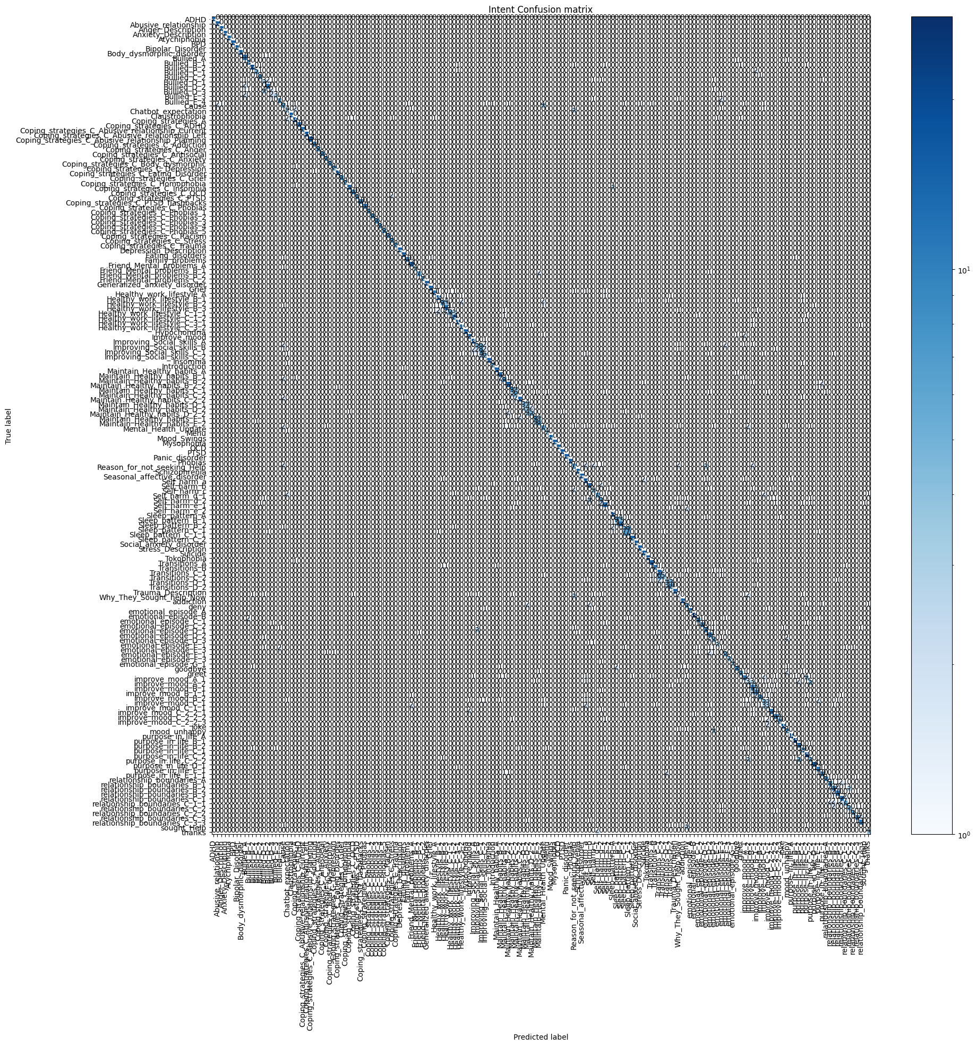

#### Figure 66 – Intent matric cross validation

### 4.2.8 – RASA Intent Histogram cross validation

The intent prediction for this cross validation shows much more results. Overall, more wrong have appeared, and possible doubled, however this is still a good consistency as the correct prediction are still extremely high. The developer is happy with the outcome of the produced results.

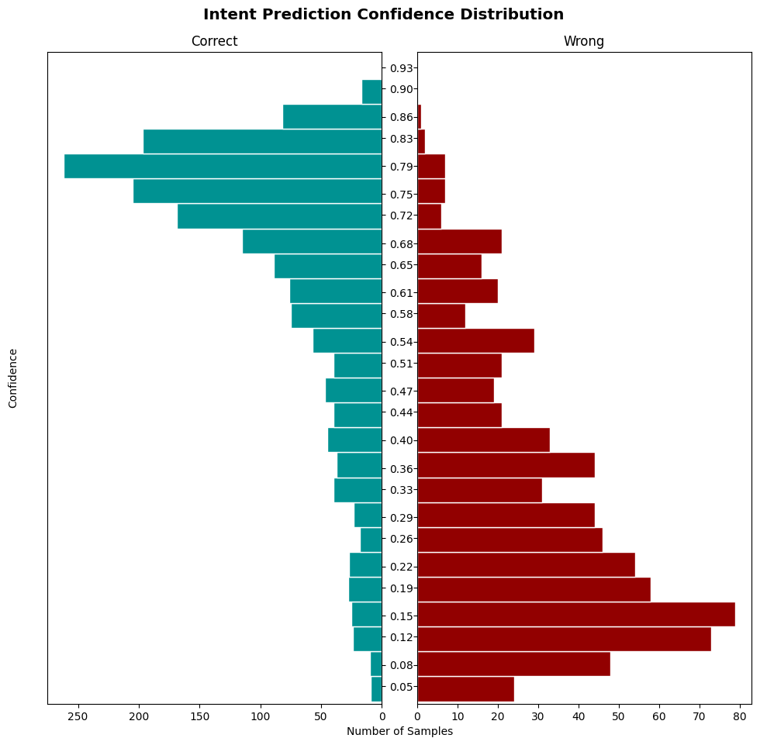

#### Figure 67 – Intent Histogram cross validation

### 4.2.9 – RASA tests Stories (Automated)

These are the automated test results for the RASA stories all stories have passed. With all have the highest precision rates possible.

|  |  |  |  |  |  |  |  |
| --- | --- | --- | --- | --- | --- | --- | --- |
| Story ID | Intent ID | Name | precision | recall | f1-score | support | Result |
| S1 | I35 | utter_emotional_episode_D_2 | 1 | 1 | 1 | 1 | PASS |
| S2 | I72 | utter_Self_harm_e_1 | 1 | 1 | 1 | 1 | PASS |
| S3 | I153 | utter_Maintain_Healthy_habits_D_2 | 1 | 1 | 1 | 1 | PASS |
| S4 | I140 | utter_Self_harm_b | 1 | 1 | 1 | 1 | PASS |
| S5 | I107 | utter_Healthy_work_lifestyle_C_1_1 | 1 | 1 | 1 | 1 | PASS |
| S6 | I27 | utter_Self_harm_e_2 | 1 | 1 | 1 | 1 | PASS |
| S7 | I190 | utter_purpose_in_life_C_2_2 | 1 | 1 | 1 | 1 | PASS |
| S8 | I52 | utter_Self_harm_d_1 | 1 | 1 | 1 | 1 | PASS |
| S9 | I30 | utter_purpose_in_life_C_2 | 1 | 1 | 1 | 1 | PASS |
| S10 | I128 | utter_relationship_boundaries_B_2 | 1 | 1 | 1 | 1 | PASS |
| S11 | I23 | utter_improve_mood_B_1_1 | 1 | 1 | 1 | 1 | PASS |
| S12 | I202 | utter_Improving_Social_skills_A | 1 | 1 | 1 | 1 | PASS |
| S13 | I94 | utter_Improving_Social_skills_B | 1 | 1 | 1 | 1 | PASS |
| S14 | I33 | utter_Bullied_C_1 | 1 | 1 | 1 | 1 | PASS |
| S15 | I57 | utter_purpose_in_life_E_1 | 1 | 1 | 1 | 1 | PASS |
| S16 | I68 | utter_Improve_mood | 1 | 1 | 1 | 1 | PASS |
| S17 | I112 | utter_Mental_Health_Update | 1 | 1 | 1 | 1 | PASS |
| S18 | I51 | utter_relationship_boundaries_A | 1 | 1 | 1 | 1 | PASS |
| S19 | I110 | utter_Healthy_work_lifestyle_C_3_2 | 1 | 1 | 1 | 1 | PASS |
| S20 | I9 | utter_Maintain_Healthy_habits_E_2 | 1 | 1 | 1 | 1 | PASS |
| S21 | I119 | utter_Transitions_C_2 | 1 | 1 | 1 | 1 | PASS |
| S22 | I93 | utter_Self_harm_d_2 | 1 | 1 | 1 | 1 | PASS |
| S23 | I16 | utter_Maintain_Healthy_habits_B_2 | 1 | 1 | 1 | 1 | PASS |
| S24 | I122 | utter_relationship_boundaries_C_1 | 1 | 1 | 1 | 1 | PASS |
| S25 | I154 | utter_Maintain_Healthy_habits_E_1 | 1 | 1 | 1 | 1 | PASS |
| S26 | I160 | utter_improve_mood_C_1 | 1 | 1 | 1 | 1 | PASS |
| S27 | I81 | utter_improve_mood_C_2_2_2 | 1 | 1 | 1 | 1 | PASS |
| S28 | I31 | utter_improve_mood_B_2 | 1 | 1 | 1 | 1 | PASS |
| S29 | I196 | utter_emotional_episode_E_1 | 1 | 1 | 1 | 1 | PASS |
| S30 | I110 | utter_Healthy_work_lifestyle_B_2 | 1 | 1 | 1 | 1 | PASS |
| S31 | I144 | utter_Bullied_D_2 | 1 | 1 | 1 | 1 | PASS |
| S32 | I59 | utter_purpose_in_life_D_1 | 1 | 1 | 1 | 1 | PASS |
| S33 | I200 | utter_Why_They_Sought_help_Now | 1 | 1 | 1 | 1 | PASS |
| S34 | I142 | utter_Transitions_A | 1 | 1 | 1 | 1 | PASS |
| S35 | I47 | utter_relationship_boundaries_C_2_2 | 1 | 1 | 1 | 1 | PASS |
| S36 | I78 | utter_purpose_in_life_E_1_1 | 1 | 1 | 1 | 1 | PASS |
| S37 | I125 | utter_Sleep_pattern_C_1 | 1 | 1 | 1 | 1 | PASS |
| S38 | I173 | utter_improve_mood_C_2_2_1 | 1 | 1 | 1 | 1 | PASS |
| S39 | I118 | utter_Healthy_work_lifestyle_B_1 | 1 | 1 | 1 | 1 | PASS |
| S40 | I101 | utter_relationship_boundaries_B_1 | 1 | 1 | 1 | 1 | PASS |
| S41 | I115 | utter_Maintain_Healthy_habits_C_2 | 1 | 1 | 1 | 1 | PASS |
| S42 | I176 | utter_Self_harm_a | 1 | 1 | 1 | 1 | PASS |
| S43 | I134 | utter_Transitions_D_2 | 1 | 1 | 1 | 1 | PASS |
| S44 | I39 | utter_Reason_for_not_seeking_Help | 1 | 1 | 1 | 1 | PASS |
| S45 | I133 | utter_Improving_Social_skills_C_1 | 1 | 1 | 1 | 1 | PASS |
| S46 | I3 | utter_relationship_boundaries_C_1_1 | 1 | 1 | 1 | 1 | PASS |
| S47 | I171 | utter_Self_harm_c | 1 | 1 | 1 | 1 | PASS |
| S48 | I148 | utter_emotional_episode_B | 1 | 1 | 1 | 1 | PASS |
| S49 | I97 | utter_improve_mood_A_1 | 1 | 1 | 1 | 1 | PASS |
| S50 | I85 | utter_Bullied_E_4 | 1 | 1 | 1 | 1 | PASS |
| S51 | I71 | utter_Sleep_pattern_A | 1 | 1 | 1 | 1 | PASS |
| S52 | I20 | utter_relationship_boundaries_B_3 | 1 | 1 | 1 | 1 | PASS |
| S53 | I114 | utter_Bullied_D_3 | 1 | 1 | 1 | 1 | PASS |
| S54 | I55 | utter_Bullied_B_2 | 1 | 1 | 1 | 1 | PASS |
| S55 | I138 | utter_emotional_episode_F_1 | 1 | 1 | 1 | 1 | PASS |
| S56 | I169 | utter_relationship_boundaries_C_3 | 1 | 1 | 1 | 1 | PASS |
| S57 | I201 | utter_Bullied_D_1 | 1 | 1 | 1 | 1 | PASS |
| S58 | I106 | utter_Bullied_B_1 | 1 | 1 | 1 | 1 | PASS |
| S59 | I15 | utter_Friend_Mental_problems_C_2 | 1 | 1 | 1 | 1 | PASS |
| S60 | I29 | utter_emotional_episode_C_2 | 1 | 1 | 1 | 1 | PASS |
| S61 | I17 | utter_purpose_in_life_B_1 | 1 | 1 | 1 | 1 | PASS |
| S62 | I74 | utter_Chatbot_expectation | 1 | 1 | 1 | 1 | PASS |
| S63 | I199 | utter_Bullied_E_3 | 1 | 1 | 1 | 1 | PASS |
| S64 | I131 | utter_Maintain_Healthy_habits_D_2_2 | 1 | 1 | 1 | 1 | PASS |
| S65 | I1 | utter_Bullied_A | 1 | 1 | 1 | 1 | PASS |
| S66 | I24 | utter_Healthy_work_lifestyle_C_3_1 | 1 | 1 | 1 | 1 | PASS |
| S67 | I76 | utter_Transitions_C_1 | 1 | 1 | 1 | 1 | PASS |
| S68 | I155 | utter_Bullied_C_2 | 1 | 1 | 1 | 1 | PASS |
| S69 | I183 | utter_emotional_episode_D_1 | 1 | 1 | 1 | 1 | PASS |
| S70 | I143 | utter_emotional_episode_E_3 | 1 | 1 | 1 | 1 | PASS |
| S71 | I28 | utter_Sleep_pattern_B_1 | 1 | 1 | 1 | 1 | PASS |
| S72 | I111 | utter_Maintain_Healthy_habits_A | 1 | 1 | 1 | 1 | PASS |
| S73 | I137 | utter_emotional_episode_G_1_1 | 1 | 1 | 1 | 1 | PASS |
| S74 | I63 | utter_emotional_episode_G_1 | 1 | 1 | 1 | 1 | PASS |
| S75 | I100 | utter_mood_unhappy | 1 | 1 | 1 | 1 | PASS |
| S76 | I103 | utter_improve_mood_B_1 | 1 | 1 | 1 | 1 | PASS |
| S77 | I77 | utter_emotional_episode_H_5 | 1 | 1 | 1 | 1 | PASS |
| S78 | I151 | utter_emotional_episode_C_1 | 1 | 1 | 1 | 1 | PASS |
| S79 | I162 | utter_emotional_episode_D_3 | 1 | 1 | 1 | 1 | PASS |
| S80 | I5 | utter_Maintain_Healthy_habits_C_1 | 1 | 1 | 1 | 1 | PASS |
| S81 | I113 | utter_Transitions_D_1 | 1 | 1 | 1 | 1 | PASS |
| S82 | I181 | utter_relationship_boundaries_C_2 | 1 | 1 | 1 | 1 | PASS |
| S83 | I166 | utter_improve_mood_C_2_2_3 | 1 | 1 | 1 | 1 | PASS |
| S84 | I126 | utter_Maintain_Healthy_habits_B_1 | 1 | 1 | 1 | 1 | PASS |
| S85 | I189 | utter_improve_mood_A_2 | 1 | 1 | 1 | 1 | PASS |
| S86 | I130 | utter_Sleep_pattern_C_1_1 | 1 | 1 | 1 | 1 | PASS |
| S87 | I14 | utter_purpose_in_life_B_2 | 1 | 1 | 1 | 1 | PASS |
| S88 | I45 | utter_improve_mood_C_1_1 | 1 | 1 | 1 | 1 | PASS |
| S89 | I121 | utter_Maintain_Healthy_habits_B_2_2 | 1 | 1 | 1 | 1 | PASS |
| S90 | I90 | utter_Friend_Mental_problems_A | 1 | 1 | 1 | 1 | PASS |
| S91 | I13 | utter_Healthy_work_lifestyle_B_3 | 1 | 1 | 1 | 1 | PASS |
| S92 | I4 | utter_Sleep_pattern_C_2 | 1 | 1 | 1 | 1 | PASS |
| S93 | I152 | utter_emotional_episode_A | 1 | 1 | 1 | 1 | PASS |
| S94 | I11 | utter_sought_Help | 1 | 1 | 1 | 1 | PASS |
| S95 | I95 | utter_Sleep_pattern_B_2 | 1 | 1 | 1 | 1 | PASS |
| S96 | I129 | utter_emotional_episode_F_3 | 1 | 1 | 1 | 1 | PASS |
| S97 | I172 | utter_Friend_Mental_problems_B_2 | 1 | 1 | 1 | 1 | PASS |
| S98 | I174 | utter_Improving_Social_skills_C_2 | 1 | 1 | 1 | 1 | PASS |
| S99 | I26 | utter_purpose_in_life_A | 1 | 1 | 1 | 1 | PASS |
| S100 | I41 | utter_purpose_in_life_C_1 | 1 | 1 | 1 | 1 | PASS |
| S101 | I61 | utter_Healthy_work_lifestyle_C_1_2 | 1 | 1 | 1 | 1 | PASS |
| S102 | I82 | utter_Friend_Mental_problems_B_1 | 1 | 1 | 1 | 1 | PASS |
| S103 | I141 | utter_Maintain_Healthy_habits_C_2_2 | 1 | 1 | 1 | 1 | PASS |
| S104 | I22 | utter_relationship_boundaries_C_3_3 | 1 | 1 | 1 | 1 | PASS |
| S105 | N/A | action_listen | 1 | 1 | 1 | 108 | PASS |
| S106 | I64 | utter_Healthy_work_lifestyle_A | 1 | 1 | 1 | 1 | PASS |
| S107 | I54 | utter_Maintain_Healthy_habits_D_1 | 1 | 1 | 1 | 1 | PASS |
| S108 | I124 | utter_Cause | 1 | 1 | 1 | 1 | PASS |
| S109 | I2 | utter_Transitions_B | 1 | 1 | 1 | 1 | PASS |

#### Table 43 – RASA test stories automated

**Prediction intent Averages**

|  |  |  |  |  |
| --- | --- | --- | --- | --- |
| **Accuracy type** | **Precision** | **Recall** | **F1-Score** | **Support** |
| macro avg | 1.0 | 1.0 | 1.0 | 216 |
| weighted avg | 1.0 | 1.0 | 1.0 | 216 |
| micro avg | 1.0 | 1.0 | 1.0 | 216 |
| conversation_accuracy | 1.0 | 82 | 0 | 82 |
| Overall Accuracy | 1.0 | | | |

#### Table 44 – RASA story prediction averages

### 4.2.10 – RASA Stories being passed

This is a screen shot of the RASA terminal producing the stories on a conversation level and correct with n exact accuracy.

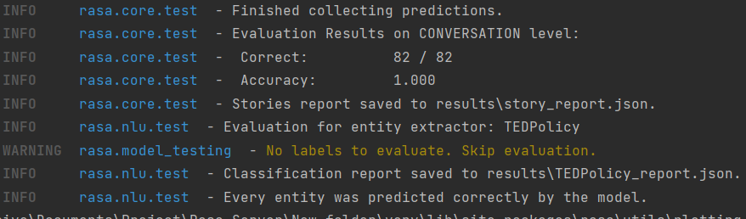

#### Figure 70 – terminal screen shot

#### Figure 68 – RASA stories being passed in the system for data validation

### 4.2.11 – RASA Story confusion matrix

The is the RASA confusion matric for the stories. As expects there is very little results from this that the table didn’t show, however the diagram will be within the folder for the source code when sent.

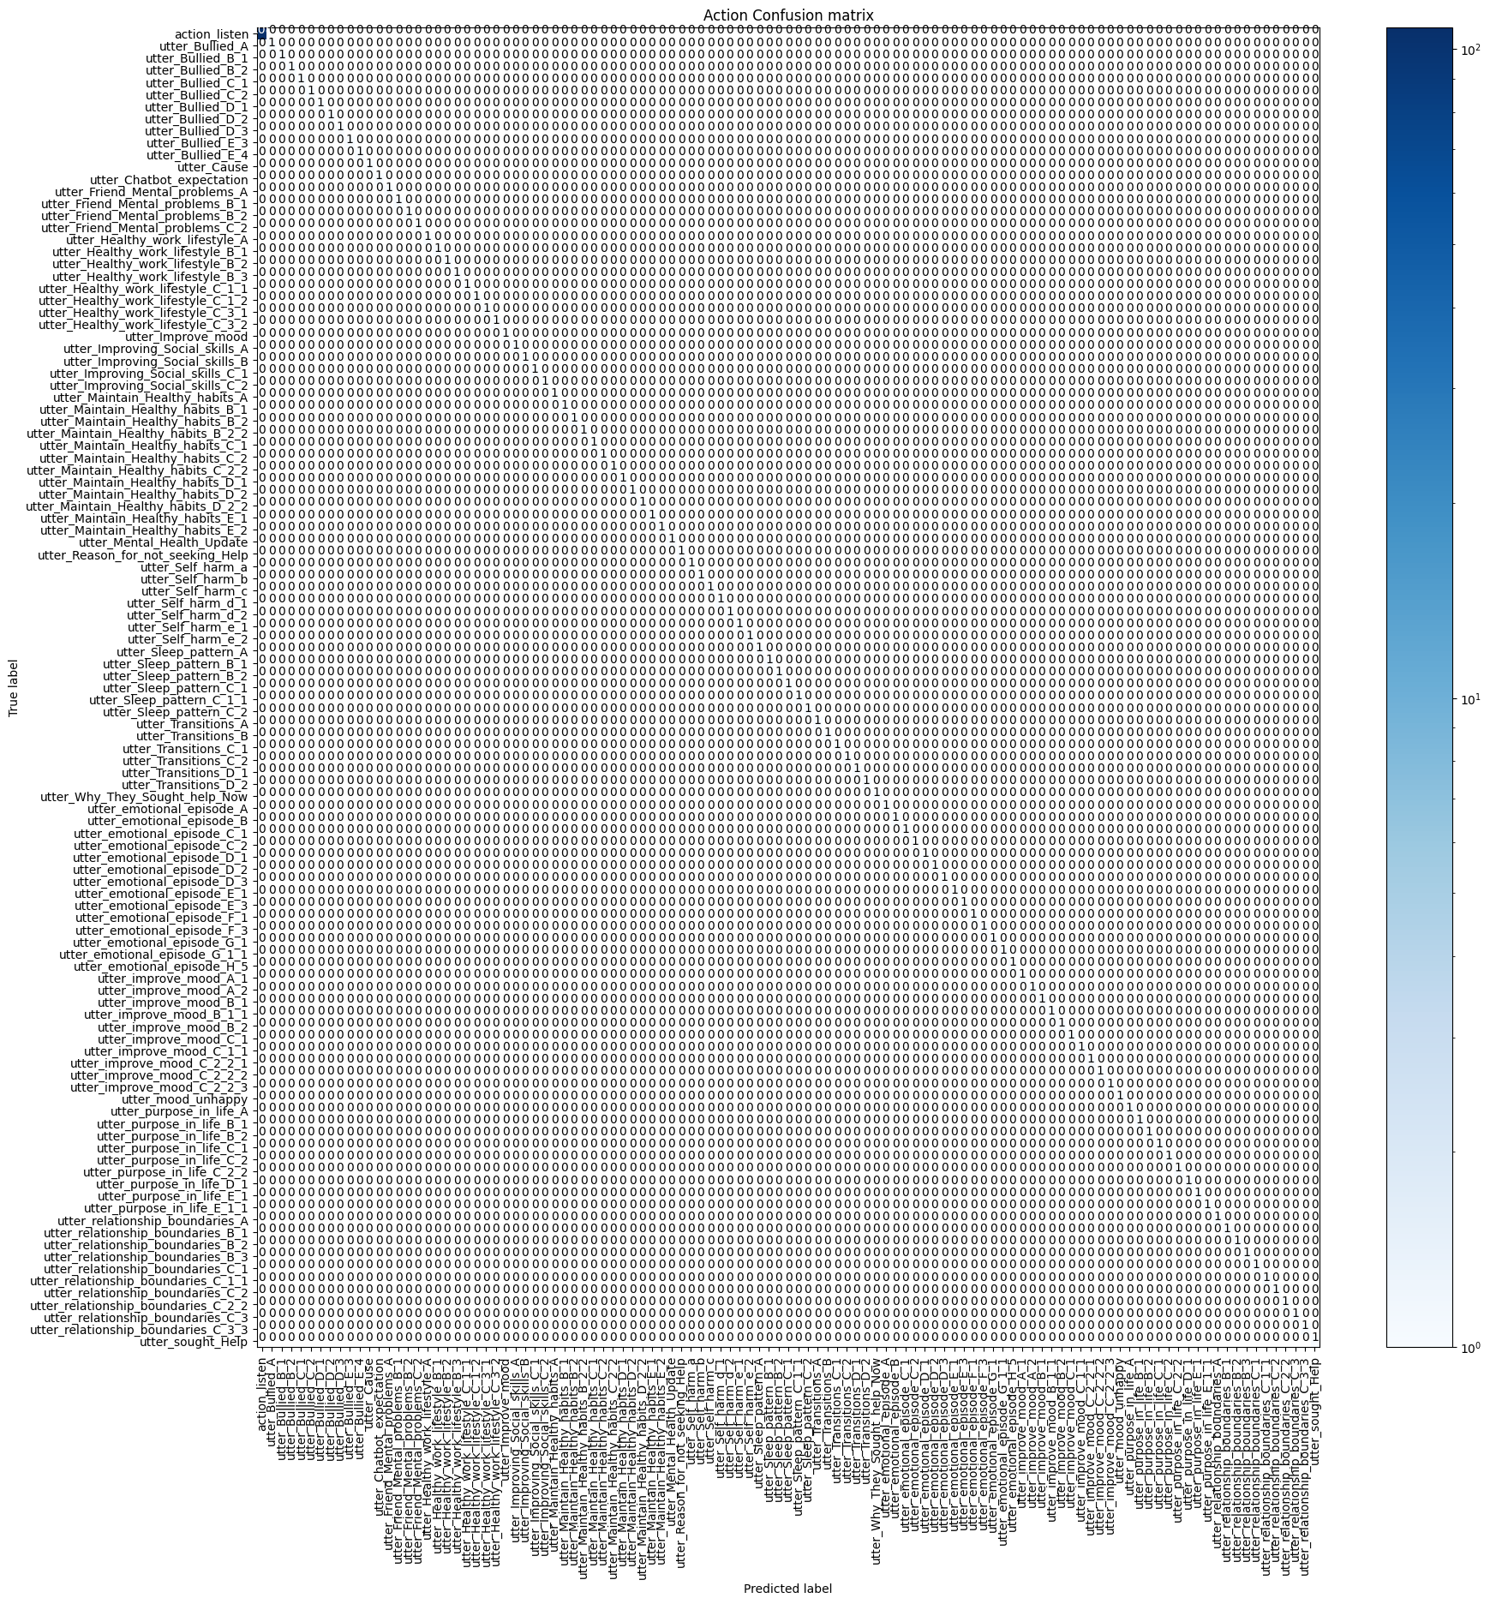

#### Figure 71 – Story confusion matrix

### 4.2.11 – RASA Story confusion matrix Cross validation

Same prediction outcome as before for the cross validation. Will be sent in folder with the rest of material.

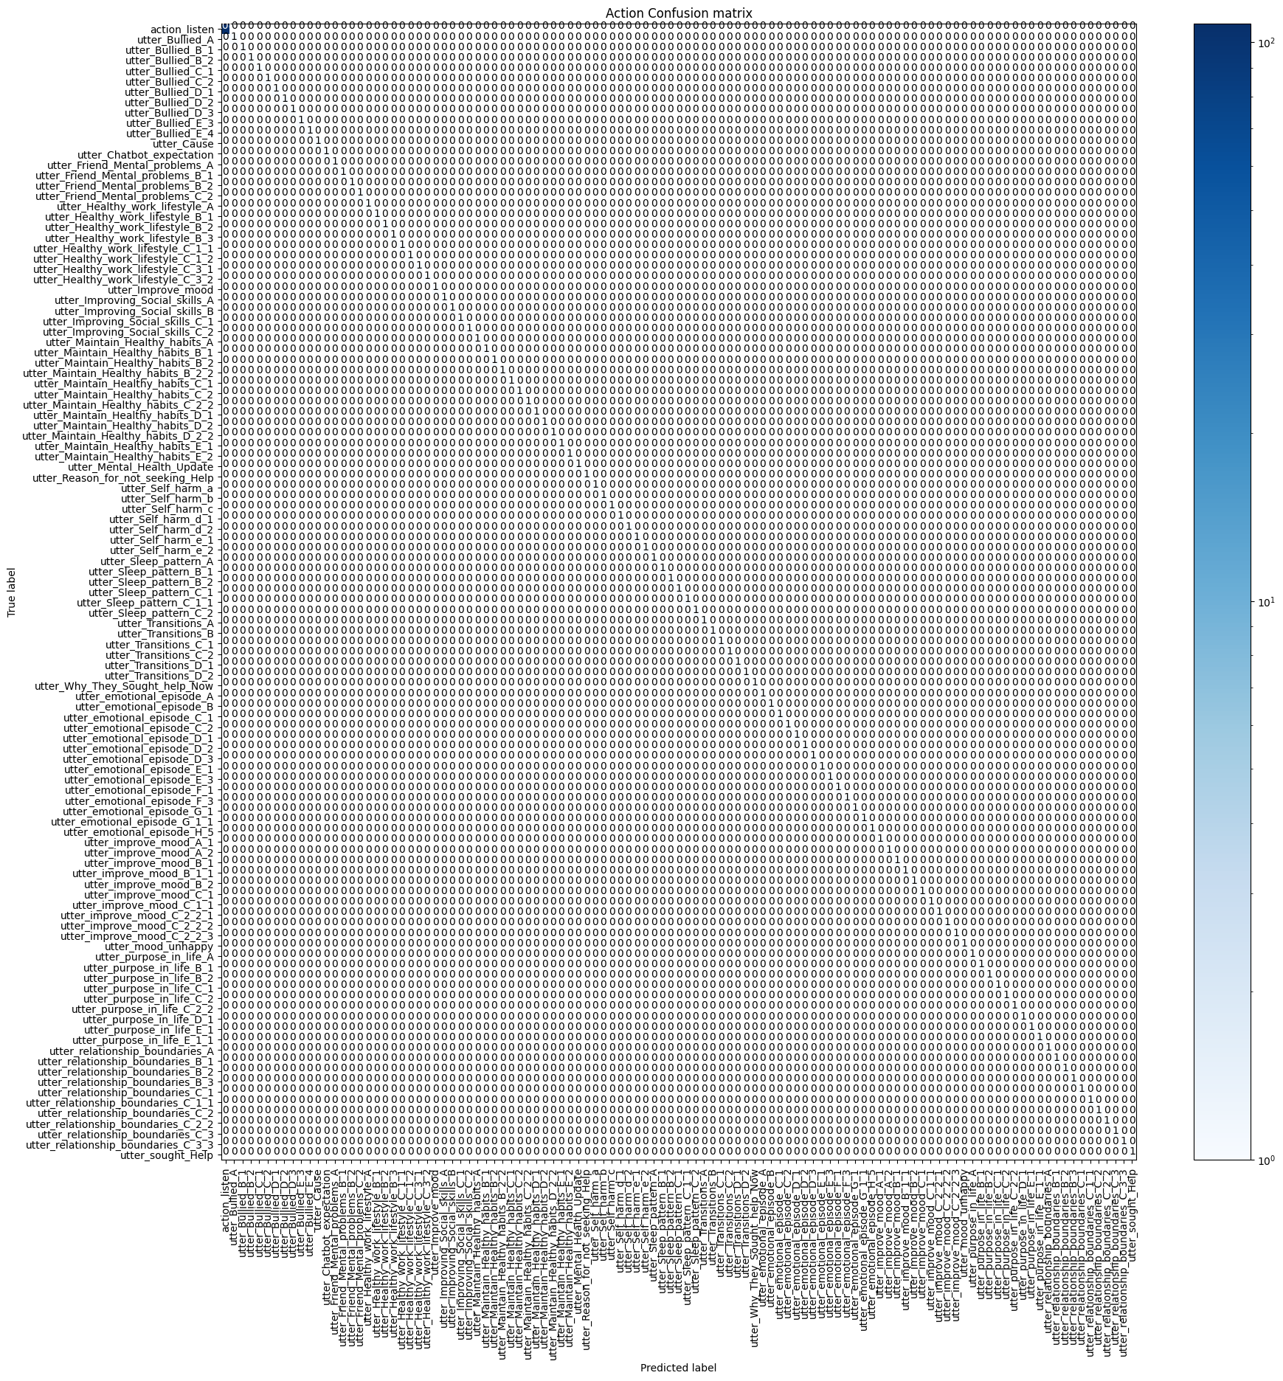

#### Figure 72 – Story confusion matrix cross validation

### 4.2.10 – RASA Rules Automated validation

Most of these were manually testing when first implemented and confirmed by the author that tests worked. However as stated before when training the model when RASA runs its RulePolciy it will compare the rules to the store to find out if there are any conflict. Overall, these results for the rules all passed.

|  |  |  |
| --- | --- | --- |
| **Type** | **Rules / Steps** | **PASS / FAIL** |
| Rule | - rule: Say goodbye anytime the user says goodbye | **PASS** |
| Steps | steps:  - intent: goodbye  - action: utter_goodbye |
|  |  |  |
| Rule | - rule: Say no problem any time the user says thanks | **PASS** |
| Steps | steps:  - intent: thanks  - action: utter_thanks |
|  |  |  |
|  | - rule: Say 'I am a bot' anytime the user challenges | **PASS** |
|  | steps:  - intent: bot_challenge  - action: utter_iamabot |
|  |  |  |
| Rule | - rule: Greet the user any time they say hello | **PASS** |
| Steps | steps:  - intent: greet  - action: utter_greet |
|  |  |  |
| Rule | - rule: When the user asks for a joke respond to cheer them up | **PASS** |
| Steps | steps:  - intent: joke  - action: utter_joke |
|  |  |  |
| Rule | - rule: When the user talks about harming themselves | **PASS** |
| Steps | steps:  - intent: Self_harm_a  - action: utter_Self_harm_a |
|  |  |  |
| Rule | - rule: Respond to based on general coping mechanism | **PASS** |
| Steps | steps:  - intent: Coping_strategies_A  - action: utter_Coping_strategies_A |
|  |  |  |
| Rule | - rule: Steps to deal with depression | **PASS** |
| Steps | steps:  - intent: Coping_strategies_C_Depression  - action: utter_Coping_strategies_C_Depression |
|  |  |  |
| Rule | - rule: How to deal with stress | **PASS** |
| Steps | steps:  - intent: Coping_strategies_C_Stress  - action: utter_Coping_strategies_C_Stress |
|  |  |  |
| Rule | - rule: How to deal with Anxiety | **PASS** |
| Steps | steps:  - intent: Coping_strategies_C_Anxiety  - action: utter_Coping_strategies_C_Anxiety |
|  |  |  |
| Rule | - rule: steps to cope with body dysmorphic | **PASS** |
| Steps | steps:  - intent: Coping_strategies_C_Body_dysmorphic  - action: utter_Coping_strategies_C_Body_dysmorphic |
|  |  |  |
| Rule | - rule: Deals with having ptsd | **PASS** |
| Steps | steps:  - intent: Coping_strategies_C_PTSD  - action: utter_Coping_strategies_C_PTSD |
|  |  |  |
| Rule | - rule: Brings up menu anytime the user needs it | **PASS** |
| Steps | steps:  - intent: Coping_strategies_C_PTSD_flashbacks  - action: utter_Coping_strategies_C_PTSD_flashbacks |
|  |  |  |
| Rule | - rule: Step for dealing with ADHA | **PASS** |
| Steps | steps:  - intent: Coping_strategies_C_ADHD  - action: utter_Coping_strategies_C_ADHD |
|  |  |  |
| Rule | - rule: Steps for dealing with OCD | **PASS** |
| Steps | steps:  - intent: Coping_strategies_C_OCD  - action: utter_Coping_strategies_C_OCD |
|  |  |  |
| Rule | - rule: Steps with dealing with Eating disorder | **PASS** |
| Steps | steps:  - intent: Coping_strategies_C_Eating_Disorder  - action: utter_Coping_strategies_C_Eating_Disorder |
|  |  |  |
| Rule | - rule: Steps with dealing with Insomnia | **PASS** |
| Steps | steps:  - intent: Coping_strategies_C_Insomnia  - action: utter_Coping_strategies_C_Insomnia |
|  |  |  |
| Rule | - rule: Steps with dealing with Anger | **PASS** |
| Steps | steps:  - intent: Coping_strategies_C_Anger  - action: utter_Coping_strategies_C_Anger |
|  |  |  |
| Rule | - rule: Steps with dealing with Grief | **PASS** |
| Steps | steps:  - intent: Coping_strategies_C_Grief  - action: utter_Coping_strategies_C_Grief |
|  |  |  |
| Rule | - rule: Steps with dealing with Antisocial | **PASS** |
| Steps | steps:  - intent: Coping_strategies_C_Antisocial  - action: utter_Coping_strategies_C_Antisocial |
|  |  |  |
| Rule | - rule: Steps with dealing with Trauma | **PASS** |
| Steps | steps:  - intent: Coping_strategies_C_Trauma  - action: utter_Coping_strategies_C_Trauma |
|  |  |  |
| Rule | - rule: Steps with dealing with a currently Abusive relationship | **PASS** |
| Steps | steps:  - intent: Coping_strategies_C_Abusive_relationship_Current  - action: utter_Coping_strategies_C_Abusive_relationship_Current |
|  |  |  |
| Rule | - rule: Steps on planning to leave an Abusive relationship | **PASS** |
| Steps | steps:  - intent: Coping_strategies_C_Abusive_relationship_Planning  - action: utter_Coping_strategies_C_Abusive_relationship_Planning |
|  |  |  |
| Rule | - rule: Steps with dealing with a Abusive relationship after leaving | **PASS** |
| Steps | steps:  - intent: Coping_strategies_C_Abusive_relationship_Left  - action: utter_Coping_strategies_C_Abusive_relationship_Left |  |
|  |  |  |
| Rule | - rule: Steps with dealing with general phobias | **PASS** |
| Steps | steps:  - intent: Coping_strategies_C_Phobias  - action: utter_Coping_strategies_C_Phobias |  |
|  |  |  |
| Rule | - rule: Steps with dealing with Claustrophobia | **PASS** |
| Steps | steps:  - intent: Coping_strategies_C_Phobias_1  - action: utter_Coping_strategies_C_Phobias_1 |  |
|  |  |  |
| Rule | - rule: Steps with dealing with Mysophobia | **PASS** |
| Steps | steps:  - intent: Coping_strategies_C_Phobias_2  - action: utter_Coping_strategies_C_Phobias_2 |  |
| Rule |  |  |
| Steps | - rule: Steps with dealing with Hypochondria | **PASS** |
|  | steps:  - intent: Coping_strategies_C_Phobias_3  - action: utter_Coping_strategies_C_Phobias_3 |  |
|  |  |  |
| Rule | - rule: Steps with dealing with Atychiphobia | **PASS** |
| Steps | steps:  - intent: Coping_strategies_C_Phobias_4  - action: utter_Coping_strategies_C_Phobias_4 |  |
|  |  |  |
| Rule | - rule: Steps with dealing with Tokophobia | **PASS** |
| Steps | steps:  - intent: Coping_strategies_C_Phobias_5  - action: utter_Coping_strategies_C_Phobias_5 |  |
|  |  |  |
| Rule | - rule: Steps with dealing with Addiction | **PASS** |
| Steps | steps:  - intent: Coping_strategies_C_Addiction  - action: utter_Coping_strategies_C_Addiction |
|  |  |  |
| Rule | - rule: Steps with dealing with Racism | **PASS** |
| Steps | steps:  - intent: Coping_strategies_C_Racism  - action: utter_Coping_strategies_C_Racism |
|  |  |  |
| Rule | - rule: Steps with dealing with Homophobia | **PASS** |
| Steps | steps:  - intent: Coping_strategies_C_Homophobia  - action: utter_Coping_strategies_C_Homophobia |
|  |  |  |
| Rule | - rule: Reference for Depression | **PASS** |
| Steps | steps:  - intent: Coping_strategies_C_Depression_REF  - action: utter_Coping_strategies_C_Depression_REF |
|  |  |  |
| Rule | - rule: user denies | **PASS** |
| Steps | steps:  - intent: deny  - action: utter_deny |
|  |  |  |
| Rule | - rule: Reference for Stress | **PASS** |
| Steps | steps:  - intent: Coping_strategies_C_Stress_REF  - action: utter_Coping_strategies_C_Stress_REF |
|  |  |  |
| Rule | - rule: Reference for Anxiety | **PASS** |
| Steps | steps:  - intent: Coping_strategies_C_Anxiety_REF  - action: utter_Coping_strategies_C_Anxiety_REF |
|  |  |  |
| Rule | - rule: Reference for Body dysmorphic | **PASS** |
| Steps | steps:  - intent: Coping_strategies_C_Body_dysmorphic_REF  - action: utter_Coping_strategies_C_Body_dysmorphic_REF |
|  |  |  |
| Rule | - rule: Reference for PTSD | **PASS** |
| Steps | steps:  - intent: Coping_strategies_C_PTSD_REF  - action: utter_Coping_strategies_C_PTSD_REF |
|  |  |  |
| Rule | - rule: Reference for PTSD flashbacks | **PASS** |
| Steps | steps:  - intent: Coping_strategies_C_PTSD_flashbacks_REF  - action: utter_Coping_strategies_C_PTSD_flashbacks_REF |
|  |  |  |
| Rule | - rule: Reference for ADHD | **PASS** |
| Steps | steps:  - intent: Coping_strategies_C_ADHD_REF  - action: utter_Coping_strategies_C_ADHD_REF |
|  |  |  |
| Rule | - rule: Reference for OCD | **PASS** |
| Steps | steps:  - intent: Coping_strategies_C_OCD_REF  - action: utter_Coping_strategies_C_OCD_REF |
|  |  |  |
| Rule | - rule: Reference for Eating Disorder | **PASS** |
| Steps | steps:  - intent: Coping_strategies_C_Eating_Disorder_REF  - action: utter_Coping_strategies_C_Eating_Disorder_REF |
| Rule |  |  |
| Steps | - rule: Reference for Insomnia | **PASS** |
|  | steps:  - intent: Coping_strategies_C_Insomnia_REF  - action: utter_Coping_strategies_C_Insomnia_REF |
|  |  |  |
| Rule | - rule: Reference for Anger | **PASS** |
| Steps | steps:  - intent: Coping_strategies_C_Anger_REF  - action: utter_Coping_strategies_C_Anger_REF |
|  |  |  |
| Rule | - rule: Reference for Grief | **PASS** |
| Steps | steps:  - intent: Coping_strategies_C_Grief_REF  - action: utter_Coping_strategies_C_Grief_REF |
|  |  |  |
| Rule | - rule: Reference for Antisocial | **PASS** |
| Steps | steps:  - intent: Coping_strategies_C_Antisocial_REF  - action: utter_Coping_strategies_C_Antisocial_REF |
|  |  |  |
| Rule | - rule: Reference for Trauma | **PASS** |
| Steps | steps:  - intent: Coping_strategies_C_Trauma_REF  - action: utter_Coping_strategies_C_Trauma_REF |
|  |  |  |
| Rule | - rule: Reference for Abusive relationship Current | **PASS** |
| Steps | steps:  - intent: Coping_strategies_C_Abusive_relationship_Current_REF  - action: utter_Coping_strategies_C_Abusive_relationship_Current_REF |
|  |  |  |
| Rule | - rule: Reference for Abusive relationship Planning | **PASS** |
| Steps | steps:  - intent: Coping_strategies_C_Abusive_relationship_Planning_REF  - action: utter_Coping_strategies_C_Abusive_relationship_Planning_REF |
|  |  |  |
| Rule | - rule: Reference for Abusive relationship Left | **PASS** |
| Steps | steps:  - intent: Coping_strategies_C_Abusive_relationship_Left_REF  - action: utter_Coping_strategies_C_Abusive_relationship_Left_REF |
|  |  |  |
| Rule | - rule: Reference for General phobias | **PASS** |
| Steps | steps:  - intent: Coping_strategies_C_Phobias_REF  - action: utter_Coping_strategies_C_Phobias_REF |
|  |  |  |
| Rule | - rule: Reference for claustrophobia | **PASS** |
| Steps | steps:  - intent: Coping_strategies_C_Phobias_1_REF  - action: utter_Coping_strategies_C_Phobias_1_REF |
|  |  |  |
| Rule | - rule: Reference for Mysophobia | **PASS** |
| Steps | steps:  - intent: Coping_strategies_C_Phobias_2_REF  - action: utter_Coping_strategies_C_Phobias_2_REF |
|  |  |  |
| Rule | - rule: Reference for Hypochondria | **PASS** |
| Steps | steps:  - intent: Coping_strategies_C_Phobias_3_REF  - action: utter_Coping_strategies_C_Phobias_3_REF |
|  |  |  |
| Rule | - rule: Reference for Atychiphobia | **PASS** |
| Steps | steps:  - intent: Coping_strategies_C_Phobias_4_REF  - action: utter_Coping_strategies_C_Phobias_4_REF |
|  |  |  |
| Rule | - rule: Reference for Tokophobia | **PASS** |
| Steps | steps:  - intent: Coping_strategies_C_Phobias_5_REF  - action: utter_Coping_strategies_C_Phobias_5_REF |
| Rule |  |  |
| Steps | - rule: Reference for Addiction | **PASS** |
|  | steps:  - intent: Coping_strategies_C_Addiction_REF  - action: utter_Coping_strategies_C_Addiction_REF |
|  |  |  |
| Rule | - rule: Reference for Racism | **PASS** |
| Steps | steps:  - intent: Coping_strategies_C_Racism_REF  - action: utter_Coping_strategies_C_Racism_REF |
|  |  |  |
| Rule | - rule: Reference for Homophobia | **PASS** |
| Steps | steps:  - intent: Coping_strategies_C_Homophobia_REF  - action: utter_Coping_strategies_C_Homophobia_REF |
|  |  |  |
| Rule | - rule: Open a menu for list of phobia coping guides | **PASS** |
| Steps | steps:  - intent: Coping_strategies_C_Phobias_Menu  - action: utter_Coping_strategies_C_Phobias_Menu |
|  |  |  |
| Rule | - rule: Brings up menu anytime the user needs it | **PASS** |
| Steps | steps:  - intent: Coping_strategies_B  - action: utter_Coping_strategies_B |
|  |  |  |
| Rule | - rule: Brings the overall menu | **PASS** |
| Steps | steps:  - intent: Menu  - action: utter_Menu |
|  |  |  |
| Rule | - rule: Bring it the command to show resources | **PASS** |
| Steps | steps:  - intent: Resource  - action: utter_Resource |
|  |  |  |
| Rule | - rule: Bot introduces itself | **PASS** |
| Steps | steps:  - intent: Introduction  - action: utter_Introduction |
|  |  |  |
| Rule | - rule: Describes Depression | **PASS** |
| Steps | steps:  - intent: Depression_Description  - action: utter_Depression_Description |
|  |  |  |
| Rule | - rule: Describes Anxiety | **PASS** |
| Steps | steps:  - intent: Anxiety_Description  - action: utter_Anxiety_Description |
|  |  |  |
| Rule | - rule: Describes Social_anxiety_disorder | **PASS** |
| Steps | steps:  - intent: Social_anxiety_disorder  - action: utter_Social_anxiety_disorder |
|  |  |  |
| Rule | - rule: Describes Mood_Swings | **PASS** |
| Steps | steps:  - intent: Mood_Swings  - action: utter_Mood_Swings |
|  |  |  |
| Rule | - rule: Describes Body_dysmorphic_disorder | **PASS** |
| Steps | steps:  - intent: Body_dysmorphic_disorder  - action: utter_Body_dysmorphic_disorder |
|  |  |  |
| Rule | - rule: Describes PTSD | **PASS** |
| Steps | steps:  - intent: PTSD  - action: utter_PTSD |
|  |  |  |
| Rule | - rule: Describes OCD | **PASS** |
| Steps | steps:  - intent: OCD  - action: utter_OCD |
|  |  |  |
| Rule | - rule: Describes ADHD | **PASS** |
| Steps | steps:  - intent: ADHD  - action: utter_ADHD |
|  |  |  |
| Rule | - rule: Describes BPD | **PASS** |
| Steps | steps:  - intent: BPD  - action: utter_BPD |
|  |  |  |
| Rule | - rule: Describes Eating disorders | **PASS** |
| Steps | steps:  - intent: Eating_disorders  - action: utter_Eating_disorders |
|  |  |  |
| Rule | - rule: Describes addiction | **PASS** |
| Steps | steps:  - intent: addiction  - action: utter_addiction |
|  |  |  |
| Rule | - rule: Describes Generalized anxiety disorder | **PASS** |
| Steps | steps:  - intent: Generalized_anxiety_disorder  - action: utter_Generalized_anxiety_disorder |
|  |  |  |
| Rule | - rule: Describes Panic disorder | **PASS** |
| Steps | steps:  - intent: Panic_disorder  - action: utter_Panic_disorder |
|  |  |  |
| Rule | - rule: Describes Seasonal affective disorder | **PASS** |
| Steps | steps:  - intent: Seasonal_affective_disorder  - action: utter_Seasonal_affective_disorder |
|  |  |  |
| Rule | - rule: Describes Abusive relationship | **PASS** |
| Steps | steps:  - intent: Abusive_relationship  - action: utter_Abusive_relationship |
|  |  |  |
| Rule | - rule: Describes Family problems | **PASS** |
| Steps | steps:  - intent: Family_problems  - action: utter_Family_problems |
|  |  |  |
| Rule | - rule: Describes Stress | **PASS** |
| Steps | steps:  - intent: Stress_Description  - action: utter_Stress_Description |
|  |  |  |
| Rule | - rule: Describes Grief | **PASS** |
| Steps | steps:  - intent: Grief  - action: utter_Grief |
|  |  |  |
| Rule | - rule: Describes Insomnia | **PASS** |
| Steps | steps:  - intent: Insomnia  - action: utter_Insomnia |
|  |  |  |
| Rule | - rule: Describes Phobias | **PASS** |
| Steps | steps:  - intent: Phobias  - action: utter_Phobias |
|  |  |  |
| Rule | - rule: Describes Trauma | **PASS** |
| Steps | steps:  - intent: Trauma_Description  - action: utter_Trauma_Description |
|  |  |  |
| Rule | - rule: Describes Tokophobia | **PASS** |
| Steps | steps:  - intent: Tokophobia  - action: utter_Tokophobia |
|  |  |  |
| Rule | - rule: Describes Claustrophobia | **PASS** |
| Steps | steps:  - intent: Claustrophobia  - action: utter_Claustrophobia |
|  |  |  |
| Rule | - rule: Describes Mysophobia | **PASS** |
| Steps | steps:  - intent: Mysophobia  - action: utter_Mysophobia |
|  |  |  |
| Rule | - rule: Describes Hypochondria | **PASS** |
| Steps | steps:  - intent: Hypochondria  - action: utter_Hypochondria |
|  |  |  |
| Rule | - rule: Describes Atychiphobia | **PASS** |
| Steps | steps:  - intent: Atychiphobia  - action: utter_Atychiphobia |
|  |  |  |
| Rule | - rule: Describes Bipolar_Disorder | **PASS** |
| Steps | steps:  - intent: Bipolar_Disorder  - action: utter_Bipolar_Disorder |
|  |  |  |
| Rule | - rule: Describes Schizophrenia | **PASS** |
| Steps | steps:  - intent: Schizophrenia  - action: utter_Schizophrenia |
|  |  |  |
| Rule | - rule: Describes Anger | **PASS** |
| Steps | steps:  - intent: Anger_Description  - action: utter_Anger_Description |
|  |  |  |
| Rule | - rule: Describes Suicide | **PASS** |
| Steps | steps:  - intent: Suicide  - action: utter_Suicide |

#### Table 45 – Rules testing tale

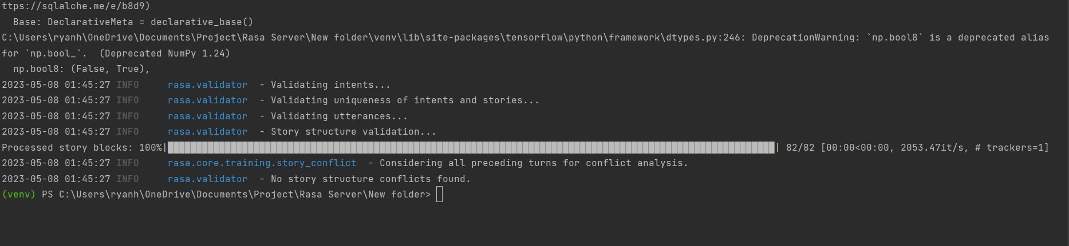

#### Figure 73 – RASA rules being automatically passed

### 4.2.10 – Chatbot questionnaire

1. For each question, assign a score from 1 to 5 based on the level of agreements from the statement

|  |  |  |  |  |  |  |  |  |  |  |  |  |  |  |  |  |
| --- | --- | --- | --- | --- | --- | --- | --- | --- | --- | --- | --- | --- | --- | --- | --- | --- |
| Question | 1 | 2 | 3 | 4 | 5 | 6 | 7 | 8 | 9 | 10 | 11 | 12 | 13 | 14 | 15 | 16 |
| Score | 4 | 3 | 5 | 1 | 4 | 1 | 4 | 3 | 3 | 2 | 4 | 2 | 3 | 3 | 3 | 2 |

1. Calculate the odd numbers and positive numbers.

Odd = 4 + 5 + 4 + 4 + 3 + 4 + 3 + 3 = 30

Even = 3 + 1 + 1 + 3 + 2 + 2 + 3 + 2 = 17

1. Subtract 8 form the Odd number.

Positive = 30 – 8 = 22

1. Sub tracts the Even overall from 40

Negative 40 – 17 = 23

1. Add the new Odd and Even.

Overall = 22 + 23 = 45

1. Convert the score from step five to find out the score out of 100.

New Score = (45 / 64 )*100 = 70.3125

The end score for the chatbot validation is 70%. The developer feels like this is an accurate representation of what the end chatbot is. It isn’t a 100% perfect but is does have very extensive knowledge base that it can work off of to help another user. It also supplies them with information and guides the user when they need to find resources anytime it gets a chance. The chatbot keeps a consistent positive personality through the whole conversation line not saying anything negative to the user. Below is the survey that the developer did after thorough testing and evaluation.

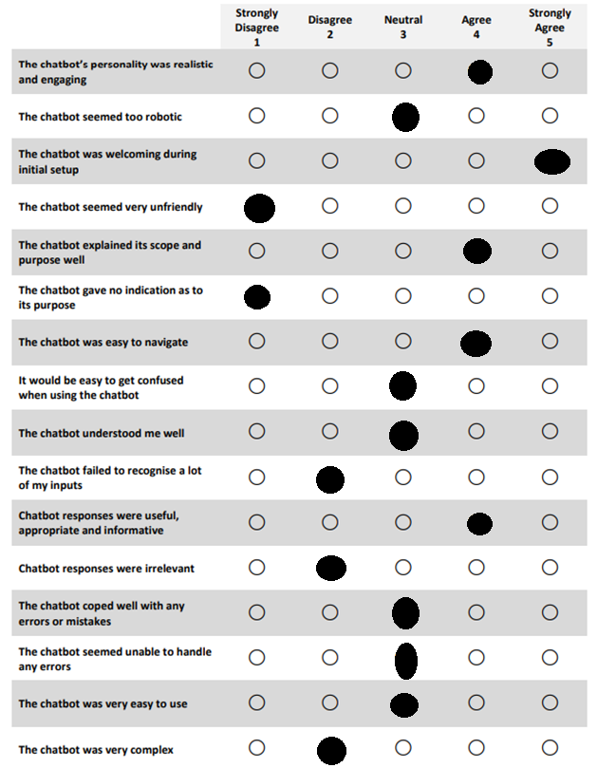

#### Figure 74 – Chatbot questionnaire filled in [7] [8]

### 4.2.11 – Testing Firebase API

This is test for the firebase Realtime dataset that can be accessed from API automated testing software like Postman. This was used to see if the application itself can connect.

|  |  |  |  |  |  |  |
| --- | --- | --- | --- | --- | --- | --- |
| Test ID | Endpoint | Request Type | Functionality | Test Parameters / Body | Status code | Outcome |
| A1 | API/buddy-ai/helpline/a | Get | To get the heading of the help line on however many there are | The name of the heading, so just ‘A’ with the limit or max set on how many to pull. | 200 | PASS |
| A2 | API/buddy-ai/helpline/b | Get | To get the description of the helpline on however many there are | The name of the heading, so just ‘B’ with the limit or max set on how many to pull. | 200 | PASS |
| A3 | API/buddy-ai/helpline/c | Get | To get the contact information of the helpline on however many there are | The name of the heading, so just ‘C’ with the limit or max set on how many to pull. | 200 | PASS |
| A4 | API/buddy-ai/userID  /conversation/ user message | Get | To pull the chat history for messages | Will need the user ID as well as correct path. | 200 | PASS |
| A5 | API/buddy-ai/userID  /conversation/ response | Get | To pull the chat history for response | Will need the user ID as well as correct path. | 200 | PASS |
| A6 | API/buddy-ai/userID  /conversation/ timestamp | Get | To pull the chat history for timestamp | Will need the user ID as well as correct path. | 200 | PASS |
| A7 | API/buddy-ai/userID  /conversation | Post | Post message history of user message response and timestamp | Send UserID  Body {  Message:  Response:  Timestamp} | 200 | PASS |
| A8 | API/buddy-ai/userID  / | Delete | Deletes the users chat logs | Send the user ID | 200 | PASS |

#### Table 46 – API testing

## 4.3 – Evidence artifact that demonstrates system verification (300 words each)

Makes sure that the correct data is appended when being sent to the firebase Realtime database. As discussed before the firebase Realtime database can better take values the way they are indexed, this is why the appended data is added to the conversation as such. A layer of security is added as well as the user will need to have a user ID to even access or add to the Realtime database for that section.

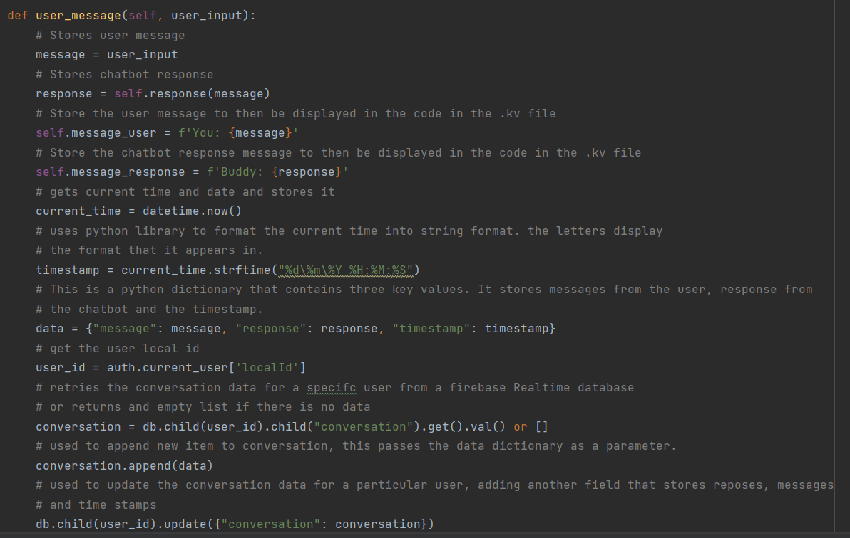

#### Figure 75 – Storing chatbot messages

## 4.4 – Confirmation statement (100 words)

All essential core requirements have been added to the application, the chatbot is work to an above acceptable degree with its arcuately producing information relatively fast. The requirements of F16 and F24 however, where not added due to time constraints so these tests were omitted from the overall tests that took place. The tests that take place show that everything that been added to the mobile application and chatbot are fully functional and can be used to a high degree.

# Chapter 5 – System Validation

## 5.1 – Reflection on the system validation plan

AP1 plan for system validation was stayed the same the whole way through with most of the validation coming at the end of a sprint or being added at the end of the sprint. It all followed the same flow of a standard test, a test case, continuous testing, and automated testing as seen from above. All types of types were used throughout the creation process, manual, continuous for the whole system after every major update, automation for the chatbot end of it and API validation.

Validation test plan below has been tested throughout the application creation process at the end of each increment. The validation plan set also helped the developer to stick to the IID methodology as there were no components that interact negatively towards each other. Validation testing was only done by the user as they had no on else to test the validation on. It is possible that potential validation in turn was missed due to the developer doing it themselves and knowing the system, so the developer crated this plan to validate and record every piece of validation they think needed added or added because it was done. Overall, the developer is happy with what was produced by the from the validation plan and that no more validation could be done on the system minus a few pop up to help guide the user when they’ve completed and action that they might not be aware of.

## 5.2 – System validation results

The system validation results only have one error. This error was expected by the developer as they knew what deals with this error when it occurs. The backend of the application is what handle the errors coming through from the chatbot. Although this validation process works effectively the developer feels like this may be bad practice and dealing with the issues using RASA fallbacks may have been the best solution. This way no error gets sent back to the application. This is definitely a possible change if the developer had more time.

|  |  |  |  |  |  |
| --- | --- | --- | --- | --- | --- |
| **Test ID** | **Test description** | **Expected outcome** | **Actual outcome** | **Comments** | **Pass / Fail** |
| V1 | Sign up validates when user has entered a email that has been validated from auth | Sends response back from firebase | As expected | N/A | **PASS** |
| V2 | Sign up validates that both passwords are the same | Sends response to firebase | As expected | N/A | **PASS** |
| V3 | Sign up validates when no data has been entered | Bring up pop up error | As expected | N/A | **PASS** |
| V4 | Forgot password validates that the email is on the system | Sends response to firebase | As expected | N/A | **PASS** |
| V5 | Forgot password validates when the email sends | Get the email | As expected | N/A | **PASS** |
| V6 | Login validates that the account is on the system | Sends login detail to firebase | As expected | N/A | **PASS** |
| V7 | Login validates when the user has entered the wrong email | Bring up pop up error | As expected | N/A | **PASS** |
| V8 | Login validates when the user enters the wrong password | Bring up pop up error | As expected | N/A | **PASS** |
| V9 | Chatbot response is validated if the chatbot produces no response to the user. | Bring up pop up error this is from the backend not RASAs end | As expected | N/A | **PASS** |
| V10 | Chatbot validates if the input is correct | Produces response | As expected | N/A | **PASS** |
| V11 | Settings forgot password disappears after one click, this is to avoid spam clicking. | It turns a light shade of grey and can’t be clicked | As expected | N/A | **PASS** |
| V12 | Settings forgot password appears again when the user logs back into the application | It originates back to its normal forms; this stops spam clicking | As expected | N/A | **PASS** |
| V13 | Show history validates the user has a chat history | Sends UID to database to compare if there Is a ID the same as that | As expected | N/A | **PASS** |
| V14 | Clear history produces pop up when clicked | Bring up pop up prompt | As expected | N/A | **PASS** |
| V15 | Show history produces a popup | Bring up pop up prompt | As expected | N/A | **PASS** |
| V16 | Clear chat logs from database validates the user username and password | Sends detail to auth to confirm the user can go ahead through the try catch | As expected | N/A | **PASS** |
| V17 | Clear chatlogs validates the user has chat logs on the system | Checks database but removes nothing | As expected | N/A | **PASS** |
| V18 | Clear chat logs validate the user UID matches the UID on the database | After logging in through the popup pulls UID from AUTH then compares to database. | As expected | N/A | **PASS** |
| V19 | When storing user message, response and timestamp the system validates the user UID to the one on the database | Checks the users UID then if the user doesn’t it adds one, and if it does it adds to it. | As expected | N/A | **PASS** |
| V20 | Delete user validates login and password | Sends response to auth, get response back to go ahead | As expected | N/A | **PASS** |
| V21 | Delete user validates the user is on the system | Checks auth to see if that user exists | As expected | N/A | **PASS** |
| V22 | Chatbot validates a response that is on the NLU | Find the response from the training data | As expected | N/A | **PASS** |
| V23 | Chatbot Validates a response that’s not from the NLU | No fall back on RASA end so it will produce null value error | As expected | This was expected to fail as the fallback occurs from the mobile backend. | **FAIL** |
| V24 | The user can’t input text or send input if they haven’t clicked lets chat button | User can’t interact with those elements | As expected | N/A | **PASS** |
| V25 | Chatbot screen reverts to normal when the user logs out | Chabot screen should get back to let’s chat button state | As expected | N/A | **PASS** |
| V26 | Show history doesn’t appear when lets chat hasn’t been clicked. | It should only show let’s chat | As expected | N/A | **PASS** |
| V27 | Home screen appears when the user logs in | Data is taken from the database and shown | As expected | N/A | **PASS** |
| V28 | Sign out clears the current user from being logged in | For test purposes a print result was put below the logout to see if it detected a user, it shouldn’t | As expected | N/A | **PASS** |
| V29 | Chatbot screen resets when deleting user | Its does reset | As expected | N/A | **PASS** |
| V30 | Chatbot screen resets when clearing chatlog | It does reset | As expected | N/A | **PASS** |

#### Table 47 – Validation results

## 5.3 – Consideration for future work

### 5.3.1 – RASA Forms

RASA forms would have added another level to what the application already has. It would of aloud the chatbot to successfully interact with the in a meaningful way were, if they had depression and work pile on it could remember that and produce and even more accurate response to the user. To push it even further the developer could of user the RASA action file to interact with the backend of the application so it could pull the users details from the profile. This way the chatbot has access and already know the information about the user. However, this may come across to the user as If the chatbot is stealing their data using a mistrust, instead the chatbot would tailor what it says based on their condition but never mention it. This would also allow the chatbot feel more like a real person as it could remember stuff that the user has done and reference that too them.

### 5.3.2 – Chatbot sending Images and link

This was one of the features that the developer tried to add to the application however it proved to be one of the many issues the developer had with kivy. Where the methods needed to add a simple function normally needed many additional functions just to make it work. Links could have been used instead of ref names allowing the user to navigate to other information more quickly.

### 5.3.3 – RASA Fallbacks

RASA fallbacks would have been useful to use to catch any errors that get produced from the RASA end. This would have meant the developer wouldn’t have had to add the catch to their backend. This would have made for better validation than the method that was chosen, as wasn’t fully thought of until the developer already have the backend set up to solve the issue. The results from the back end are useful as it can tell the user where to go and what to do but this could have just been added to RASA

### 5.3.4 – UI Overall

Overall, the UI isn’t great. It isn’t horrible and the user can clearly see and navigate throughout the system. However, it is still clearly bland. Especially for the homepage and chatbot screen perspective. As discussed before the chatbot screen was meant to have chat bubbles to contain the text to work like Facebook messenger. But instead, the actual output is more like a chat room screen, which is not bad but does not look great compared to what I could have been. The home page looks especially bland and should attract the attention more to the information, instead of just being plain text, however this couldn’t be added due to some limitations to kivy.

### 5.3.5 – Chat suggestions

Chat suggestions were a feature that was going to be added but didn’t due to time constraints, and lack of knowledge on how to do it. Chat suggestion would have been an excellent way to guide the user through conversations. This would have let users make less mistake or for the chatbot to misunderstand them causing for better conversation flow. This would have made the application feel a bit more menu based when the user was talking but would have overall made the chatbot section of the application a lot more accommodating.

### 5.3.6 – Search for message through timestamp

This was a requirement that was added at the start of the AP2 documentation but was no implemented. This just would have made the overall navigation of the messages a lot easier to view. It would have let the user type in the correct date or a range of dates that they could have possibly of had a conversation from. It then would have let them go into more details by letting them by choosing the possible hour or even minute of the conversation, this can be useful when trying to get past advice that they may not know how to navigate through from the chatbot. This was going to go even further by letting the chatbot interact with the firebase real time database so that it could then find the chat logs for the user. This would have been great for navigation of the application.

### 5.3.7. – User profile page

This was a requirement that was taken away in AP2 due to the importance of other requirements. If it was added it wouldn’t affect the application system at all or even interacted with anything that’s why this was removed, however as seen from other future improvements the chatbot would have been able to utilize this so that it could talk to the user in a particular way depending on mental health of the user. This can allow for the chatbot to be careful on some users who may have serious mental health problems. This was also planned to affect the homepage as it would tailor the recommendation based on what the user was suffering with.

## Chapter 6 – Conclusion and Reflection

## 6.1 – Overall Critical Appraisal (500 words)

Overall, the author is happy with the work that has been produced. Originally, they doubted their skills when it came to developing the project as he felt they might have not been up to power. What the author set out to do was to develop an application that could “help people struggling with mental health who have no one to talk to or are afraid to talk to other loved ones about it. The main aim is to help everyone”. The author feels like they have achieved exactly that and more. They also managed to complete every must have in terms of requirements with only missing out two requirements that don’t overall negatively impact the system. Countless validation was added to any function that needed it, making most functions added to the system work to a high level. The Author enjoyed trying to learn new and technical aspects of not just the programming side but the mental health side of things to, like how to interact with someone, what’s best to say and how it should be said. The application allowed the developer to learn and use so many different, like Auth, real time databases, further API development, Web wrapper, AI, machine learning, kivy, neural networks and management skills. Services like firebase allowed the author to test aspect like scalability as it could host up to 100 users for free and even grow if the number of users using the application goes up.

The requirements for the overall system have been met besides **F16** and **F24**. **F24** was a new feature added in in AP2 that the developer thought would have been nice to add if they got the time to do it however unfortunately the increment ended before the user could. The time function would have overall improved he navigational purposes of the feature was allowing the user to find chat logs much quicker than it is now, this is one of the downsides to the application. F16 was not added due to its technical demands, as the author had trouble with certain elements of python kivy that made it hard to implement such functions. The author couldn’t find any method to produce that method through python kivy and had to ditch the requirement due to it taking up so much time. Another downside to the application as stated previous before was the UI. The developer did not like the final product of the UI as they felt like it was very bland and basic, yes, the user could navigate through the application easy, and they could also see all data without it being obscured but it doesn’t look good. The homepage is just chunks of text taken from the data base with no image or another method to attract the user’s attention. The chatbot UIs is where the authors biggest compliant come in as it too basic, bland and has too big of gaps.

Overall, the author feels like they have produced the best possible application they could.

## 6.2 – Reflection on the project plan (500 words)

The author thinks the project plan went well over the course of the project after the changes made at the start of AP2. This doesn’t mean that the plan in AP1 was bad just that the developer used what they learned and applied it to the plan to give a better outlook of what they think they could achieve from the project over the course of the coming months. The other factor that changed the plan was from the feedback the author reaction from AP1. The feedback confirmed to the author that the AP1 produced was lacking, which the author thought would have been the chase, which caused the author too to look at the plan differently and make those changes. The feedback also introduced other methods to help improve the plan with chatbot development life cycle and guidelines. These were used extensively throughout the chatbot development, to cover for the author lack of knowledge, this in turn made the author feel more confident as less and less error came up as they went on.

The best choice the author made must be changing the increments to small more information segments rather than one long obscure segment like it was in AP1 as the author didn’t have much knowledge on how much work it would take to produce the finale product. These smaller increments helped to save more time for the developer in the long run as they would end up using those extra days on the chatbot development side of the project. The extra days also helped the developer to improve on the validation and flexibility of the application allowing it to handle more error better in a effective way. Another choice was following the guidelines from the Chatpal toolkit which helped to show the developer how to tackle the problem more efficiently, this toolkit also aimed at the same area showed the developer how they can produce a high standard chatbot.

The one downside to the plan it that there was no standalone increment for the UI or stylization side of the application which would have been needed based on the finale output. Although this change could have been made from the extra time for the plan the developer though it would be best o go with functionality over style. Its uncertain until the stake holders review what was the better option, but the developer feels like adding the functionality was more important than the pages looking nice.

The author feels like out of everything they accomplished throughout the projects documentation that the plan was always the best produced piece of work. It broke everything down for the author and all of the steps that they had to take stopping them from making as little mistakes as possible. Each lifecycle, each testing plan, each method for development was well thought out and was planned to the smallest of details. AP2 then helped to further this by using the feedback given to help refine even more of the plan.

## 6.3 – Reflection on the appropriateness of initial time (500 words)

The initial time effort set has changed drastically in AP2. This wasn’t from bad planning although the time set still was not great, this was due to understanding. From the AP1 prototype produced, the author knew more time would have to be put into AP2 if they want to output anything worthwhile. They knew they had to delegate the time they had appropriately to what would be hard to implement and give the lesser time to what they knew would be easy. This was the downfall for the stylization of the application as it wasn’t given anytime and instead was expected to be done in the time frame set. The initial time frame was never expected to stay the same as everything changes with more knowledge about what you are doing. This especially came into effect when the end prototype was produced and the author was not happy with the way it was, thinking it was bare bones and needed to have more to it, the reason for this could potentially be delegating less time to the prototype and too much for the write up.

The new AP2 approach it more fined tuned to fit the rest of the development requirements. They are now broken-down step by step to guide the developer through each week and what tasks they should take on for that week. This complete breakdown of the time frame gives the developer of how much time he really had to produce the project to the best of their abilities. This new time frame really helped during the chatbot development as the developer knew how long they could spend on the NLU, Stories and rules for the chatbot before having to produce the final model that was trained. The time frame fit well for the new development lifecycle producing segments of the AI throughout the application and bit by bit and day by day the author new how much they could produce. This was then used again when the author used the extra development time, they had left to further refine the chatbot to an even higher standard.

Another important part of planning was the project mentor. They helped to set goals of what I should have done and when I should have it done as well as other advice which would affect the AP2 timeframe plan. This helped the author to further refine their timeframe window they had as well as the requirements for their plan and what was to be expected going forward throughout the year.

Overall, the author is happy with how they managed their time in the project always putting it to good use and never wasting their time on any components the felt was not necessary or was taking up too much time in the plan. Although some areas could have been better like for the UI the author realises that more time could have been put to that but thinks they didn’t waste time either as it went into more chatbot functionality.

## 6.4 – Reflection on the appropriateness of Software methodology (500 words)

The software methodology that was chosen was the iterative and incremental development (IID) approach. This original approach was taken as the author was very familiar with the methodology using it before in other subjects. From this the author new that this approach better suited their skill set and the way they like to development, with taking the program piece by piece to build it then ensuring that before they move onto any other feature that the current one is produced to a high standard. This like the chatbot development lifecycle stops the developer from making mistake that they most likely would give made going forward in the project. This is why that lifecycle is like the methodology in the way they like to produce the given results and ensure that the feature is fully finished before its produced.

This could be by far the best choice the developer made in the project as taking a methodology that is so flexible in the way it can change is great for dealing with errors or time change the way AP2 must undertake. AP2 saw increments and iterations take place that allowed the plan to change to better suit what the developer was doing; other mythologies may have not been so accommodating like the way IID was when making the changes to the plan. IID even handles a new methodology in the chatbot lifecycle extremely well without it affecting the overall workflow. The capabilities of this methodology are Widley showcased throughout AP2 with changes to the plan, certain requirements, being removed, extra time being saved, functionality added to the program is fully working and operational.

The development process using this plan couldn’t have been smoother as each requirement was added piece by piece and tested thoroughly through each increment showcased in chapter 4 with the amount of testing that takes place within that section. This also meant that the model was trained and tested rigorously throughout the chatbot development lifecycle even though the cross validation was only produced at the last minute I simply couldn’t be done at the end of every iteration as it would have been too time consuming on the author computer. But normal data validation and training of the model could be done at the end of every iteration which managed to keep the chatbot in a consistent track with predictions and helped to keep the author on track as they could see it was slowly getting more accurate through each adjustment

Overall, the developer is happy with the output of IID methodology as it managed to produce all the features needed to help make a functional mobile application. From the chatbot end it ensured that the extra time given to it didn’t go to waste with around 60 more intents and about 30 or 40 new stories being added to the chatbot, this allowed for quick creation to produce accurate output for the chatbot, then allowed for the author to train it so the data could be accurate.

# References

#### [1]

Archive, V.A. and feed, G. author R. (2023). *Married father commits suicide after encouragement by AI chatbot: widow*. [online]

Available at: <https://nypost.com/2023/03/30/married-father-commits-suicide-after-encouragement-by-ai-chatbot-widow/>

#### [2]

‌Google (n.d.). *Firebase*. [online] Firebase.

Available at: <https://firebase.google.com/>

#### ‌[3]

Qbus Werbeagentur GmbH (2022). *Toolkit for the co-creation of health-based chatbots*. [online] Interreg-npa.eu.

Available at: <https://chatpal.interreg-npa.eu/toolkit-for-the-co-creation-of-health-based-chatbots/>

[Accessed 25 Apr. 2023].

#### ‌[4]

Swaid, S. and Suid, T. (2017). Usability of Mobile Apps: An Integrated Approach Some of the authors of this publication are also working on these related projects: Usability of Mobile Apps View project Usability of Data Analyses and Visualization Tools View project Usability Heuristics for M-Commerce Apps. *Samar Swaid*. doi: <https://doi.org/10.1007/978-3-319-94947-5_8>

#### [5]

Lazo, Sean. “Service Design Transforms [24]7.Ai’s Bot Building Operations.” *UXSL*, 24 Feb. 2022,

[www.uxsl.design/post/service-design-for-bot-building](http://www.uxsl.design/post/service-design-for-bot-building) [Accessed 25 Apr. 2023].

#### [6]

Potts, C., Bond, RR., Mulvenna, M., McTear, M., Booth, F., Lindström, F., Kostenius, C., Dhanapala, I. S. A., Vakaloudis, A., Cahill, B., Boyd, K., Broderick, T., Bickerdike, A., Burns, C., Coughlan, E., Nieminen, H., Vartiainen, A-K., & Kuosmanen, L. (2022). Toolkit for the co-creation of health-based chatbots. (1 ed.) Ulster University. <https://doi.org/10.21251/g9jd-5067>

#### [7]

“Chatbot Usability Questionnaire Usage Guide.” 2019.

<https://www.ulster.ac.uk/__data/assets/pdf_file/0009/478809/Chatbot-Usability-Questionnaire.pdf>

#### [8]

Holmes Samuel, Moorhead Anne, Bond Raymond, Zheng Huiru, Coates Vivien, McTeer Michael, et al. “Usability Testing of a Healthcare Chatbot: Can We Use Conventional Methods to Assess

Conversational User Interfaces?” *Proceedings of the 31st European Conference on Cognitive Ergonomics*,

10 Sept. 2019, <https://doi.org/10.1145/3335082.3335094> [Accessed 25 Apr. 2023].

#### [9]

“Testing Your Assistant.” *Rasa.com*, rasa.com/docs/rasa/testing-your-assistant/#using-cross-validation. Accessed 1 May 2023.

#### [10]

GeeksforGeeks. (2018). *Introduction to Kivy ; A Cross-platform Python Framework*. [online] Available at: <https://www.geeksforgeeks.org/introduction-to-kivy/>

#### [11]

“KivyMD 0.104.2.” *GitHub*, 15 Mar. 2022, github.com/kivymd/KivyMD

#### [12]

“Introduction to Rasa Open Source.” *Rasa.com*, rasa.com/docs/rasa/.

#### [13]

Python Software Foundation. “What Is Python? Executive Summary.” *Python.org*, Python.org, 2019, [www.python.org/doc/essays/blurb/](http://www.python.org/doc/essays/blurb/)

#### [14]

*What Is Firebase Authentication?* 30 Jan. 2021, blog.back4app.com/firebase-authentication/#:~:text=What%20is%20Firebase%20authentication%3F%20It%20is%20a%20token-based. Accessed 1 May 2023.

#### [15]

“Firebase Realtime Database.” *Firebase*, 2019, firebase.google.com/docs/database/

#### [16]

“What Is GitHub? A Beginner’s Introduction to GitHub.” *Kinsta®*, kinsta.com/knowledgebase/what-is-github/#:~:text=GitHub%20is%20a%20for-profit%20company%20that%20offers%20a Accessed 1 May 2023.

#### [17]

“Testing Your Assistant.” *Rasa.com*, rasa.com/docs/rasa/testing-your-assistant/. Accessed 2 may. 2023.

# Bibliography

<https://firebase.google.com/docs/auth/admin/verify-id-tokens#python>

Rasa. (n.d.). *13 Guidelines for Conversational User Interface Design*. [online] Available at: https://rasa.com/blog/13-rules-for-cui-design/

‌Vishal (2020). *Python Post JSON using requests library*. [online] PYnative. Available at: https://pynative.com/python-post-json-using-requests-library/

‌Rasa Community Forum. (2020). *How to make requests to Rasa API with Python’s requests library?* [online] Available at: https://forum.rasa.com/t/how-to-make-requests-to-rasa-api-with-pythons-requests-library/30358

‌kivy.org. (n.d.). *Kivy Language — Kivy 2.1.0 documentation*. [online] Available at: https://kivy.org/doc/stable/api-kivy.lang.html

kivy.org. (n.d.). *Label — Kivy 1.11.1 documentation*. [online] Available at: <https://kivy.org/doc/stable/api-kivy.uix.label.html>.

kivymd.readthedocs.io. (n.d.). *Label - KivyMD 1.1.1 documentation*. [online] Available at: <https://kivymd.readthedocs.io/en/1.1.1/components/label/>.

www.youtube.com. (n.d.). *Python Firebase Realtime Database CRUD tutorial #4 - Retrieve Data [Pyrebase]*. [online] Available at: https://www.youtube.com/watch?v=sVwWEoDa_uY

rasa.com. (n.d.). *Components*. [online] Available at: https://rasa.com/docs/rasa/components/#fallbackclassifier

rasa.com. (n.d.). *Fallback and Human Handoff*. [online] Available at: https://rasa.com/docs/rasa/fallback-handoff/#1-creating-an-out-of-scope-intent

learning.rasa.com. (n.d.). *Responses – Rasa Learning Center*. [online] Available at: https://learning.rasa.com/conversational-ai-with-rasa/responses/

rasa.com. (n.d.). *Responses*. [online] Available at: <https://rasa.com/docs/rasa/responses/>.

<https://rasa.com/docs/rasa/stories/>

Rasa. (n.d.). *13 Guidelines for Conversational User Interface Design*. [online] Available at: <https://rasa.com/blog/13-rules-for-cui-design/>.

learning.rasa.com. (n.d.). *Basic Forms – Rasa Learning Center*. [online] Available at: https://learning.rasa.com/conversational-ai-with-rasa/basic-forms/

<https://chatpal.interreg-npa.eu/>

Firebase. (n.d.). *Understand Firebase Realtime Database Rules*. [online] Available at: <https://firebase.google.com/docs/database/security>.

Firebase. (n.d.). *Verify ID Tokens | Firebase Authentication*. [online] Available at: https://firebase.google.com/docs/auth/admin/verify-id-tokens#python

‌

# Appendices

## Appendix A: Final Requirements Formal Format

This appendix should contain all the project’s final set of requirements presented using VOLERE or IEEE template as appropriate

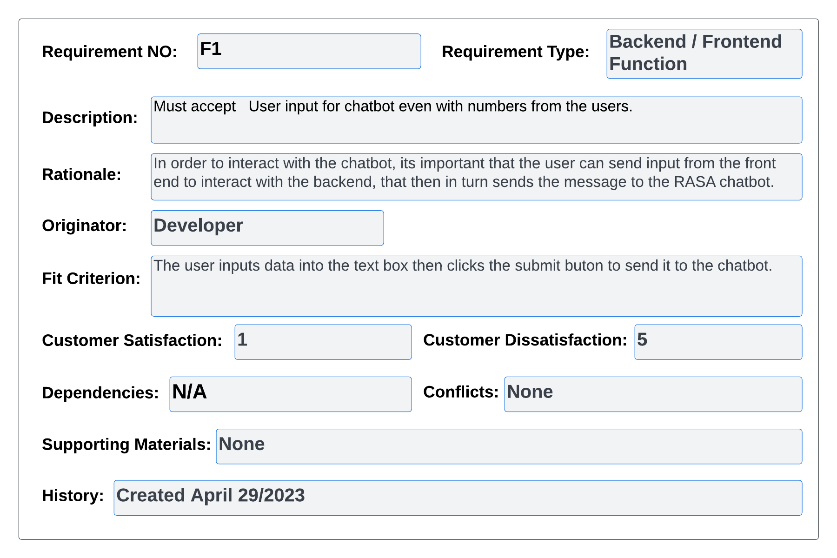

#### Figure 76 – volere Req 1

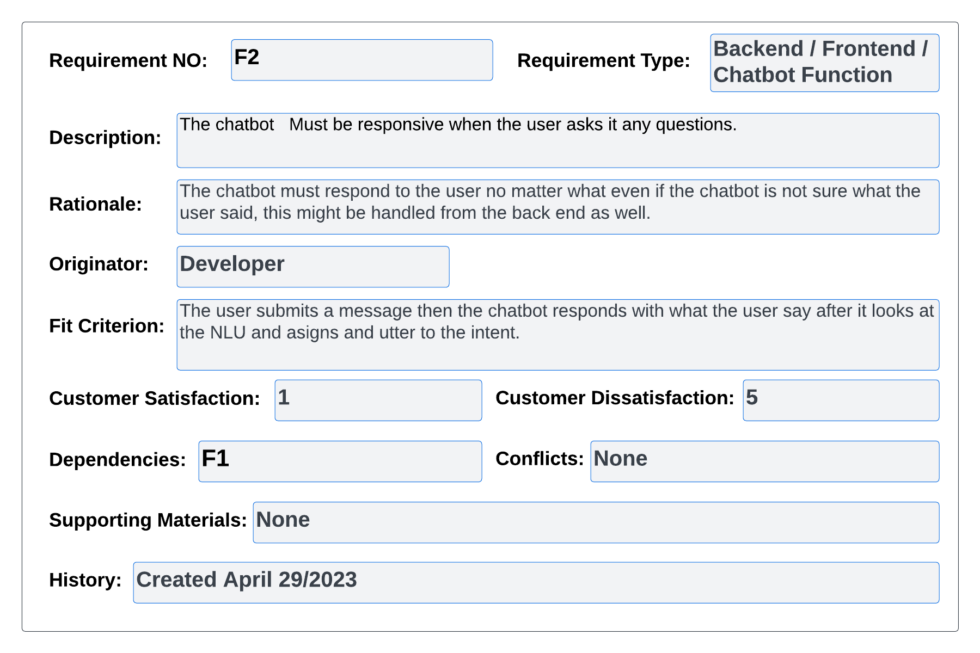

#### Figure 77 – volere Req 2

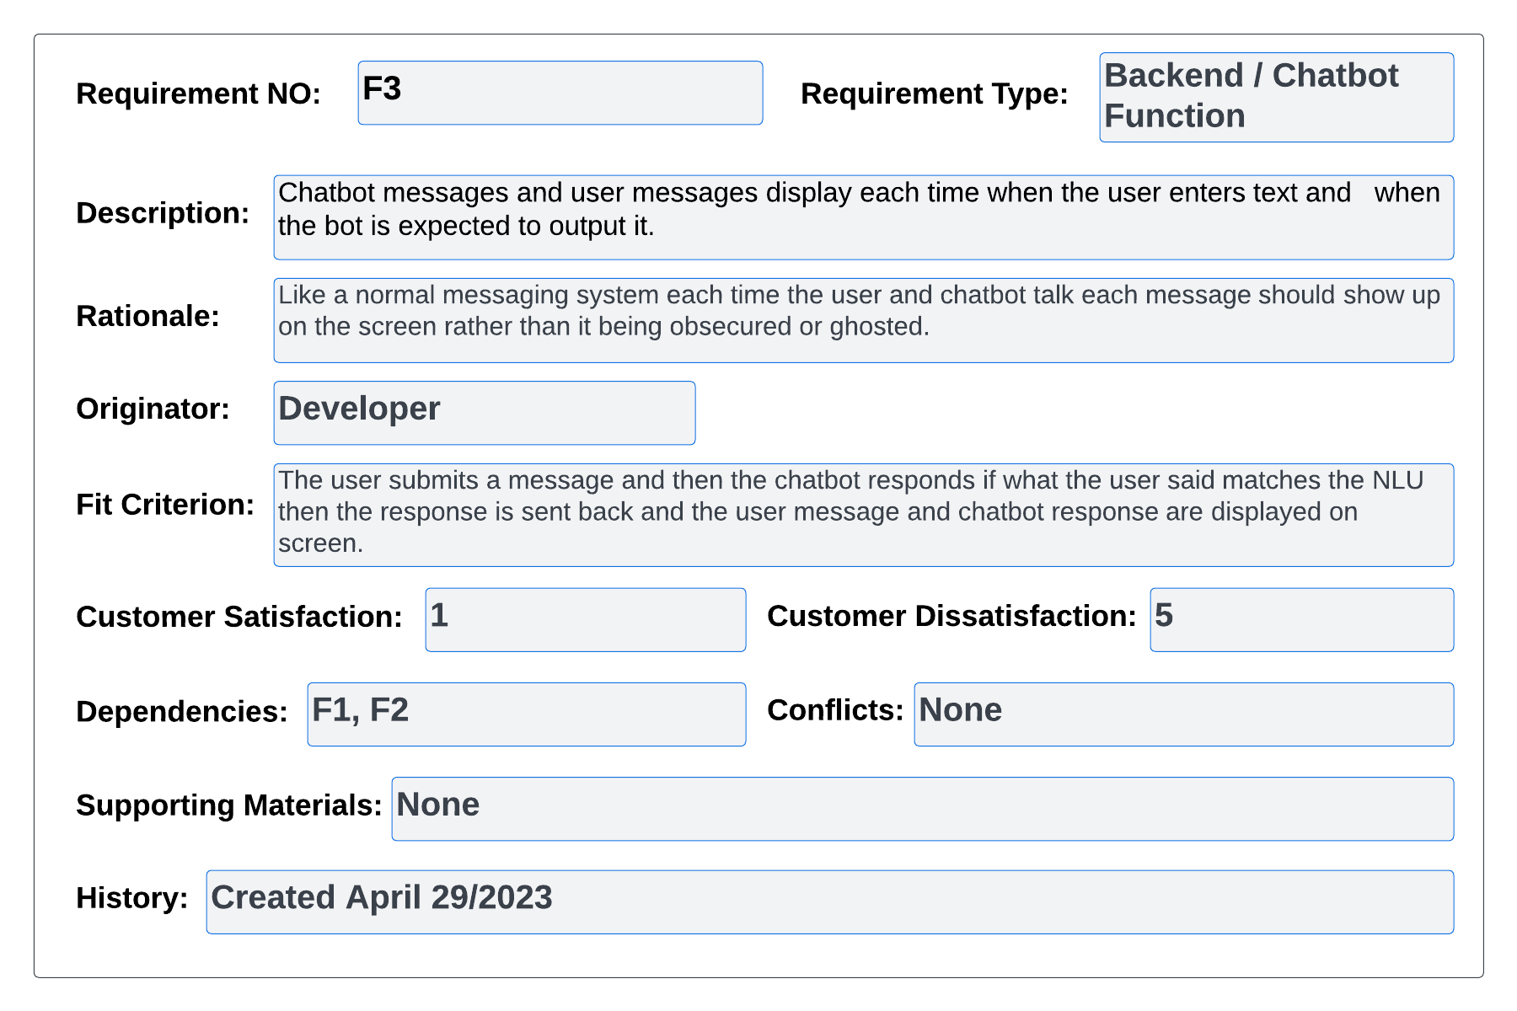

#### Figure 78 – volere Req 3

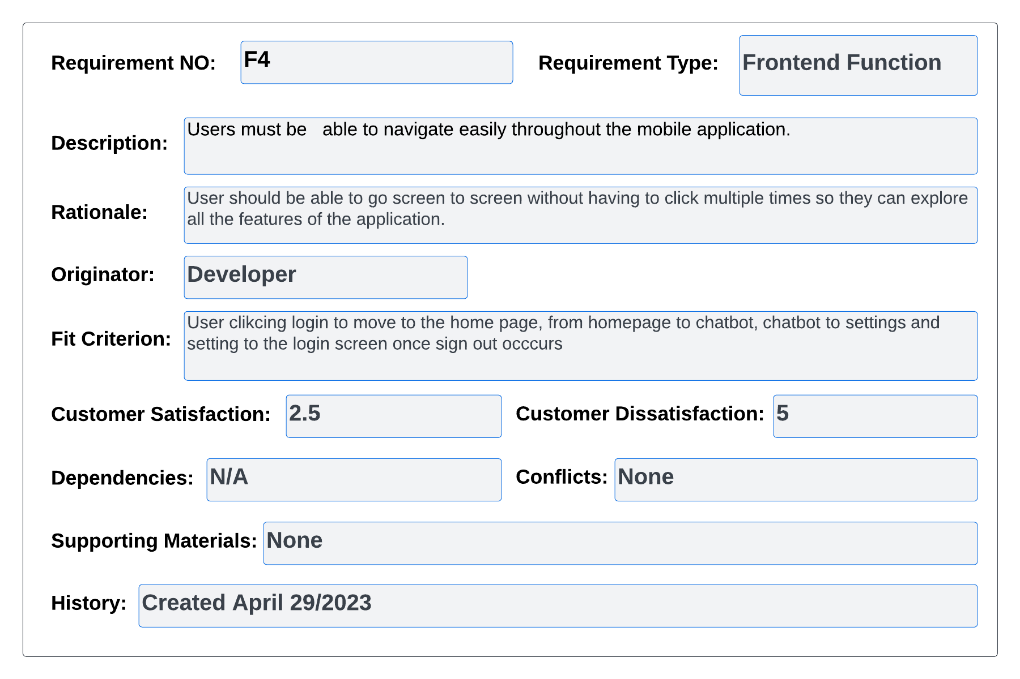

#### Figure 79 – volere Req 4

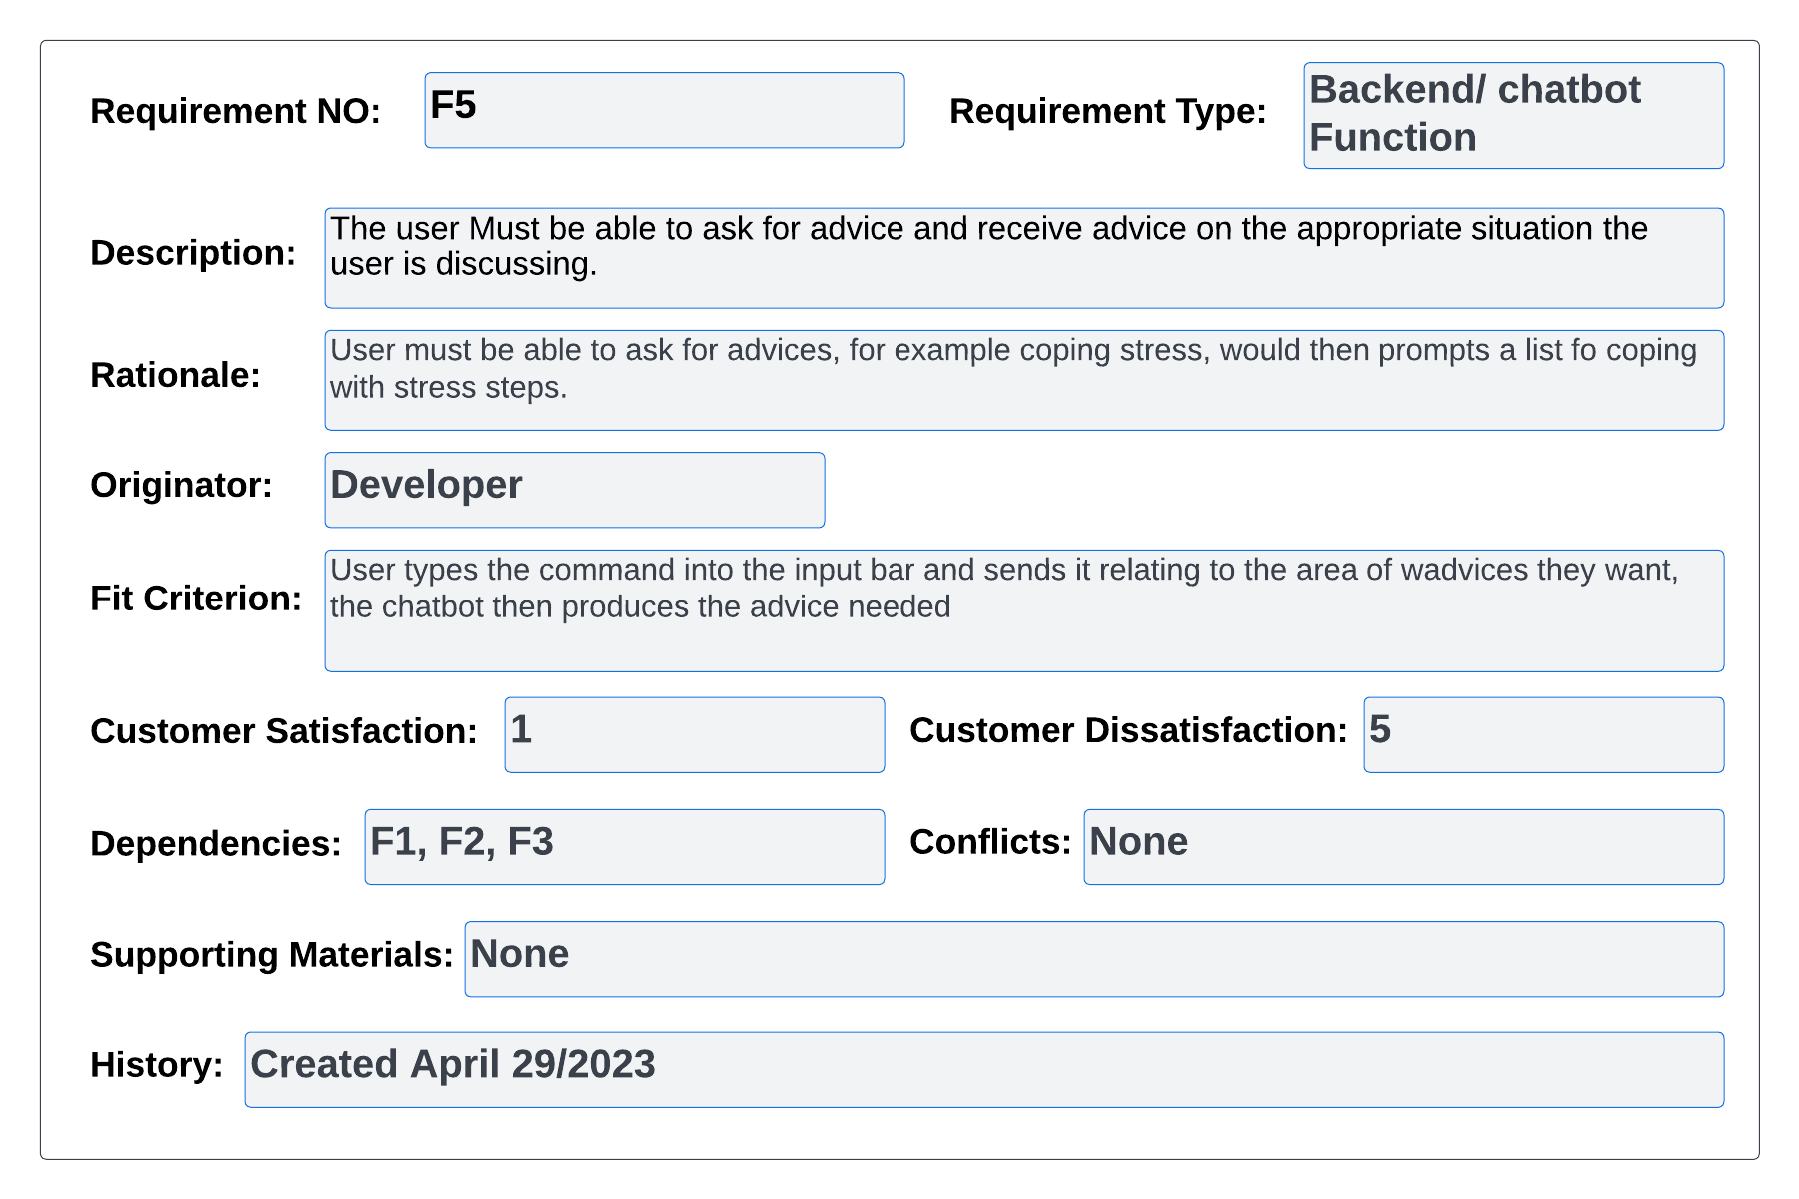

#### Figure 80 – volere Req 5

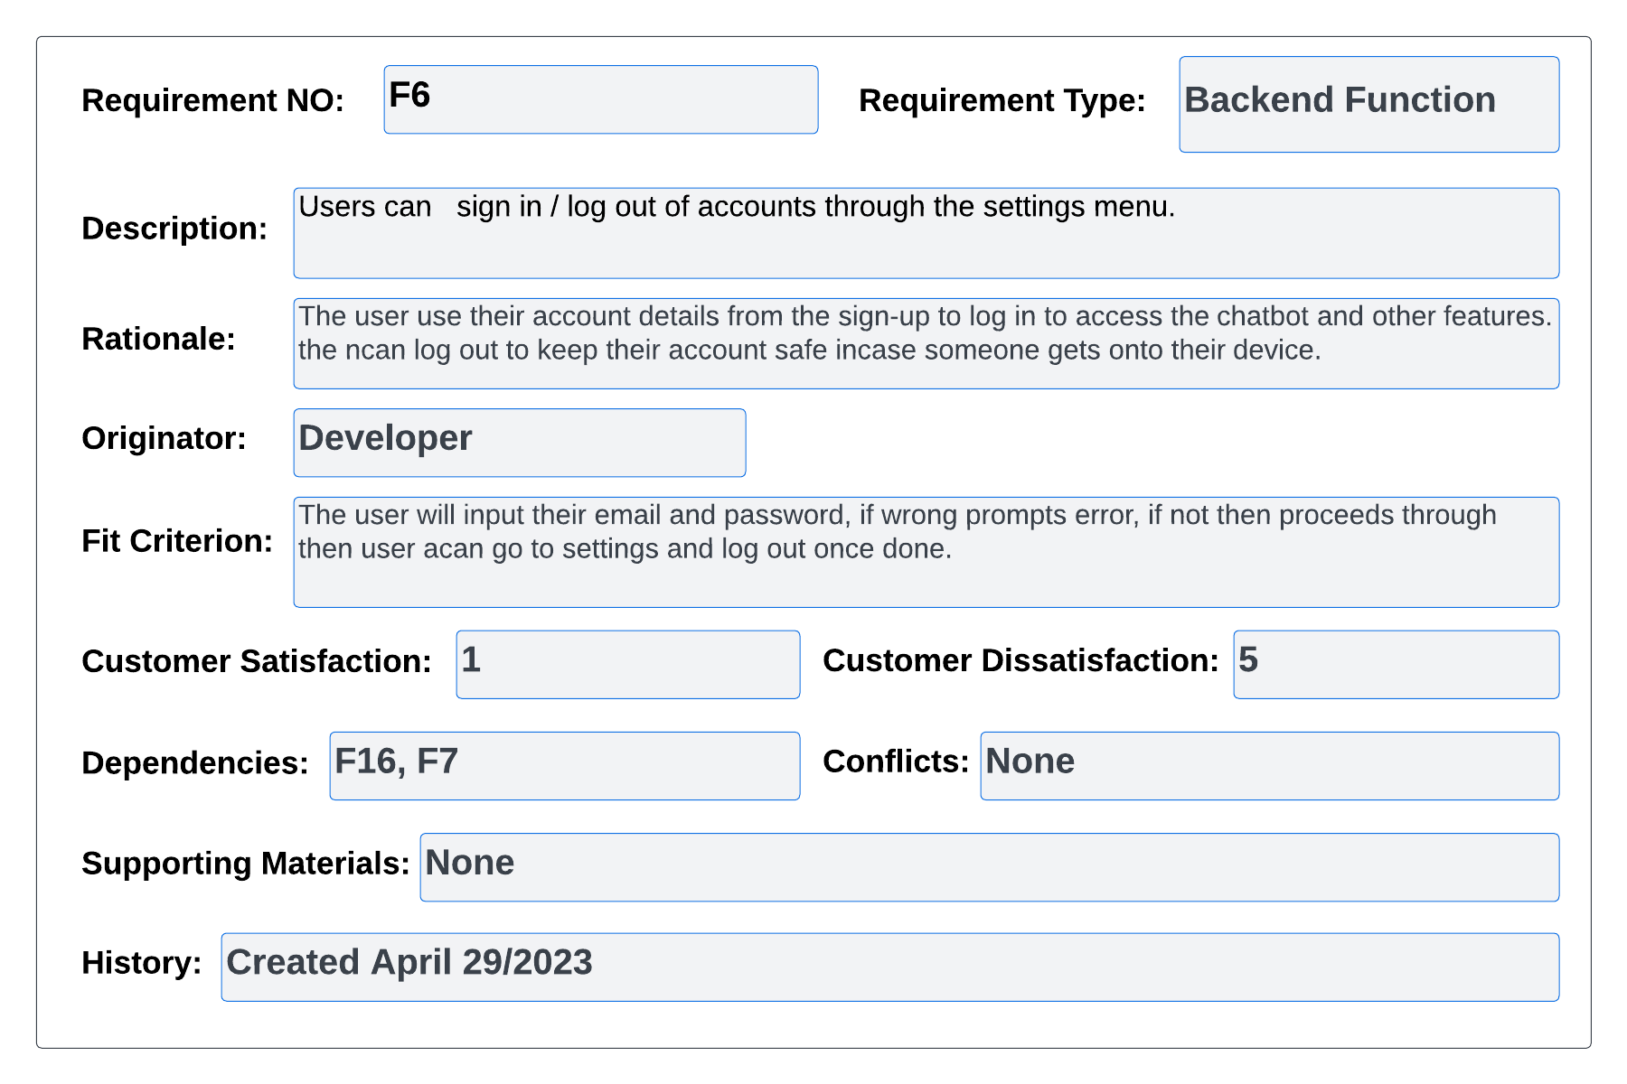

#### Figure 81 – volere Req 6

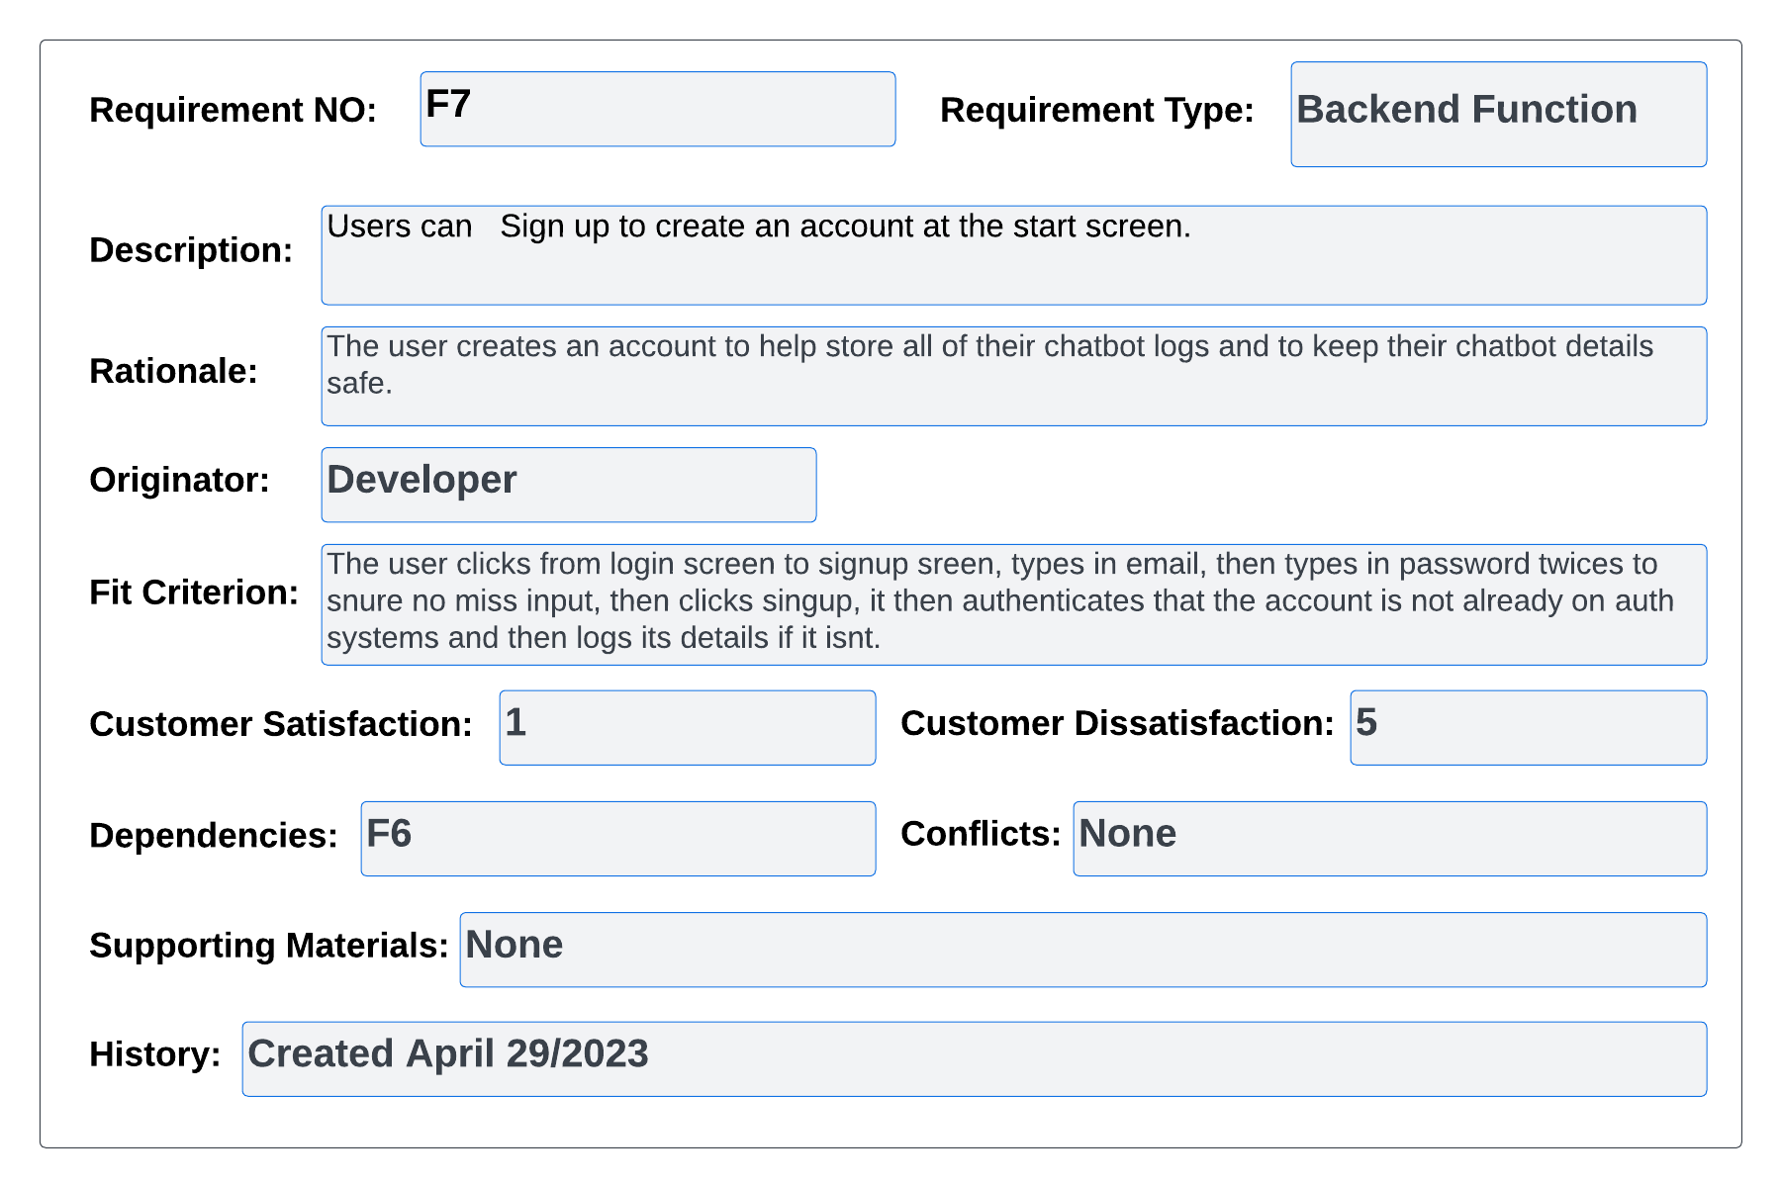

#### Figure 82 – volere Req 7

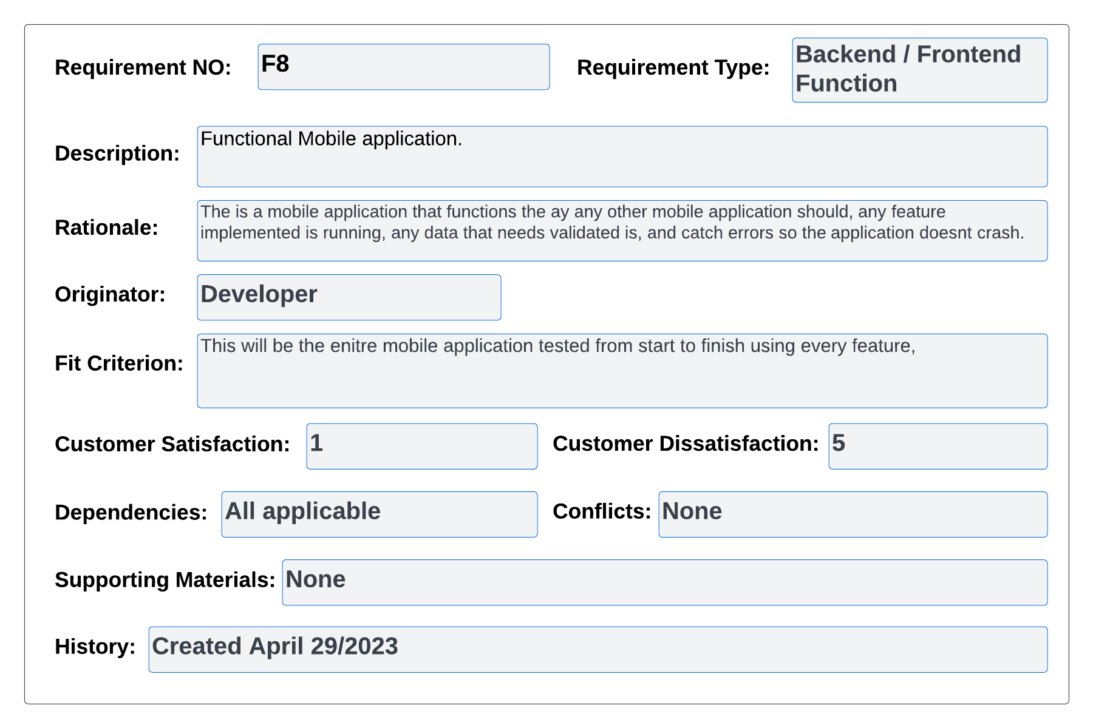

#### Figure 83 – volere Req 8

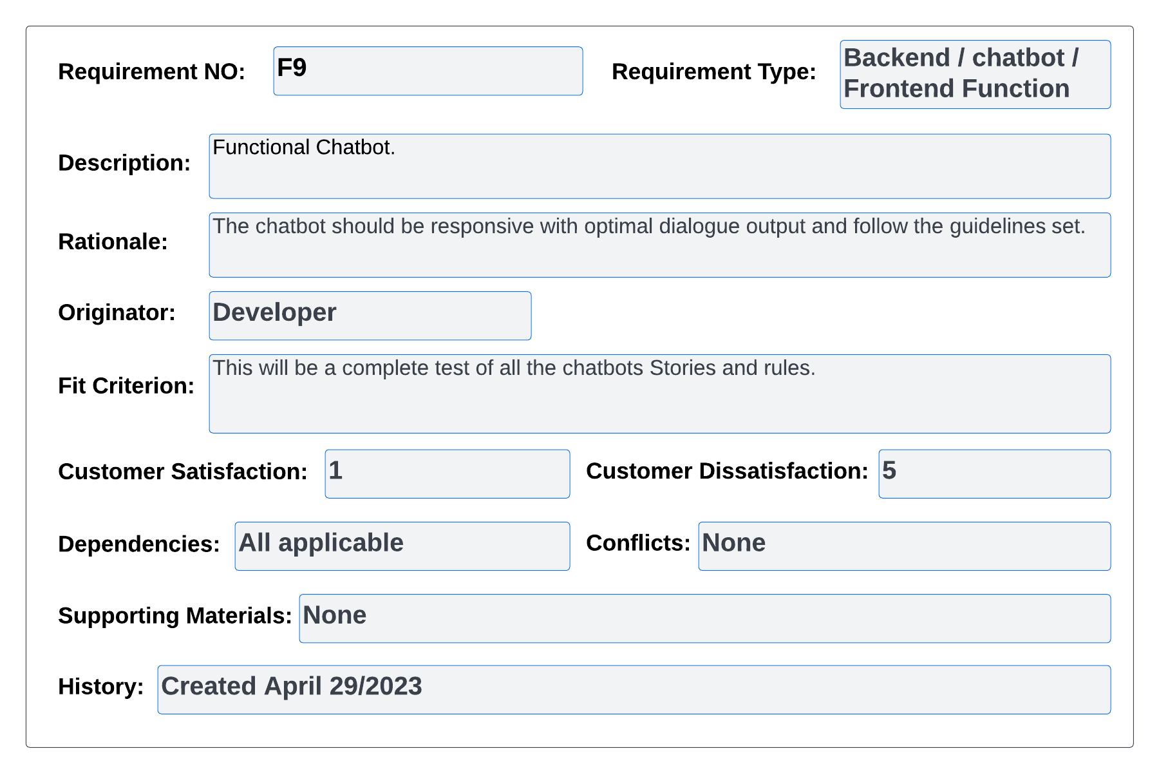

#### Figure 84 – volere Req 9

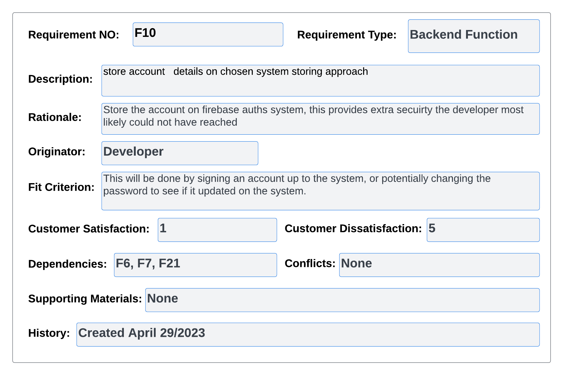

#### Figure 85 – volere Req 10

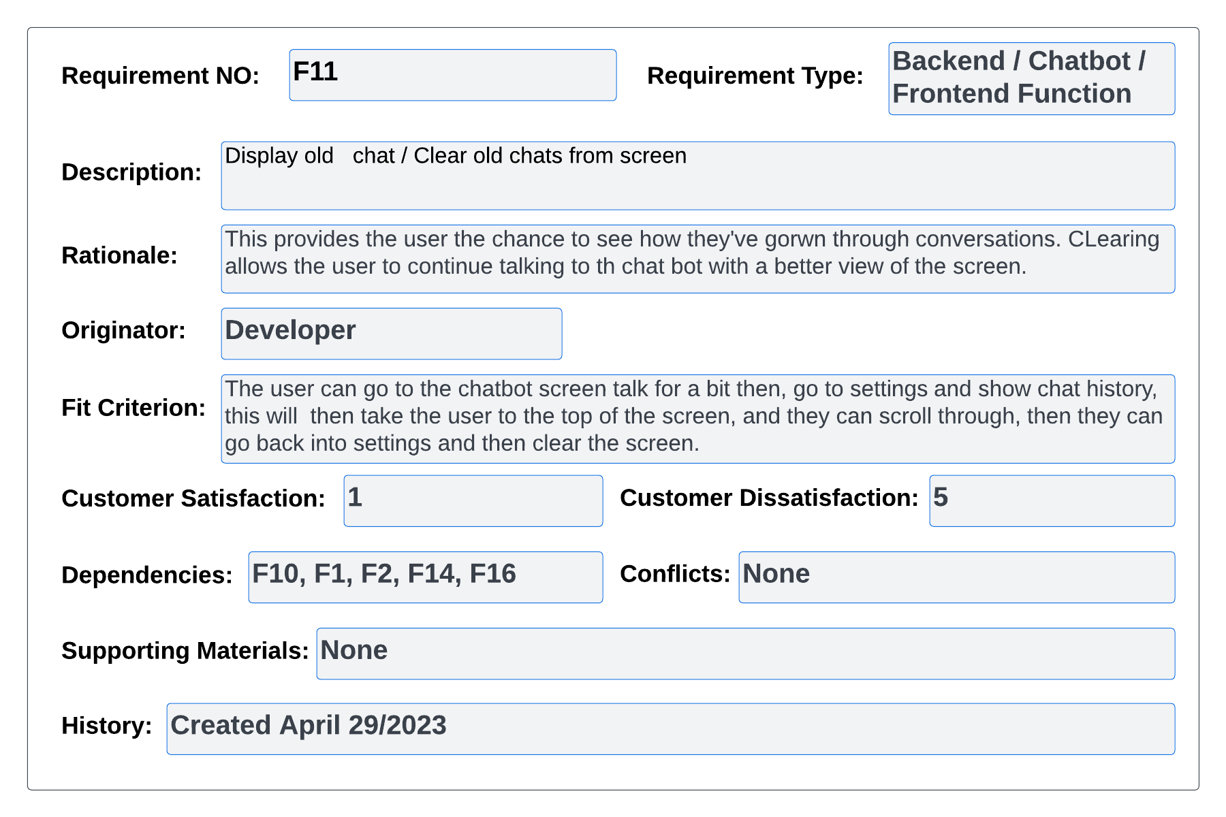

#### Figure 86 – volere Req 11

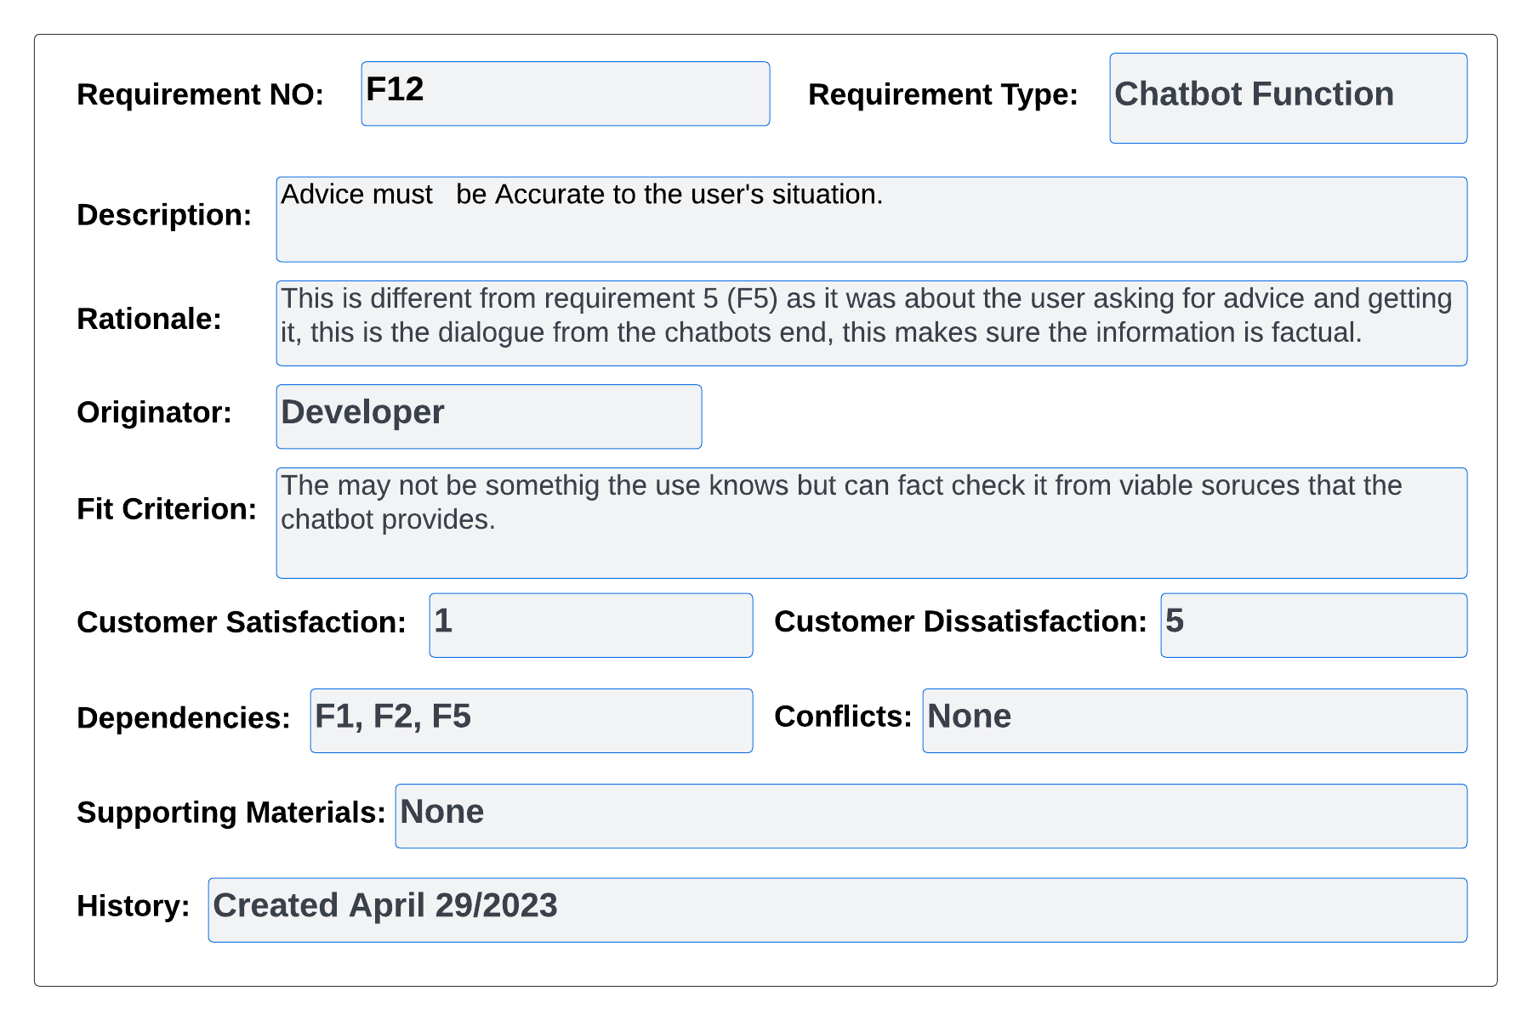

#### Figure 87 – volere Req 12

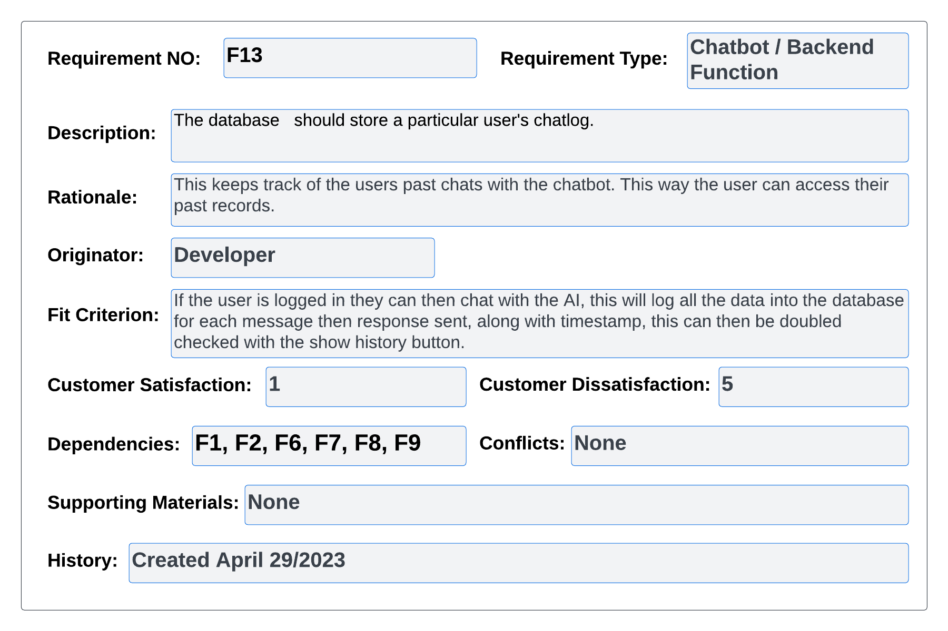

#### Figure 88 – volere Req 13

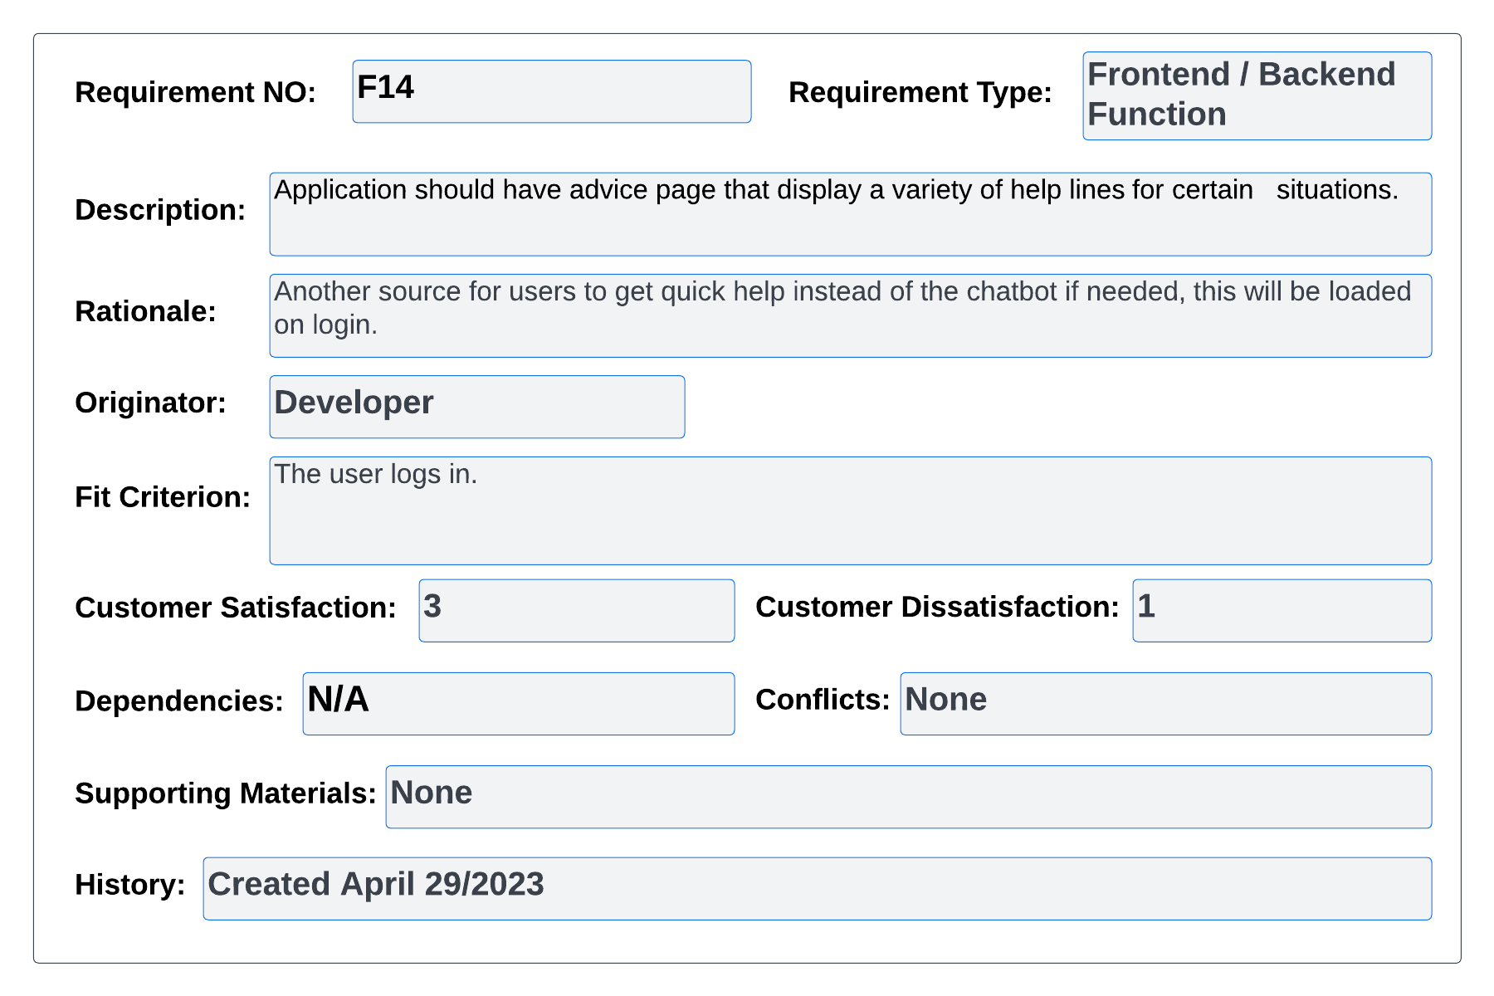

#### Figure 89 – volere Req 14

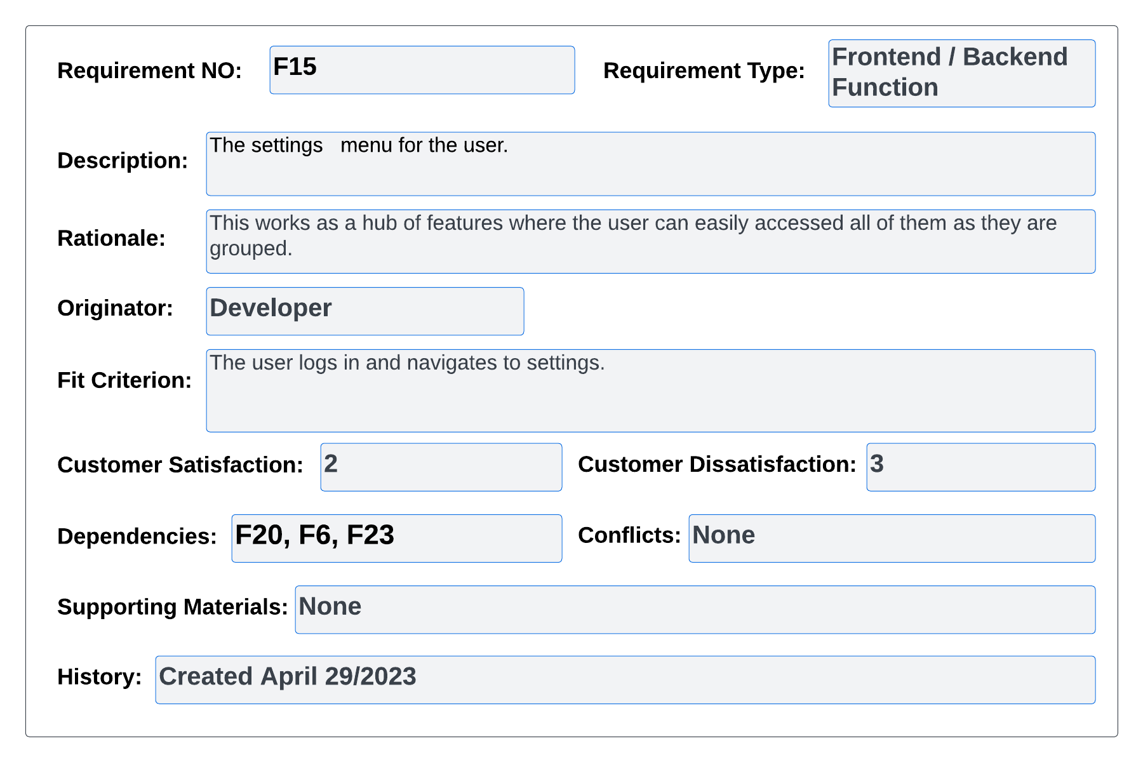

#### Figure 90 – volere Req 15

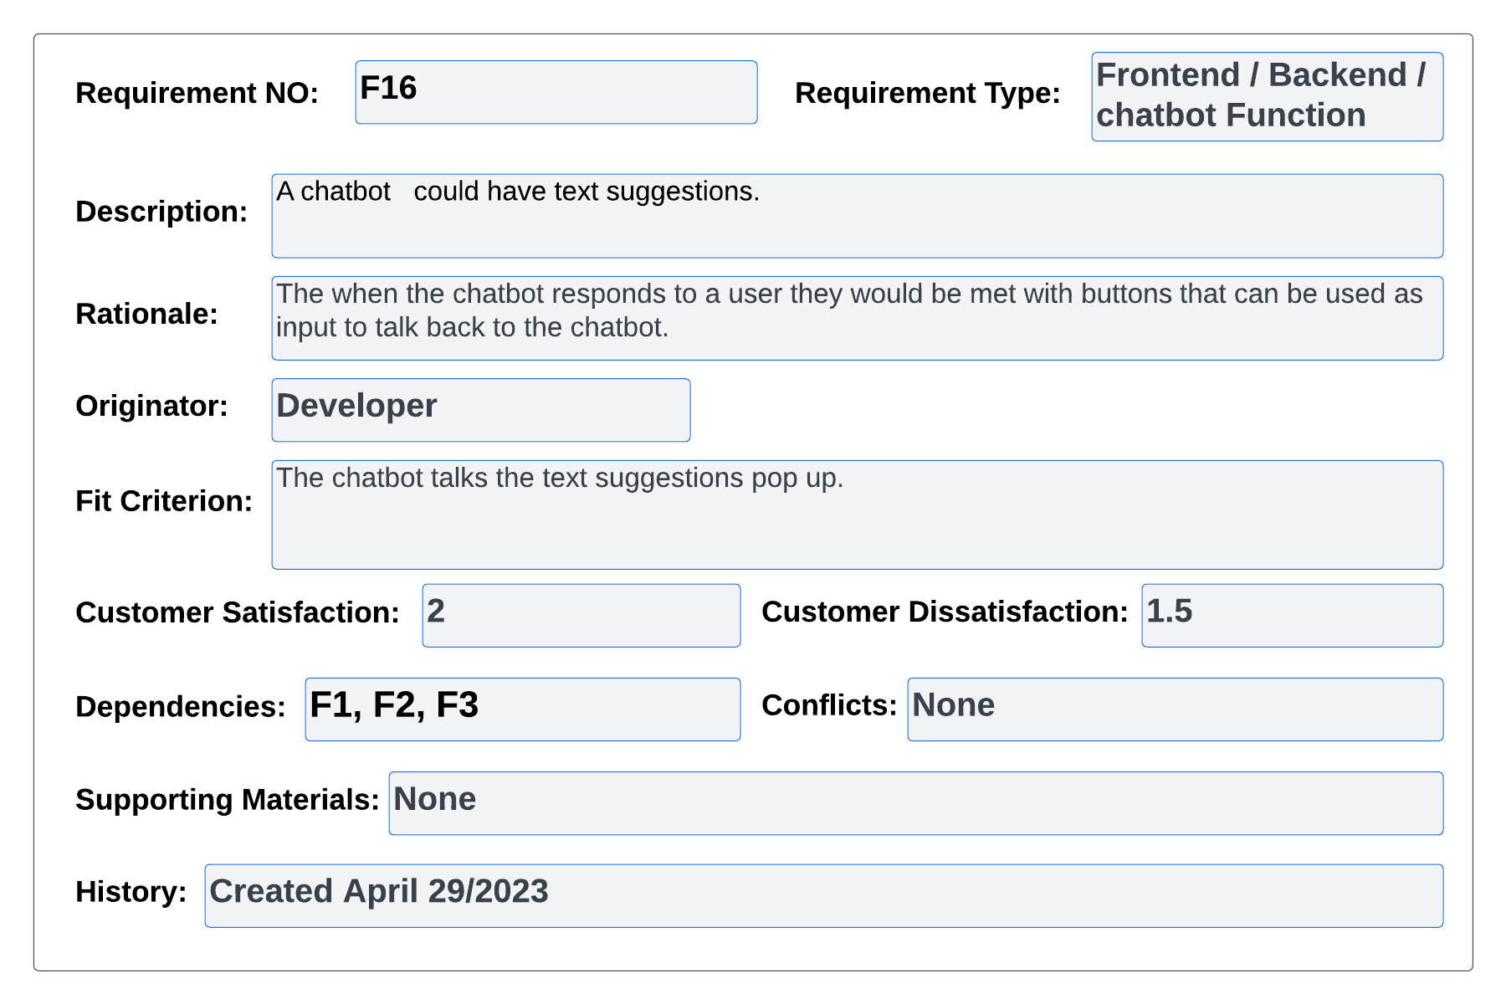

#### Figure 91 – volere Req 16

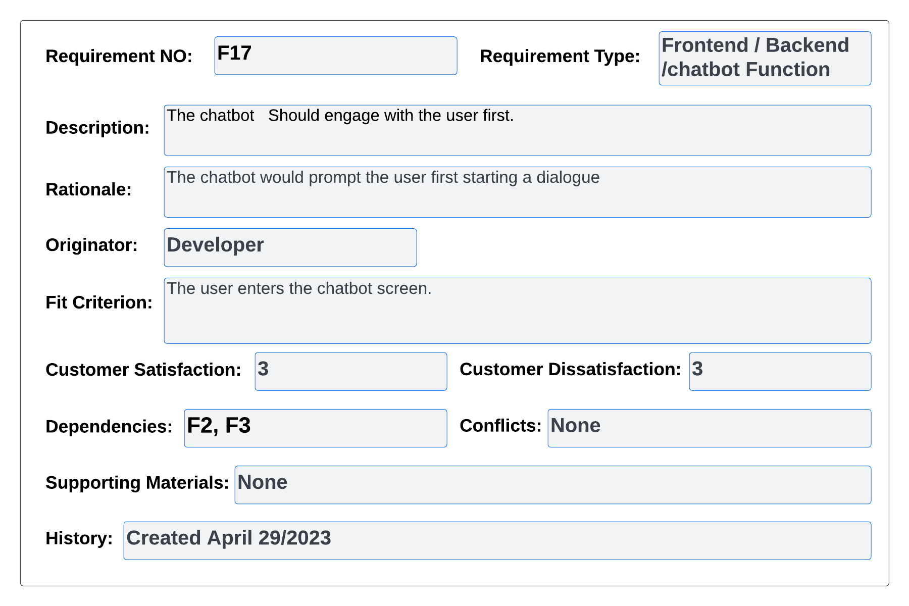

#### Figure 92 – volere Req 17

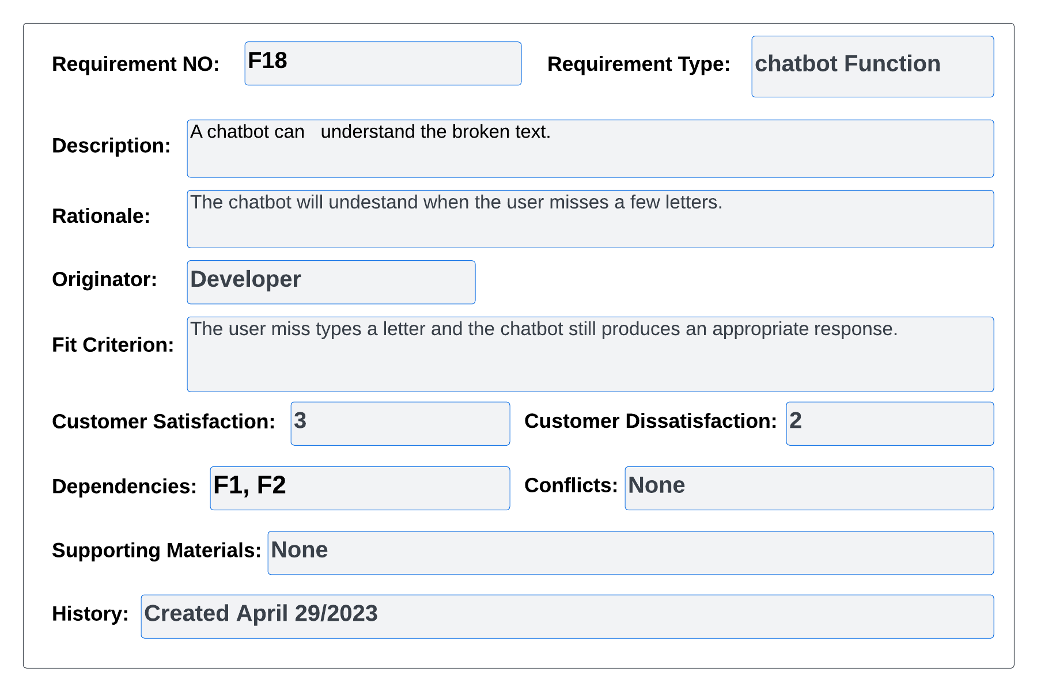

#### Figure 93 – volere Req 18

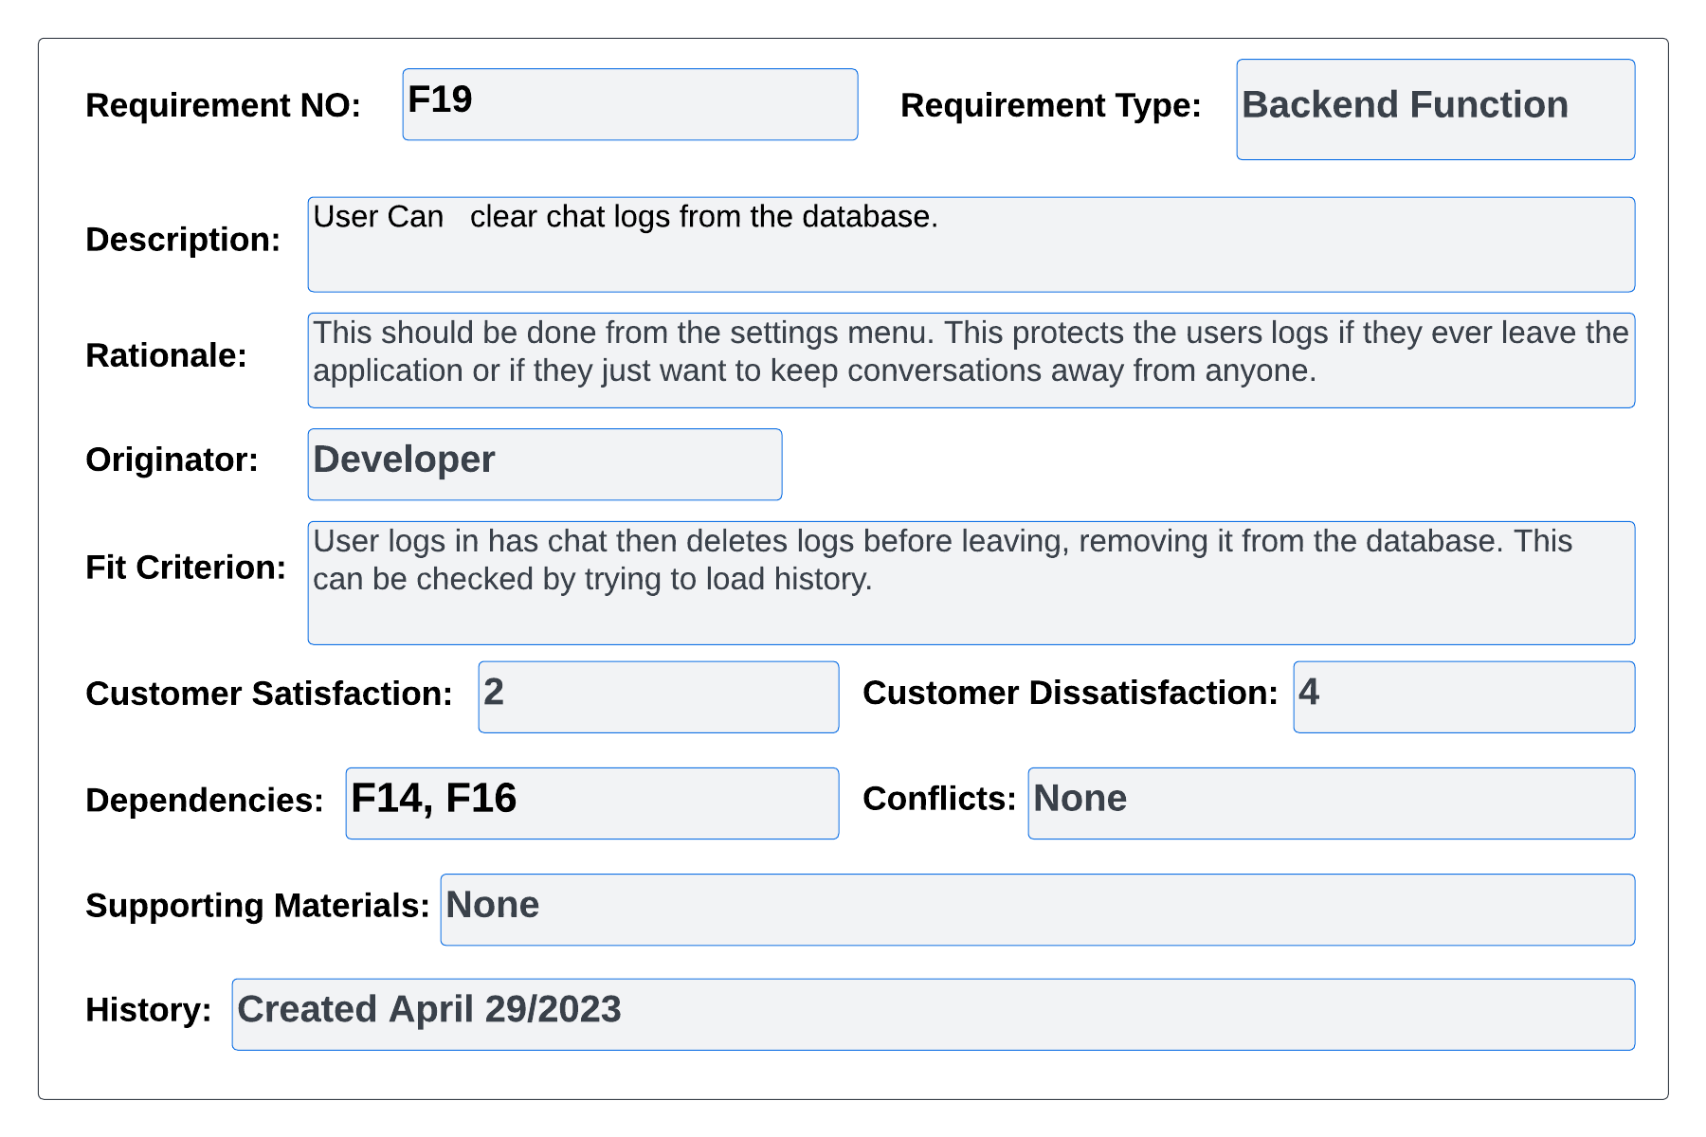

#### Figure 94 – volere Req 19

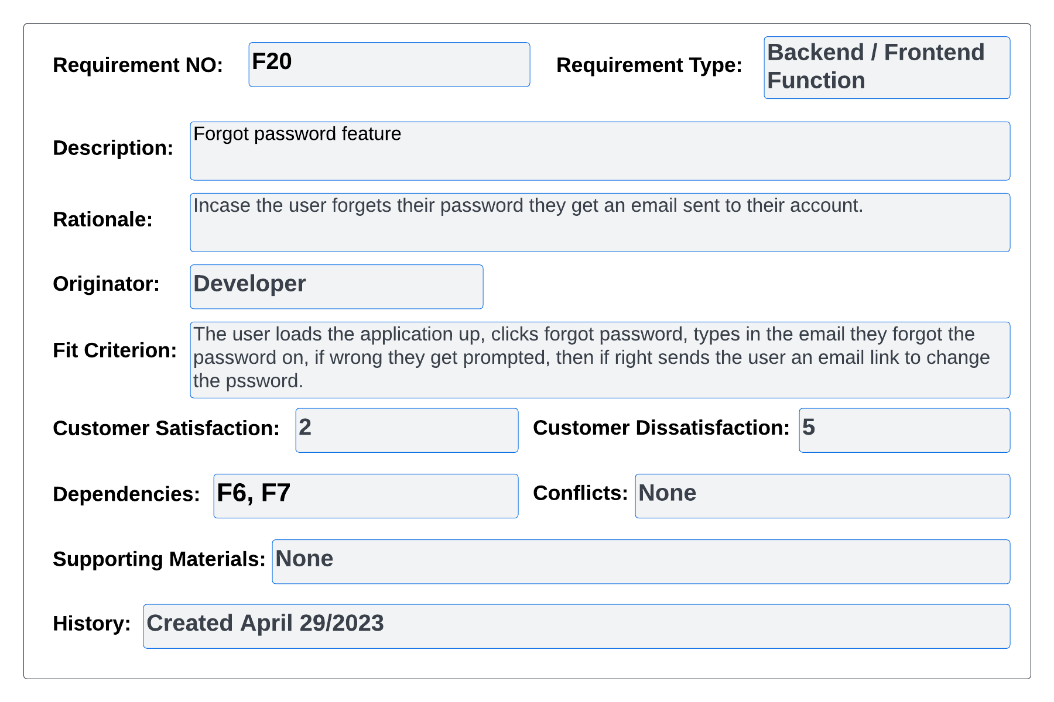

#### Figure 95 – volere Req 20

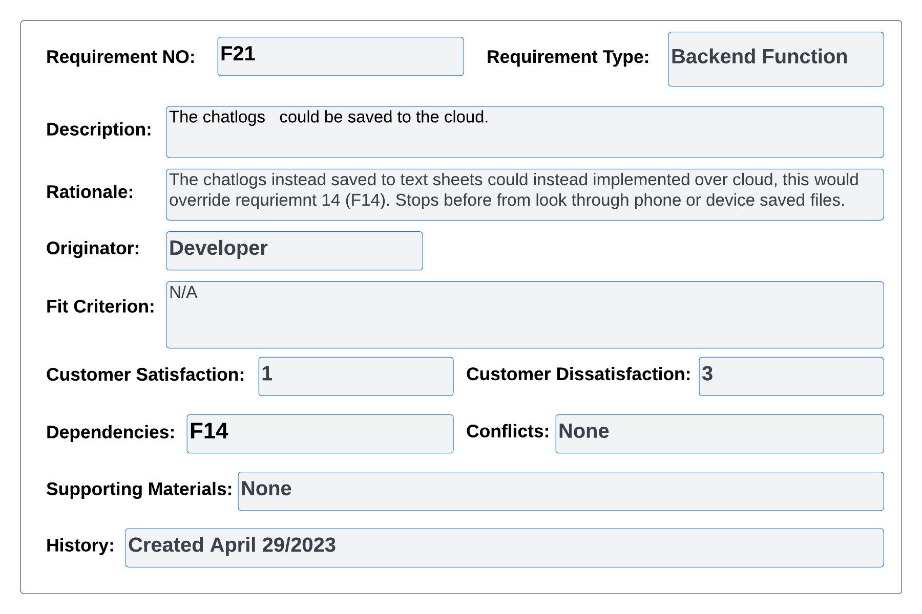

#### Figure 96 – volere Req 21

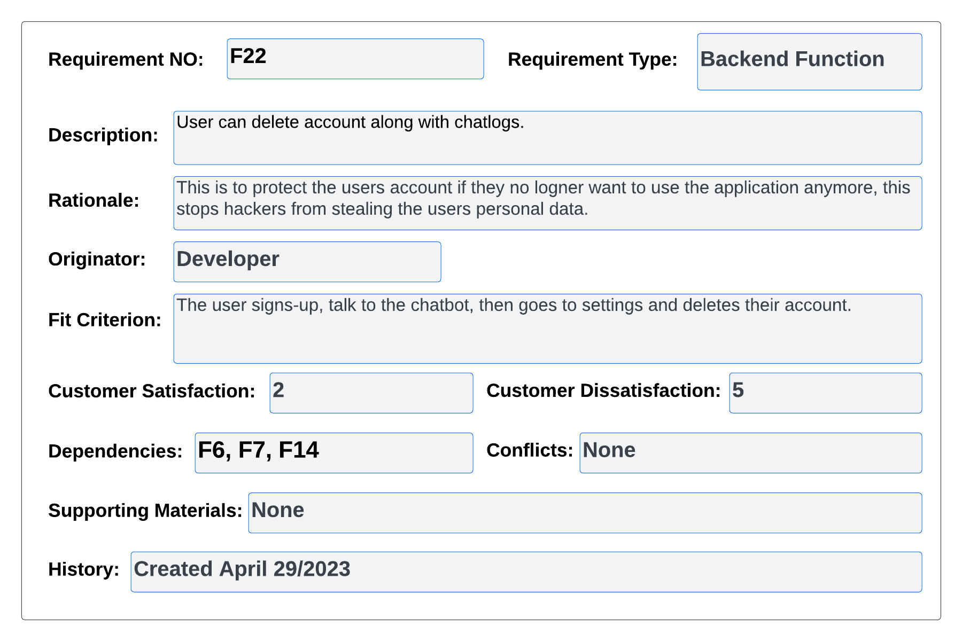

#### Figure 97 – volere Req 22

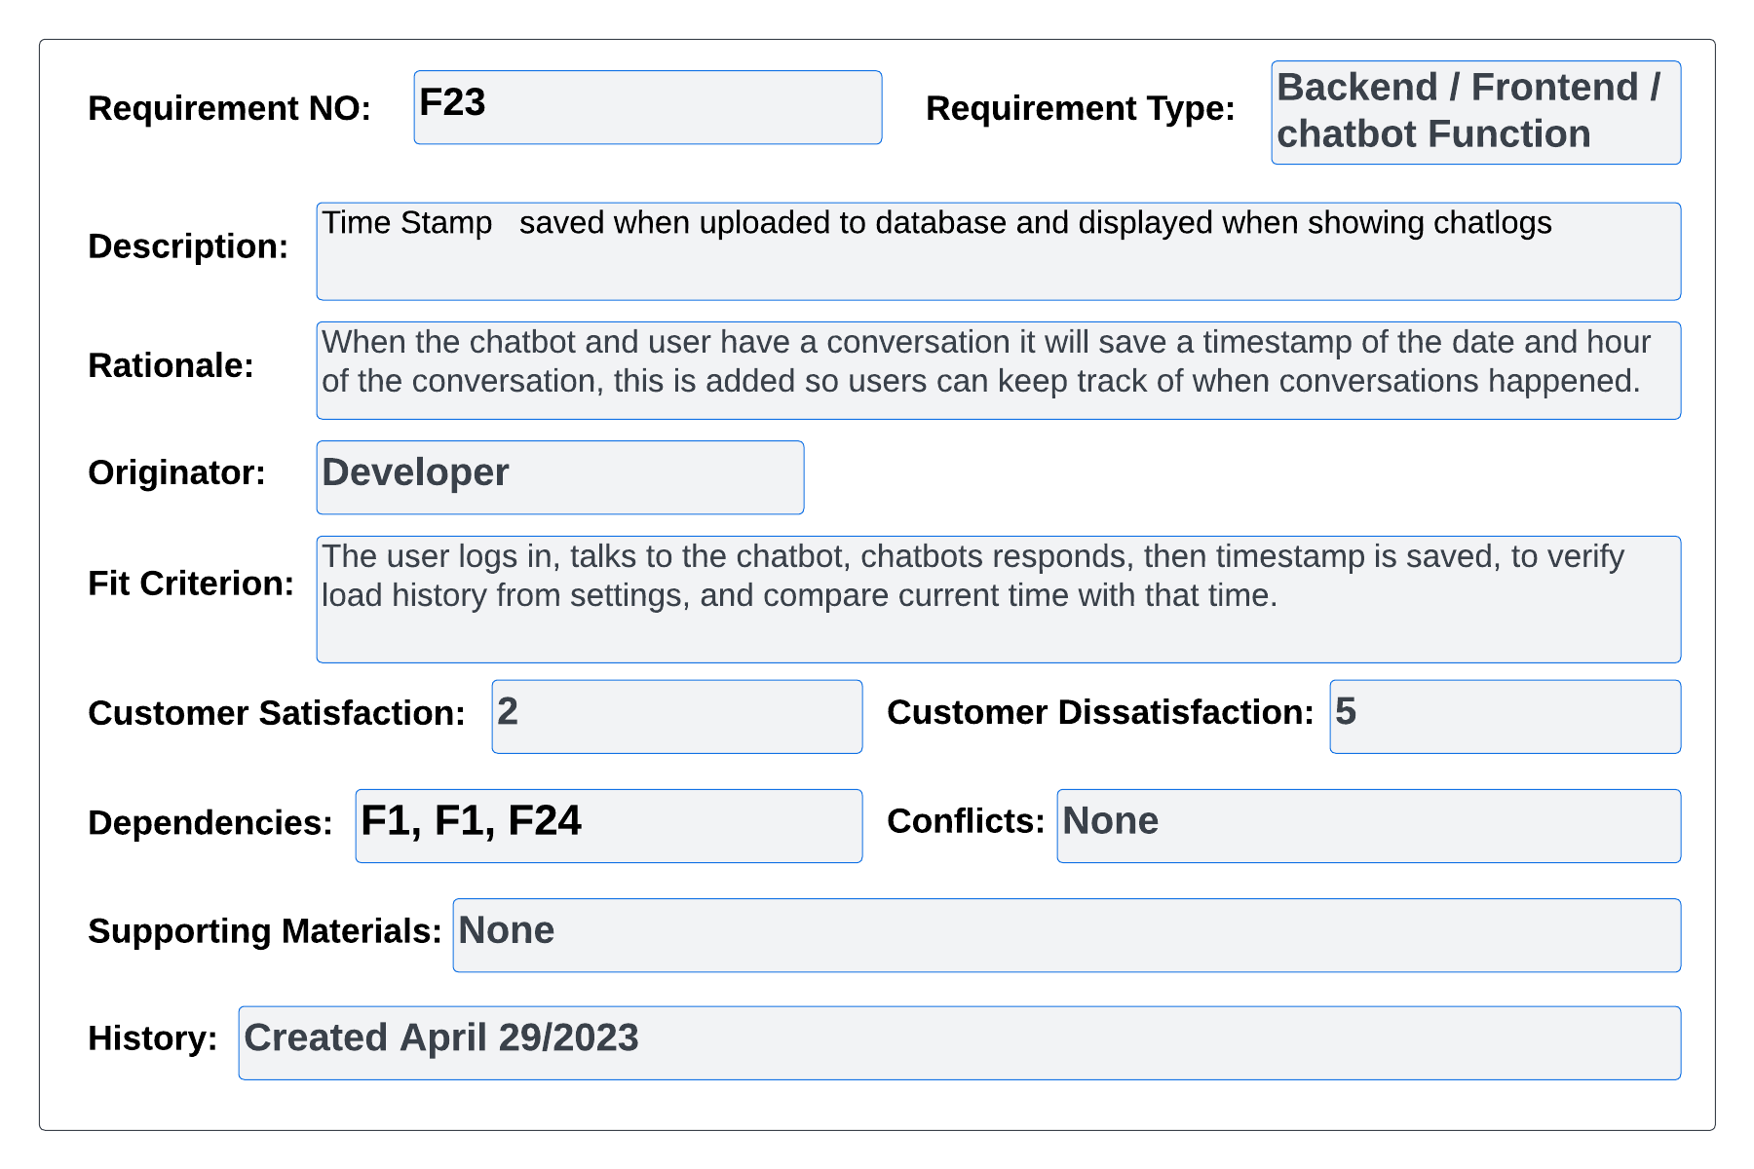

#### Figure 98 – volere Req 23

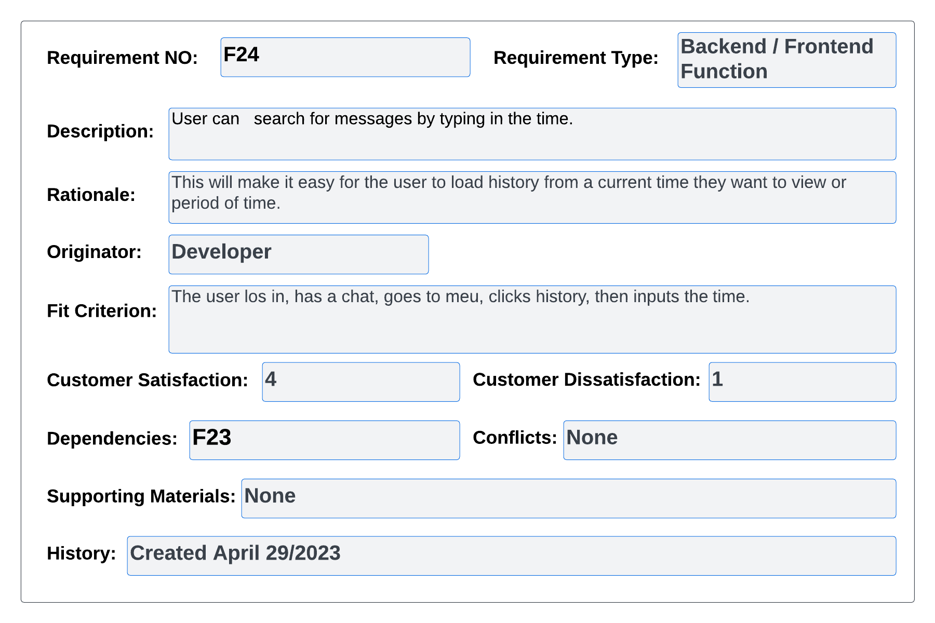

#### Figure 99 – volere Req 24

## Appendix B: Code Manifest

|  |  |  |  |
| --- | --- | --- | --- |
| File | Purpose of file | Created or modified | Contribution |
| App.py | Backend of the project | CREATED | Developer |
| My.KV | Frontend of the project | CREATED | Developer |
| Nlu.yml | Natural language understanding file for intents and examples of the RASA chat bot | CREATED | Developer |
| Rules.yml | Rules that have been set in RASA for conversational flow | CREATED | Developer |
| Stories.yml | Stories that have been set in RASA for conversational flow | CREATED | Developer |